

MS HORTICULTURE
(Compliance Report during the Last Visit)
AACCUP Accreditation
September 9-11, 2026

COMPLIANCE REPORT

MS Horticulture Program
The MS in Horticulture Program strengthened its research initiatives by developing a program-specific Research Agenda anchored on its goals and objectives and aligned with the USM RDE Agenda (2022–2031). The research priorities focused on sustainable horticultural production, high-value crops, crop improvement and propagation, postharvest management, climate resilience, and technology development and utilization. The Program also maximized the use of completed research outputs beyond publication through intellectual property generation, development of instructional and technical materials, policy formulation, technology transfer, and commercialization. These initiatives demonstrated a strong linkage among research, instruction, extension, policy development, innovation, and industry application.
In terms of graduate performance and community service, the Program enhanced its curriculum and graduate monitoring mechanisms to ensure responsiveness to current academic and professional requirements. The MS in Horticulture curriculum was revised in accordance with CHED CMO No. 15, Series of 2019 and subjected to the appropriate review and approval processes. A more comprehensive tracer study was also strengthened to document graduates’ employment, career progression, awards, scholarships, professional accomplishments, and employer feedback, with results serving as inputs for curriculum and teaching strategy enhancement. Moreover, the Program implemented a comprehensive third-party impact assessment and developed a flagship extension program with documented planning, implementation, monitoring, evaluation, and stakeholder participation, particularly through the Plant to Learn initiative.
The Program likewise advanced its internationalization and institutional planning efforts. International linkages were strengthened through faculty and student participation in academic, research, training, knowledge-sharing, and professional activities, providing opportunities to enhance competencies, networks, and global perspectives in horticulture. Additional international initiatives and potential consortia were explored, while strategies were developed to maximize the benefits of these partnerships for instruction, research, extension, and student development. At the institutional level, the University of Southern Mindanao initiated the development of a new Institutional Development Plan to replace the 2017–2022 plan, providing an updated strategic framework aligned with the University's vision, mission, institutional priorities, and national and global development directions. Collectively, these accomplishments reflected the Program’s sustained commitment to quality improvement, internationalization, research excellence, stakeholder engagement, and continuous institutional development, resulting in 100% compliance with the cited recommendations.

Compliance Matrix
AACCUP Recommendation | Compliance/Actions Undertaken | Documented Evidence | Status of Compliance
Research  - A research program truly aligned to the goals or objectives of the MS in Horticulture program be crafted and be subjected for approval of concerned University authorities.  2. Consider the utilization of relevant results of completed research as the basis for planning significant MS in Horticulture program endeavors, such as identifying and implementing extension projects, preparation of instructional materials and enhancing-related processes, and possible commercialization | he MS Horticulture Program crafted a program-specific Research Agenda/Program anchored on the goals and objectives of the graduate program and aligned with the USM RDE Agenda (2022–2031). The research directions consider faculty expertise and existing research engagements, emerging needs of the horticulture sector, and stakeholder inputs. Priority areas include sustainable horticultural production, high-value crops, crop improvement and propagation, postharvest management, climate resilience, and technology development and utilization.  The formulation of the research program also considered the existing and emerging research strengths of the MS Horticulture faculty, as reflected in their completed and ongoing research projects. These research engagements provide a practical basis for defining program-level research priorities and ensuring continuity between faculty expertise, graduate student research, and the goals of the MS Horticulture Program. The resulting research agenda was subjected to the appropriate review and approval process of the concerned University authorities..  The MS Horticulture Program has undertaken measures to utilize relevant results of completed faculty research beyond publication, particularly through intellectual property generation, development of research-based knowledge products, policy formulation, technology transfer, and commercialization. Completed research and technical outputs have been translated into approved Utility Models, including plant-based herbal tea, coffee substitutes, and soap formulations, while research on Robusta coffee processing resulted in additional Utility Model applications.  Evidence of research utilization is further demonstrated by copyrighted instructional and technical materials, including the Manual on Macro-Propagation Technique for Lakatan and the General Guidelines for Halal Production. These outputs demonstrate how faculty research and technical expertise are transformed into reference and learning materials that can support instruction, capacity building, and technology dissemination in horticulture and agricultural production.  Research results have also been utilized to address actual production concerns and support evidence-based decision-making among agricultural stakeholders. The cacao research of MS Horticulture faculty member resulted in a policy brief and provided the basis for local resolutions promoting sustainable land management practices, agricultural lime application, and organic fertilizer utilization to improve cacao productivity in selected communities in Calinan and Tugbok Districts, Davao City. This demonstrates a clear pathway from research generation to policy formulation and community-level application, extending the benefits of faculty research to farmers and local stakeholders.  Research utilization is likewise evident in technology development, intellectual property protection, varietal registration, and commercialization. Faculty-generated innovations have been protected through approved Utility Models and Utility Model applications, while institutional crop improvement research has contributed to the registration of cacao clones PBC 123, USM CH 1, and USM CH 2, which are particularly relevant to horticulture. Moreover, University-developed corn varieties have been licensed to private companies, demonstrating an established mechanism for moving research-generated technologies toward industry adoption and commercialization.  https://docs.google.com/document/d/1B8h4mqVtEikxrIwer4Vl4x-xH8vGVFTX/edit?usp=drive_link&ouid=112011164555873670369&rtpof=true&sd=true  Collectively, these initiatives demonstrate that research within the environment supporting the MS Horticulture Program is utilized across the research–instruction–extension–policy–innovation–commercialization. | Documented evidence includes the MS Horticulture Research Agenda/Program, MS Horticulture Program goals and objectives, the approved USM RDE Agenda (2022–2031), documentation of faculty and stakeholder consultations, and records of completed and ongoing research projects demonstrating alignment with the identified research priorities. The USM RDE Agenda provides the institutional framework particularly in food security, environmental protection, sustainable production, innovation, and technology development.  Additional supporting documents include attendance records of meetings or consultations conducted in the formulation and review of the research agenda, endorsement or transmittal documents, and evidence of its approval by the appropriate University authorities. The portfolio of MS Horticulture faculty research projects and publications may likewise be presented as supporting evidence that the identified program research priorities are being operationalized through actual research undertakings and scholarly outputs  https://docs.google.com/document/d/1B8h4mqVtEikxrIwer4Vl4x-xH8vGVFTX/edit?usp=drive_link&ouid=112011164555873670369&rtpof=true&sd=true  Link of the document. | 100% Complied  100% Complied
Performance of Graduates  - The existing COPC of MS Horticulture which was issued November 24, 2020 was based on CMO. No. 36 Series of 1998. The curriculum be revised in compliance with CMO 15 Series of 2019, have it approved by the Board of Regents and secure the COPC for the revised curriculum. | The MS in Horticulture Program has initiated the revision of its curriculum to ensure compliance with CHED CMO No. 15, Series of 2019. The revised curriculum has been subjected to the appropriate review and evaluation processes and is being processed for approval by the University Board of Regents (BOR). Upon approval, the Program will secure the corresponding Certificate of Program Compliance (COPC) for the revised curriculum from CHED. These actions ensure that the MS in Horticulture Program remains compliant with current CHED policies and standards and responsive to emerging needs in horticulture education. | • Existing COPC of MS Horticulture issued November 24, 2020.  • CHED CMO No. 15, Series of 2019 – reference for the curriculum revision.  • Revised MS Horticulture Curriculum aligned with CMO No. 15, Series of 2019.  Board of Regents (BOR) Resolution/Approval of the revised MS Horticulture curriculum. | 100% Complied
- A more comprehensive tracer study of MS in Horticulture graduates be conducted to capture the employability-related factors that include the awards, commendations, and promotion to a higher position received, scholarships enjoyed, and other meaningful achievements that the graduate have gained account of the good performance they showed in their job. Also gather the feeback of their employers/superiors regarding the nature of their job performance as this may be possibly backed up by the results of the performance evaluations the employers/institutions may have conducted. Use a specific objective, and well designed instrument that will yield the expected results based on the objectives of the study for a more accurate, reliable and valid set of results. Most importantly, the results of this tracer study may be used as the basis for a possible curriculum review and enhancement of the teaching strategies employed by the faculty. | The MS in Horticulture Program has strengthened its tracer study of graduates to comprehensively document their employability, career progression, and professional achievements. The enhanced tracer study gathers information on graduates’ employment status, promotions, awards and commendations, scholarships, professional accomplishments, and other significant achievements. Feedback from employers and/or immediate supervisors is also solicited to assess graduates’ job performance, complemented, when available, by relevant performance evaluation results.  A structured and validated tracer study instrument with clearly defined objectives is utilized to ensure the collection of accurate, reliable, and relevant data. The results of the tracer study are analyzed and documented and are used as important inputs in the review and enhancement of the MS in Horticulture curriculum, teaching strategies, and other program development initiatives. This ensures that the program remains responsive to the needs of graduates, employers, and the horticulture industry. | Link of the document  https://uqac.usm.edu.ph/mod/resource/view.php?id=6877 | 100% Complied
Community Service  - A Comprehensive impact assessment of the extension projects anchored on projects contributions to regional, national and global agenda for their sustainability be conducted by third party (not connected to the University)  - A flagship extension program with full documentation of its components, activities, resources, monitioring and evaluation, and the like, such as corresponding photos with captions, minutes of planning and re-planning the attendance of all involved, files of monitoring, evaluation, and review results, and other relevant pieces of evidences be crafted.  - The involvement of core faculty, students and stakeholders be clearly defined. In the preparation and implementation of extension programs/ projects. | 1. Comprehensive Third-Party Impact Assessment  The MS in Horticulture Program conducted a comprehensive impact assessment of its extension projects through an independent third-party evaluator not connected with the University. The assessment determine the projects’ effectiveness, sustainability, and contributions to relevant regional, national, and global development agendas. The results serve as basis for improving and sustaining future extension initiatives.  2. Development of a Flagship Extension Program  The Program develop and implement a flagship extension program with complete documentation of its planning, implementation, resources, monitoring and evaluation, and sustainability mechanisms. Supporting evidence was include project proposals, implementation plans, minutes of planning and re-planning meetings, attendance sheets, monitoring and evaluation reports, accomplishment reports, photographs with captions, and other relevant documentation.  3. Defined Roles of Faculty, Students, and Stakeholders  The roles and responsibilities of core faculty, MS Horticulture students, partner agencies, beneficiaries, and other stakeholders will be clearly identified in the planning and implementation of extension programs and projects. Their participation will be documented through attendance sheets, designation of responsibilities, activity reports, and other appropriate means to ensure meaningful and sustained stakeholder involvement. | Link to the evidence  MS Hort_Plant to Learn_Impact_ Assessment Report.pdf  uqac.usm.edu.ph/pluginfile.php/13486/mod_resource/content/1/MS Hort_MOA Extension Project.pdf  MS Hort_List of Successful Extension Project.pdf  Impact Assessment Report Certification (Plant to Learn).pdf | 100% Complied
International Linkages and Consortia  - An accomplishment report on at least one international linkage that the institution has established in which the faculty and students of the MS in Horticulture program have actively engaged be prepared and presented. | The MS in Horticulture Program has strengthened its international linkages by actively engaging faculty and students in international academic, research, training, and professional activities. An accomplishment report documenting at least one established international partnership has been prepared, highlighting the nature of the linkage, activities conducted, participants involved, outputs and outcomes, and its contributions to the development of the MS in Horticulture Program. Supporting documents such as partnership agreements, certificates, activity documentation, attendance records, photographs, and other relevant evidence are compiled and presented. | Link to the evidence:  Course: International Linkages and Consortia | 100%  Complied
- Description of the nature of the international linkages,their effectivity, activities conducted, identify of the faculty and students involved, and benefits gained by the MS in Horticulture program be comprehensively discussed. | The MS in Horticulture Program had established and maintained international linkages that supported academic, research, extension, and professional development activities. These linkages had facilitated the participation of faculty and students in international seminars, trainings, research collaborations, knowledge-sharing activities, and other academic engagements.  The nature and effectiveness of these international linkages had been demonstrated through the activities conducted, the active participation of identified faculty and students, and the outputs and outcomes generated. The engagements had provided opportunities for the faculty and students to gain new knowledge, skills, technologies, and perspectives in horticulture and related fields. These linkages had also contributed to faculty capability development, student learning, research enhancement, networking, and the strengthening of the MS in Horticulture Program's internationalization efforts. Supporting documents, including activity reports, certificates, photographs, attendance records, communication materials, and other relevant evidence, had been compiled to substantiate these engagements and accomplishments | Link to the evidence:  Course: International Linkages and Consortia | 100% Complied
- A Manual of Operations for Internationalization be crafted and mechanism of evaluating linkages and consortia be developed to objectively determine whether the objectives of the linkages and consortia. In the crafting of the MOA or MOU, the Institution must see to it that the students should obtain the maximum benefits that the consortia/linkages can offer in instruction, research, extension. | The Institution had developed and implemented a Manual of Operations for Internationalization to provide clear guidelines and procedures for establishing, managing, monitoring, and evaluating international linkages and consortia. Mechanisms for evaluating the effectiveness and sustainability of linkages had also been established to objectively determine the extent to which their intended objectives, activities, outputs, and outcomes had been achieved.  In the preparation and review of Memoranda of Agreement (MOAs) and Memoranda of Understanding (MOUs), provisions had been incorporated to ensure that the partnerships provided meaningful opportunities and maximum benefits to students and faculty. These included opportunities for instruction, research collaboration, extension activities, capacity-building, academic exchange, training, and other professional development activities.  The MS in Horticulture Program had utilized these mechanisms to strengthen its internationalization efforts and ensure that established linkages and consortia had contributed directly to the enhancement of instruction, research, extension, and student development. Documentation of the Manual of Operations, evaluation mechanisms, MOAs/MOUs, activities, participation, and resulting benefits had been compiled as supporting evidence. | Link to the evidence:  Course: International Linkages and Consortia | 100% Complied
- Addiitional international initiatives and consotia be explored where the MS in Horticulture program core faculty and students will directly benefit. | The MS in Horticulture Program had explored and established additional international initiatives and potential consortia that provided meaningful opportunities for its core faculty and students. These initiatives had focused on strengthening international collaboration in instruction, research, extension, capacity building, academic exchange, and professional development.  The Program had actively identified potential international partners and collaborative opportunities aligned with its program goals and the needs of faculty and students. These initiatives had provided opportunities for participation in international conferences, training programs, research collaborations, knowledge-sharing activities, and other academic engagements. The exploration of additional international linkages had further strengthened the Program’s internationalization efforts and expanded opportunities for faculty and students to gain relevant knowledge, skills, networks, and experiences in horticulture and related fields.  The participation of Dr. Lorelyn Joy N. Milagrosa, core faculty of the MS in Horticulture Program, together with MS Horticulture students and selected USM students, in the Educational Visit and Cultural Innovation Immersion Program in Singapore provided a valuable opportunity to explore and strengthen international initiatives, academic linkages, and potential consortia with universities, research institutions, and industry partners. The activity exposed the faculty and students to innovative approaches in horticulture, sustainable agriculture, urban farming, agricultural technologies, and educational practices that can be adapted to the local context. Such international engagements are expected to facilitate future collaborations in joint research, faculty and student exchanges, technical training, benchmarking, curriculum enhancement, and knowledge-sharing activities, thereby directly benefiting the MS in Horticulture Program and contributing to the professional and academic development of its faculty and students. | Link to the evidence:  Course: International Linkages and Consortia | 100% Complied
- Strategies on how the program core faculty and students would benefit from various learning opportunities provided by the consortia/ linkages be developed | The MS in Horticulture Program had developed and implemented strategies to maximize the learning opportunities provided through various consortia and international linkages. Core faculty and students had been encouraged to participate in international seminars, conferences, trainings, workshops, research collaborations, academic exchanges, and knowledge-sharing activities relevant to horticulture.  The Program had also facilitated the dissemination and application of knowledge and skills gained from these activities through seminars, research activities, classroom instruction, extension initiatives, and other academic engagements. These strategies had enhanced the professional competencies of faculty and students, strengthened research and instructional capabilities, expanded academic networks, and contributed to the continuous improvement and internationalization of the MS in Horticulture Program. | Photo documentation of various learning activities | 100% Complied
Planning Process  - A new USM Institutional Development Plan be crafted to replace the old one (Institutional Development Plant for 2017-2022) | The University of Southern Mindanao had initiated the development of a new USM Institutional Development Plan (IDP) to replace the previous Institutional Development Plan covering 2017–2022. The new IDP had been formulated to provide an updated strategic framework aligned with the University’s vision, mission, goals, emerging institutional priorities, and current national and global development directions. The planning process had involved consultation and participation of relevant academic and administrative units and stakeholders to ensure that the identified programs, projects, and strategies were responsive, achievable, and sustainable. | Link to the Evidence:  Course: Planning Process | 100% Complied

RESEARCH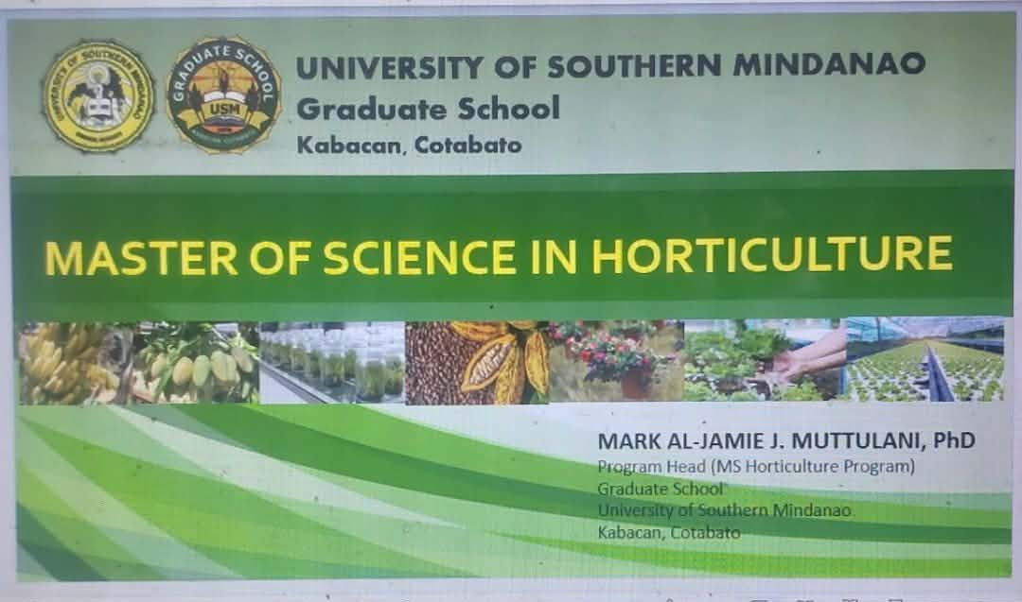
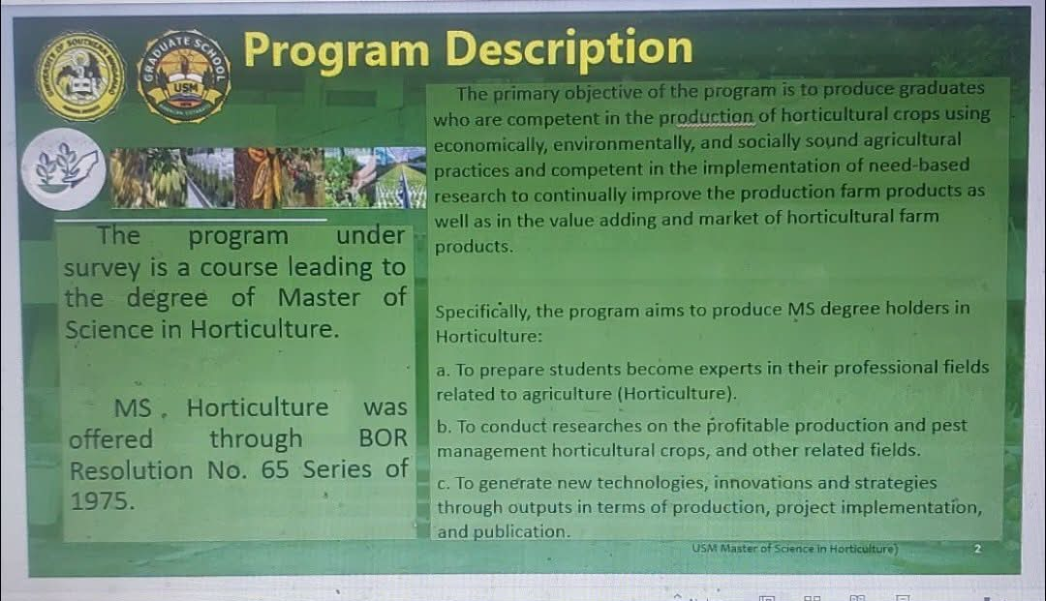

Approved Program Description of the Master of Science in Horticulture (MS Horticulture) Program
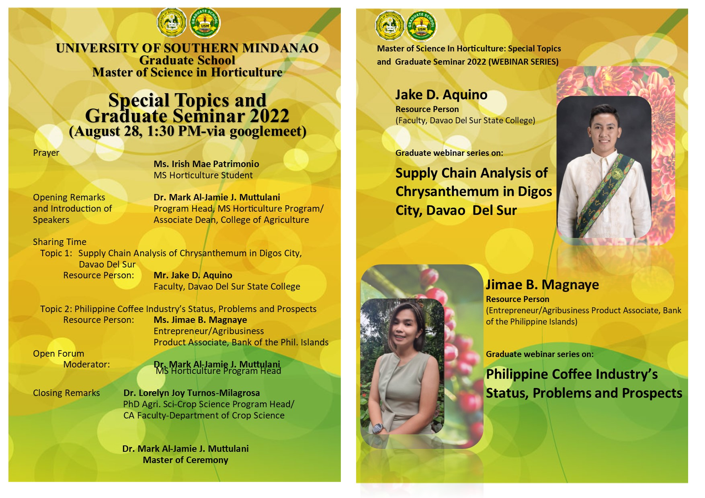

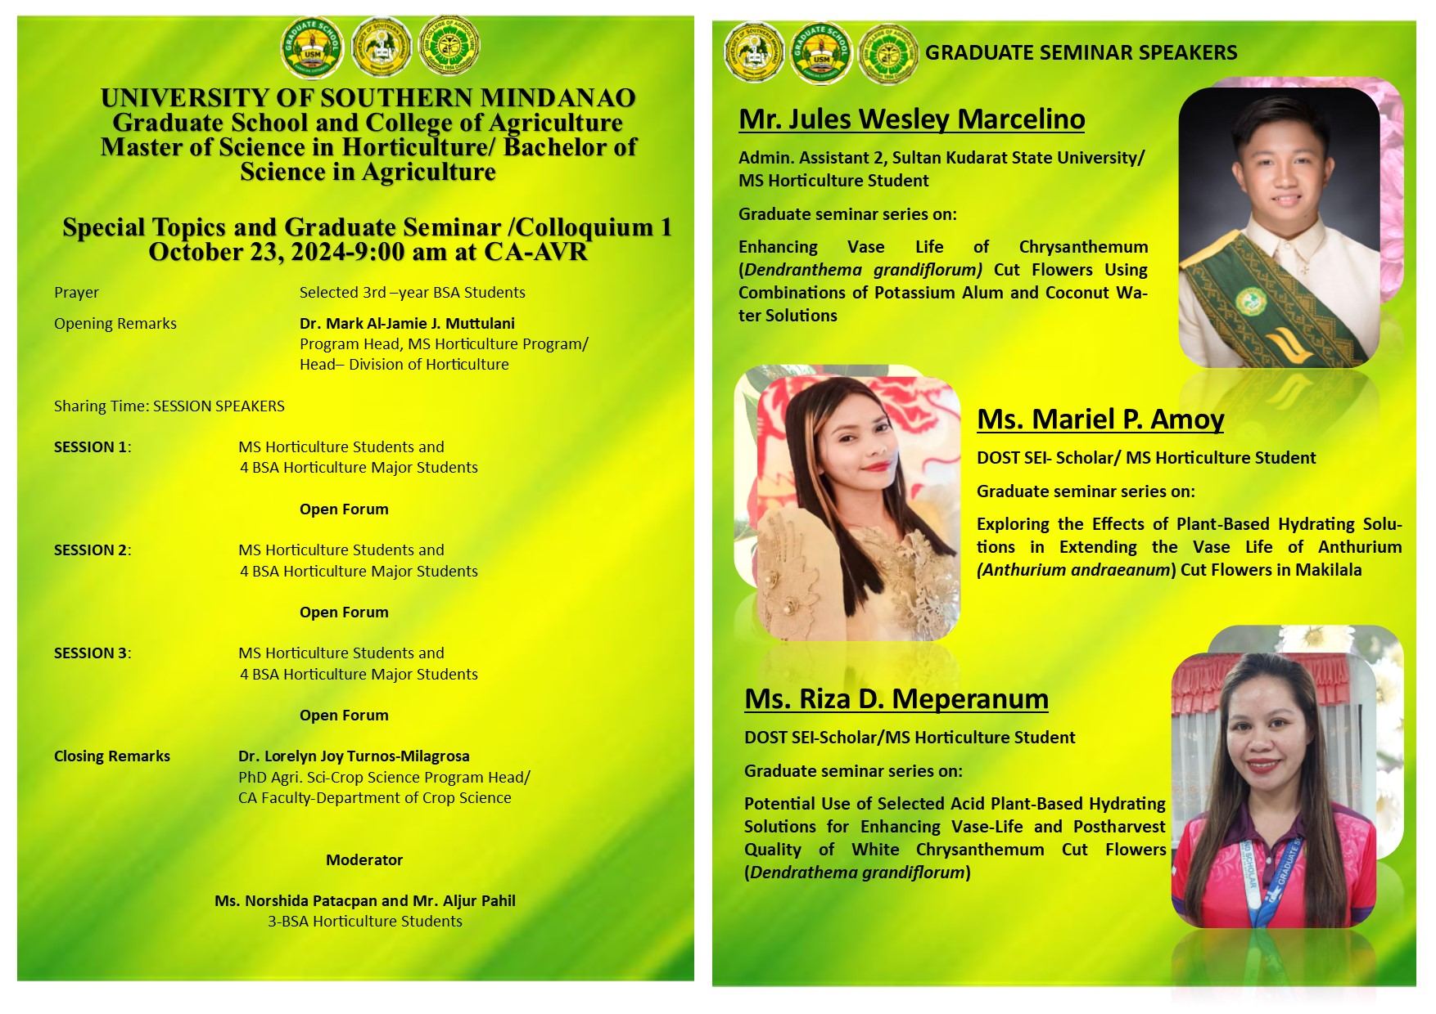

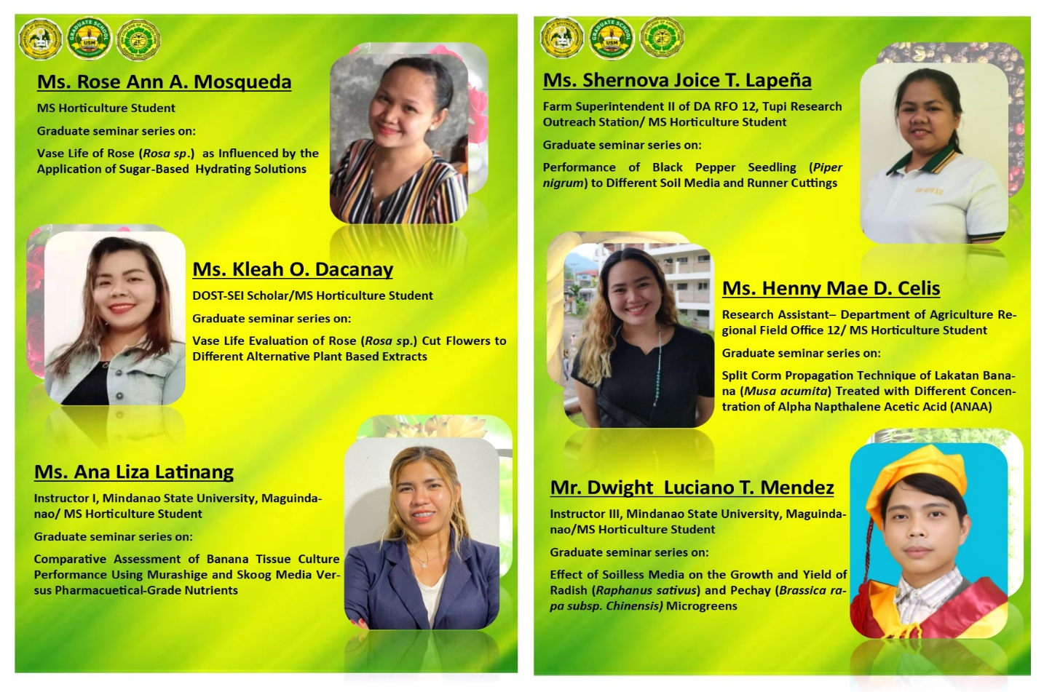

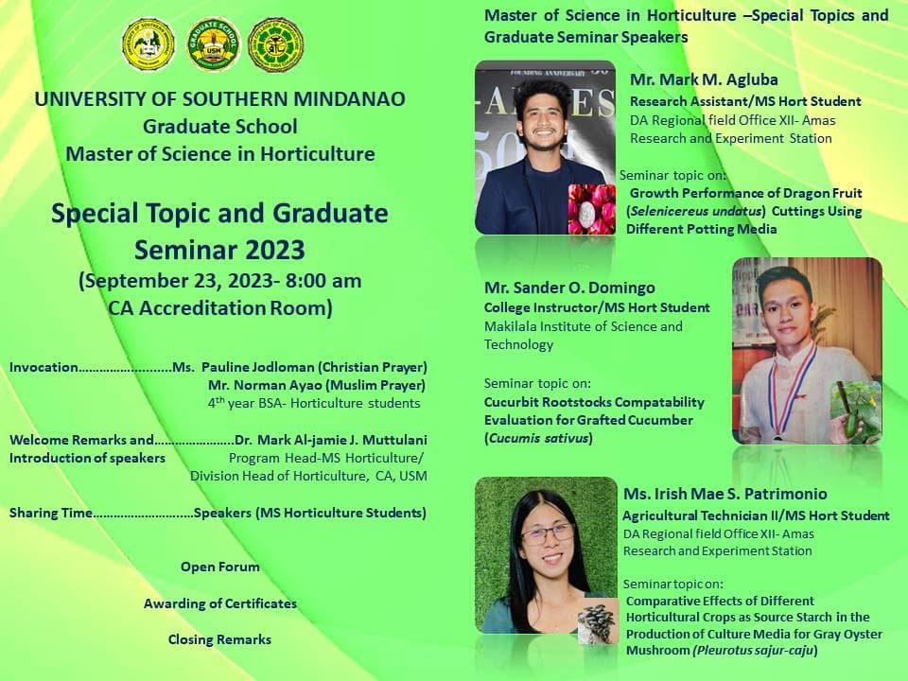

Utilization of Relevant Results of Completed Research as Basis for Planning Significant MS in Horticulture Program Endeavors through a Seminar Series on
MS Research Outputs

Strategies facilitated the dissemination and application of knowledge and skills through seminars, research, classroom instruction, extension initiatives, and other academic engagements, enhancing the professional competencies of faculty and students, strengthening research and instructional capabilities, expanding academic networks, and supporting the continuous improvement and internationalization of the MS in Horticulture Program.
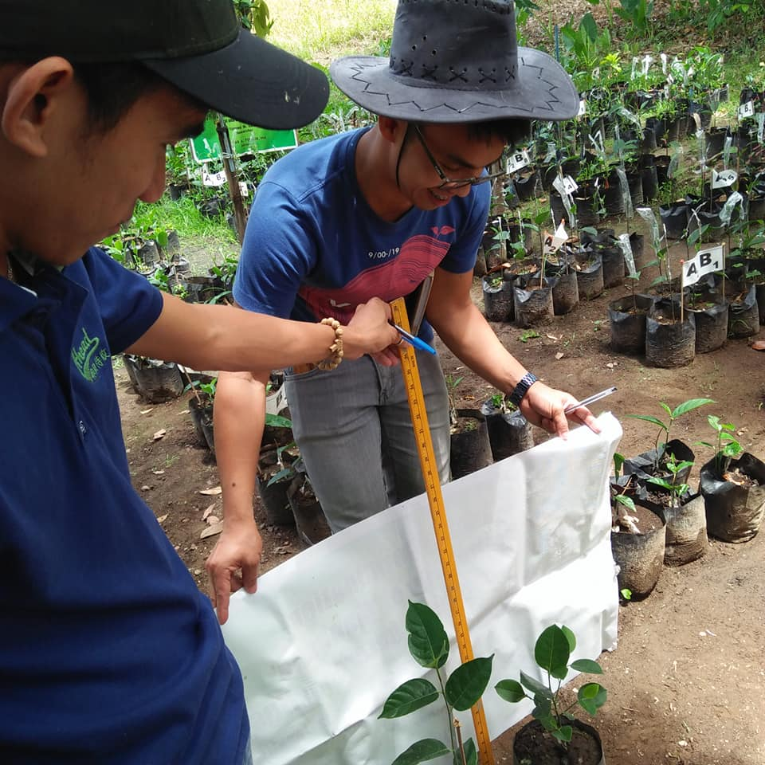
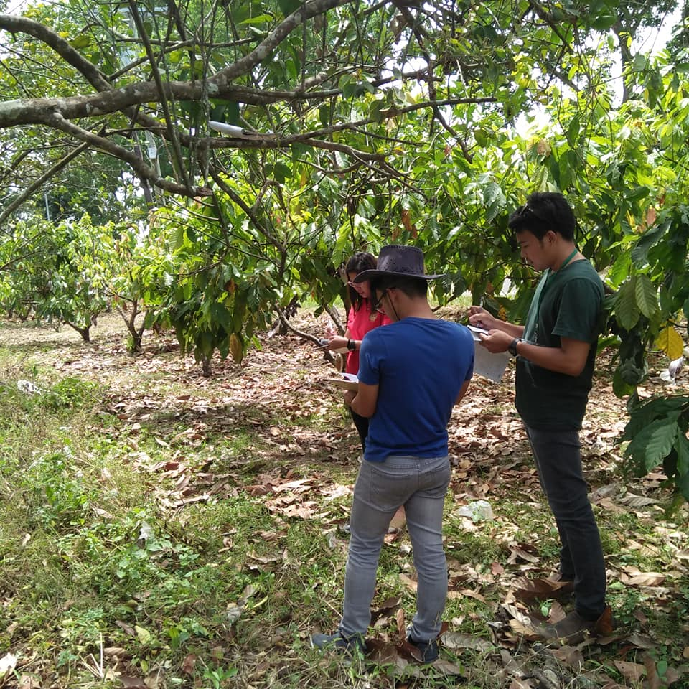

MS Horticulture graduates engaged research outputs and extension projects conducted
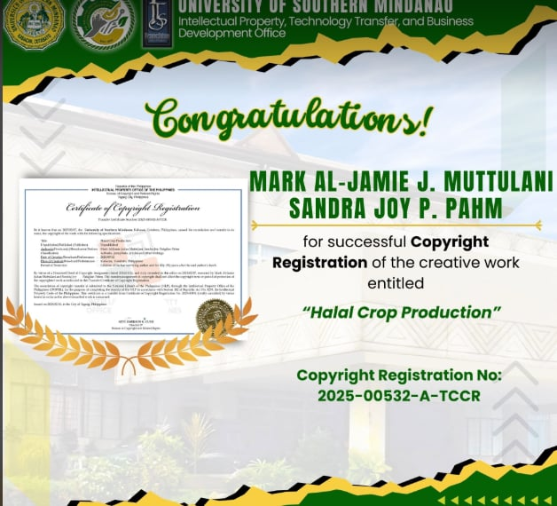
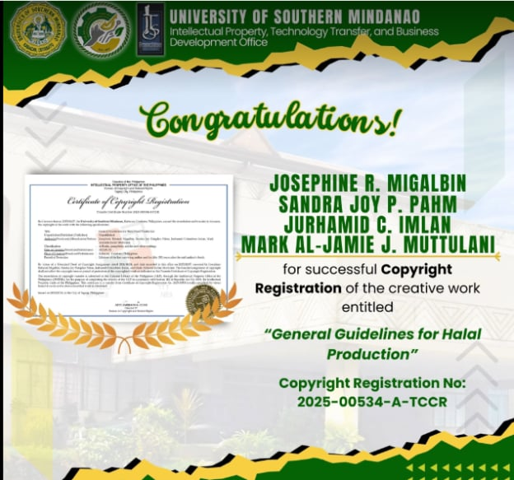

Copyright generated by MS Horticulture alumnus

PERFORMANCE OF GRADUATES
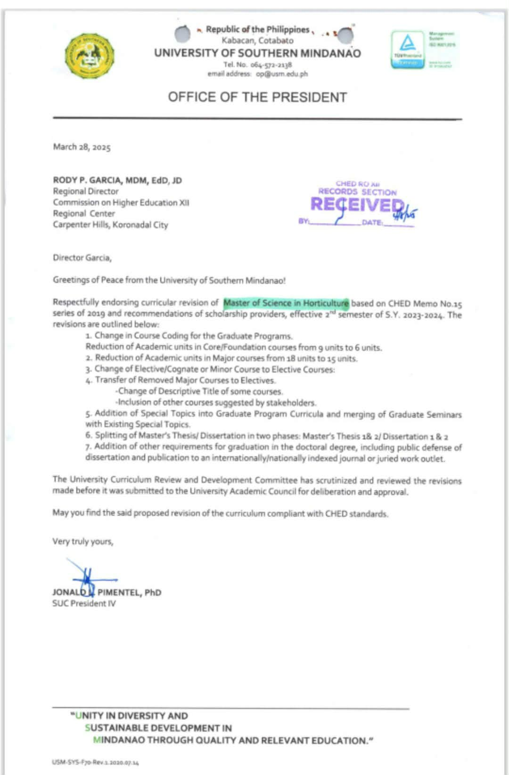

Endorsement letter from the President of curricular revision
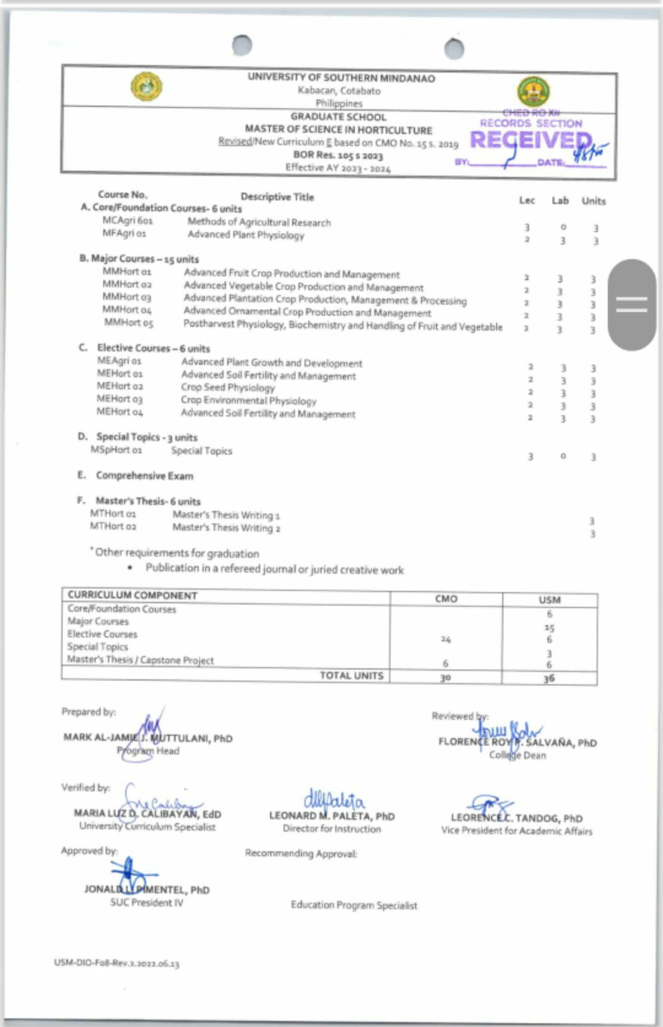

Approved revised curriculum (MS Horticulture Program)
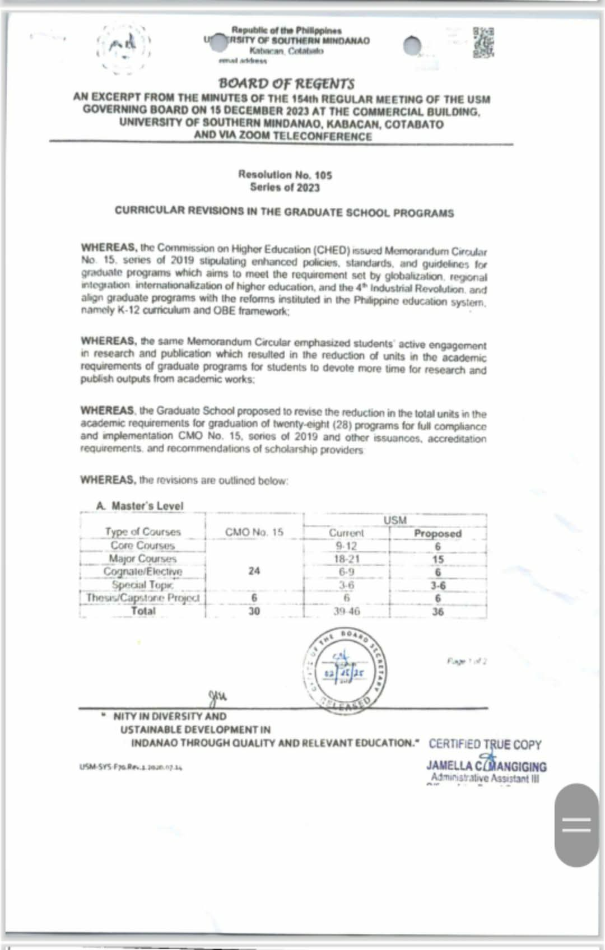

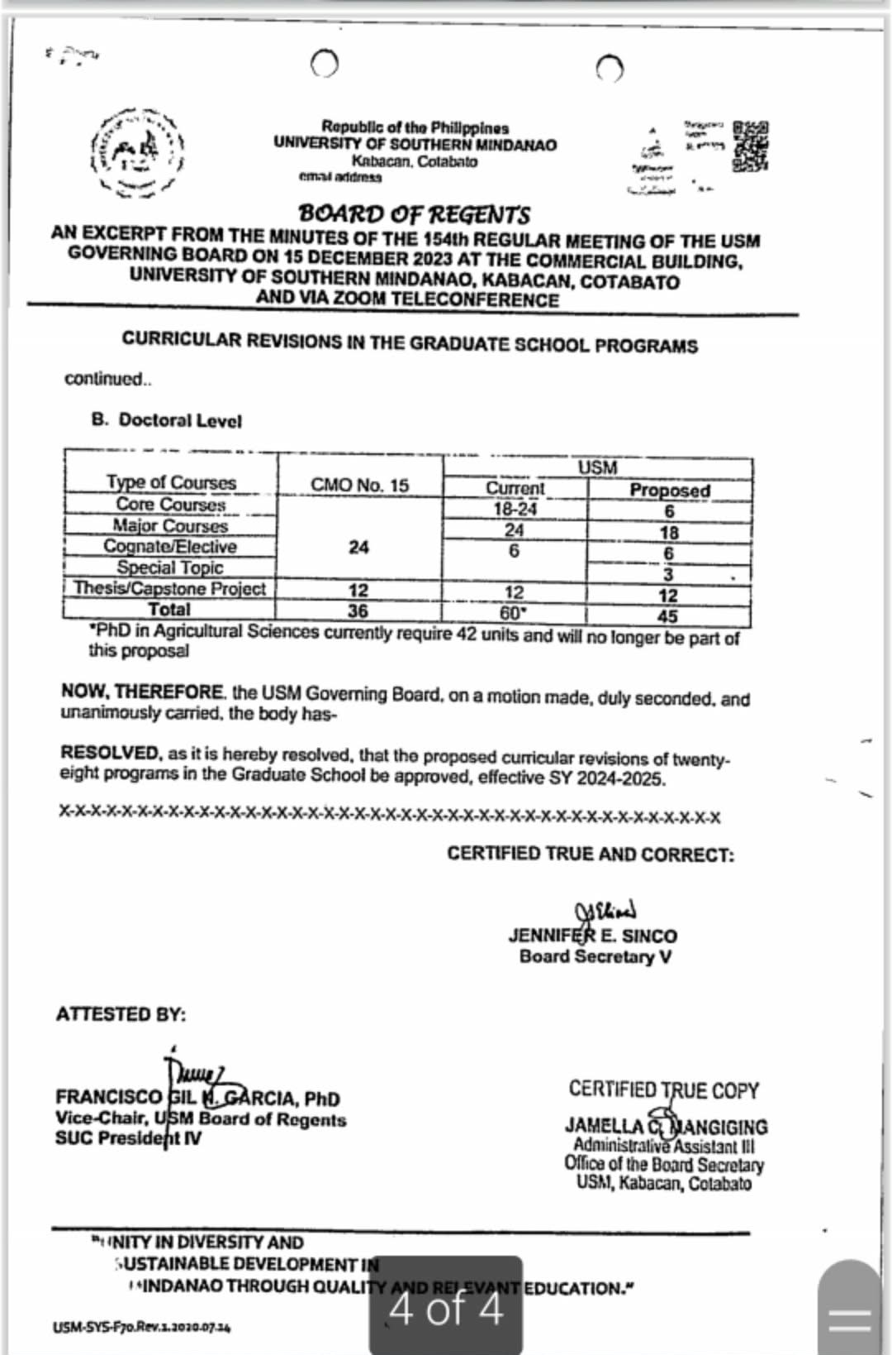

BOR Resolution Approval of MS Horticulture Program
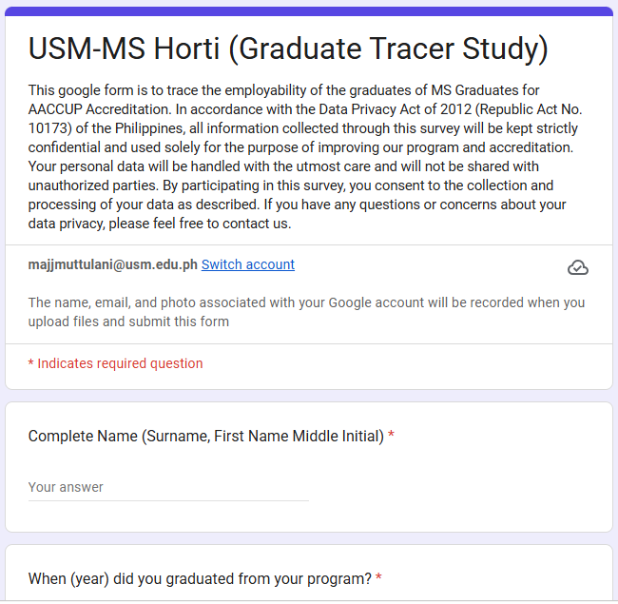
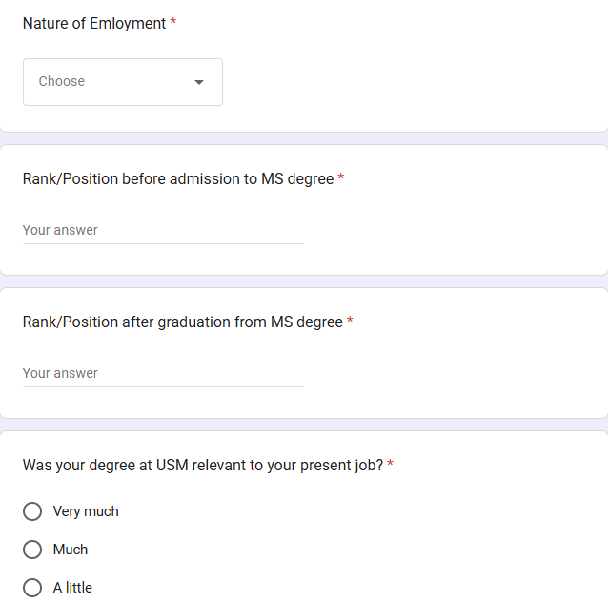

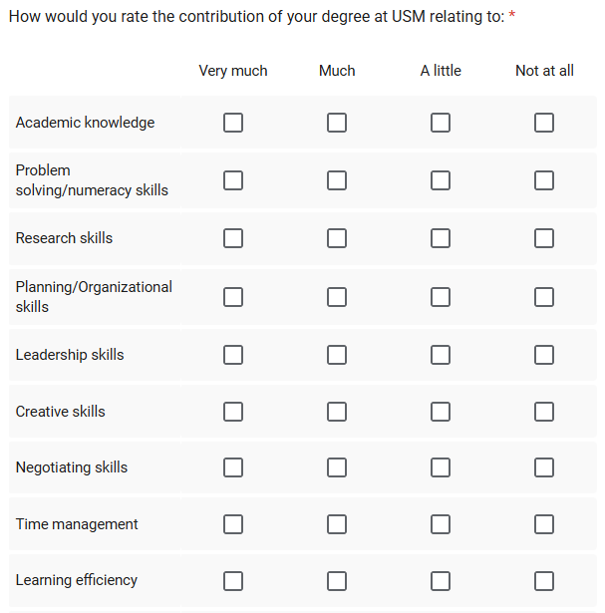
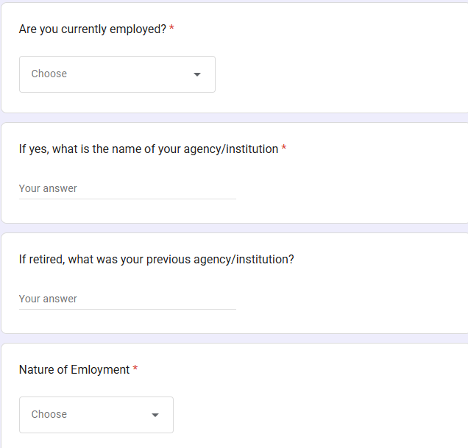

Link:USM-MS Horti (Graduate Tracer Study)
Structured validated tracer study instrument

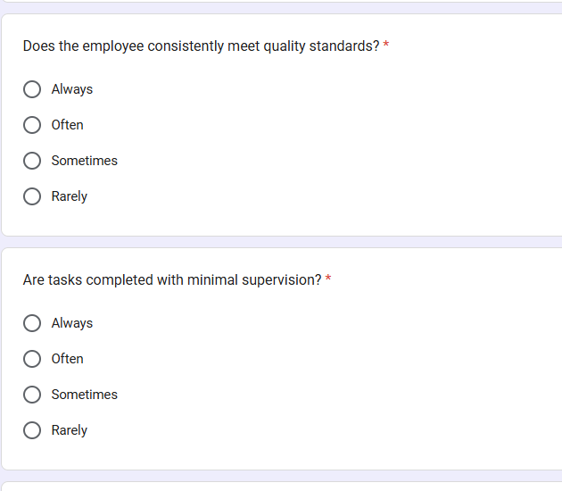
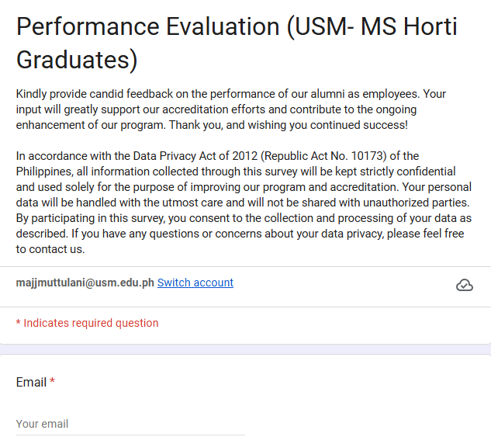

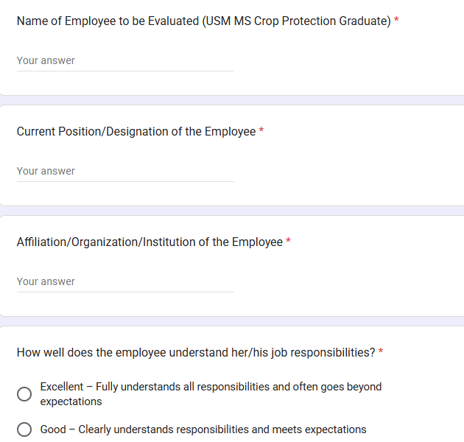
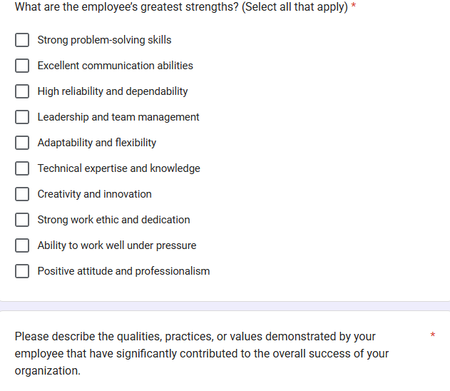

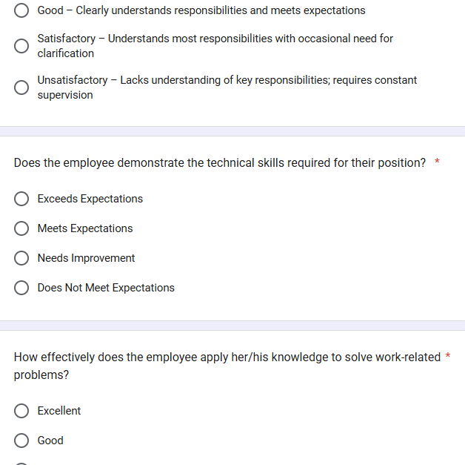
Structured Performance Evaluation (USM- MS Horti Graduates)

Link: Performance Evaluation (USM- MS Horti Graduates)

COMMUNITY SERVICE
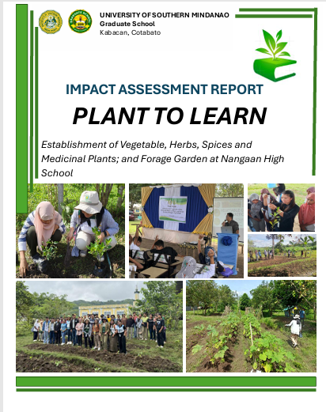

Impact Assessment of Report
Link to the File: MS Hort_Plant to Learn_Impact_ Assessment Report.pdf

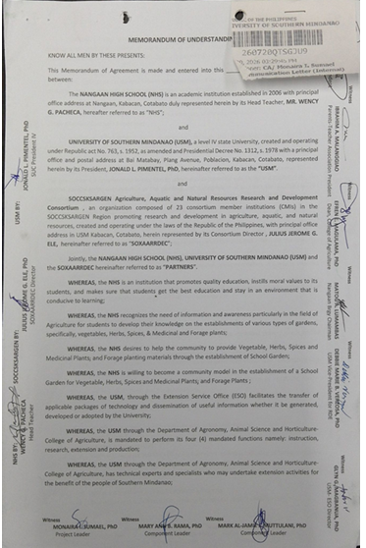

MOA of Extension Project
Link to the File: MS Hort_MOA Extension Project.pdf

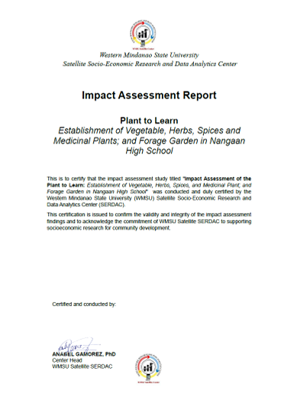
Impact Assessment Report of Extension Project

INTERNATIONAL LINKAGES AND CONSORTIA

Table 1. List of Core Faculties of the MS Horticulture Program
Faculty | Program/Project/Organizations
1. MEL CHRISEL A. SALES, PhD | Development of Export Quality Assurance programme on Mango for the Benefit of Mango Farmer’s in Midsayap and Stakeholders of the entire mango industry in Mindanao (Project)  -New Zealand Institute for Plant and Food Research (PFR), New Zealand  Technical Expert  (ANNEX 1)
Developing Land Management Options for Diverse Cacao-based System in Mindanao (Project)
-Global Green Growth Institute-BIMP-EAGA-Republic of Korea Cooperation Fund (GGGI-BKCF), Seoul, South
Project Leader
(ANNEX 2)
Sustainable Agricultural Environment Through the Organization of Durian Producers in MIndanao, Philippines (Project)
Center for ASIAN Mission for the POOR ASIA (CAMP ASIA) and Korea International Cooperation Agency (KOICA), South Korea
Project Technical Expert
(ANNEX 3)
Sustainable, Resilient and Productive Agri-Food Systems
(Short-Term Training Scholarship)
Manaaki New Zealand Scholarships
Massey University
2. MEL CHRISEL A. SALES  (Coordinator/Presentor) | Visit of Kenya Delegates  Food and Agriculture Organization of the United Nations -Kenya  Department for Industry, Ministry of Investments, Trade and Industry-Kenya  United Nations Industrial Development Organization  Kenya  (ANNEX 5)
3. MONAIRA I. SUMAEL
(Assistant Coordinator)
4. HAREM R. ROCA
(Presentor)
5. KHRIS JUNE CALLANO
(Tissue Culture Laboratory Tour In-Charge)
6. EFREN E. MAGULAMA  (Project Technician) | Development of the Second Phase of a Seed Multiplication Pilot Project  International Committee of the Red Cross (ICRC)  Switzerland  (ANNEX 4)
7. ARDNIEL A. BALADJAY | Developing soil knowledge, information and capacity to improve the  productivity and sustainability of key cropping systems in Philippines  Australian Centre for International Agricultural Research (ACIAR)  Australia  (Annex 6)
OTHER LINKAGES (NATIONAL LEVEL)
8. LORELYN JOY MILAGROSA TURNOS | Development of Appropriate Treatments to Coconut Inflorescences to improve Hybridizations Operations  Department of Science and Technology – Philippine Council for Agriculture, Aquatic and Natural Resources Research and Development.  (Annex 7)
9. MARK AL-JAMIE JUDAN MUTULLANI | Influence of Plant Growth Regulators to Improve Hybrid Nut Production in Dwarf Coconut  Department of Science and Technology – Philippine Council for Agriculture, Aquatic and Natural Resources Research and Development.  (Annex 8)

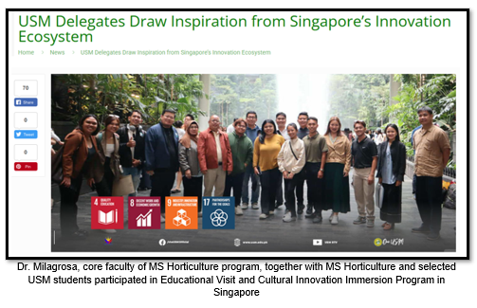

Table 2. MS Horticulture Faculty and Students Experiential Learning through International Network Initiatives

MS Students and Core Faculty Engagements | Activities
Lorelyn Joy N. Turnos PhD (Faculty) | Educational Visit and Cultural Innovation Immersion Program in Singapore
Vengie V. Mencias (MS Student)
John Paul A. Cabangal (MS Student)
Apple Grace Miles (MS Student)
John Rey Alejo (MS Student)
Max Dave Agudos (MS Student)
Elinor Fernandez (MS Student)
Mel Chrisel A. Sales (Faculty) | Sustainable, Resilient and Productive Agri-Food Systems Massey University New Zealand

Table 3. Faculty and Student Engagement to International Agencies/Organization
World Coffee Research (California, USA) | Enhancing Productivity of Robusta Coffee through Organic-Based Fertilization for Increased Profitability
Charoen Pokphand Foods (Thailand) | OJT/Apprenticeship Program in the fields of agriculture, veterinary medicine, home ecology and food sciences, business development economics and management
Bixter (Denmark) | Traineeship Program in the field of agriculture
Global Green Growth Institute (Korea International Cooperation Agency) | Developing Land Management Options for Diverse Cacao-based System in Mindanao
Maejo University (Thailand) | Research collaboration, academic exchange (students and faculty), twinning program/sandwich programs, joint sponsorship of seminars/conferences
Chulalongkorn University (Thailand) | Research collaboration, academic exchange (students and faculty), twinning program/sandwich programs, joint sponsorship of seminars/conferences especially in the field of Halal Science
Daegu Health College (South Korea) | Information exchange in the field of bio-health, research collaboration, academic exchange (students and faculty)
Faculty of Agriculture Khon Kaen University (Thailand) | Research collaboration, academic exchange (students and faculty), joint publication, joint sponsorship of seminars/conferences/trainings
Universitas Gadja Mada | Research collaboration, academic exchange (students and faculty), joint publication, joint sponsorship of seminars/conferences/trainings
Adjeenkya D Y Patil University, Pune, India | Research collaboration, academic exchange (students and faculty), joint publication, joint sponsorship of seminars/conferences/trainings, credit transfer, etc
Universitas Muhammadiyah Siddoarjo (Indonesia) | Research collaboration, academic exchange (students and faculty), joint publication, joint sponsorship of seminars/conferences/trainings
Sultan Shyarif Kasim State Islamic University of Riau (Indonesia) | Research collaboration, academic exchange (students and faculty), joint publication, joint sponsorship of seminars/conferences/trainings

SOCCSKSARGEN Agriculture, Aquatic and Natural Resources Research and Development Consortium (SOXAARRDEC) | Based at the University of Southern Mindanao (USM), SOXAARRDEC is an organization composed of 20 member agencies in the SOCCSKSARGEN Region promoting research and development in agriculture, aquatic and natural resources.  It envisions responsive, culturally sensitive, and sustainable Research, Development, Extension innovations in the region with the mission of engaging minds to effect positive change in the lives of people in the Agriculture, Aquatic and Natural Resources (AANR) sector through Research & Development, Technology Transfer, Science Communication and ICT initiatives in the SOCCSKSARGEN Region.  It has nine priority commodities where the Consortium Member Institutions (CMI) are working, namely: rice, corn, cacao, banana, coffee, rubber, ruminants and poultry, tilapia and tuna.  Faculty members of the PhD program are active in research and development involving their graduate students with their short-term researches.
SOCCSKSARGEN (SOX) Industry, Energy, Emerging Technology Research and Development Consortium (SOXIEERDC) | The Consortium shall create a mechanism for proper coordination, programming, development, and utilization of resources for related R&D works; foster inter-agency collaboration and participation between and among the academe, local / national government agencies, and private sector / industry; promote adoption and utilization of R&D output; formulate an R&D Agenda for sectors that will be identified by the Consortium; and generate funding to conduct R&D activities.
Region 12 State Universities and Colleges | Capacity building, Collaboration on research, development and extension, Addressing regional sustainable development goals (SDGs), enhancement of niches of each SUC to address needs and gaps
MINSUPALA – IRDC (Mindanao, Sulu, Palawan-Innovative Research and Development Consortium) | The University of Southern Mindanao joins a consortium of agencies formed to coordinate regional innovative research and development priorities anchored on the Philippine Development Plan 2023-2028. The newly created consortium, named MINSUPALA – IRDC (Innovative Research and Development Consortium), consists of state universities and colleges (SUCs) from Mindanao, Sulu, and Palawan. It was formalized through the signing of a Memorandum of Understanding held at the Department of Budget and Management (DBM) Regional Office, Koronadal City on July 20, 2023.  The consortium aims to promote innovative research and development for sustainable and inclusive development of communities in the MINSUPALA region, provide an avenue for joint planning, monitoring, evaluation, and sharing of R&D resources through collaborative interventions among its members, collaborate with the national and regional Government through DBM XII and consortium member SUCs in maximizing the utilization of research results to support regional development, and source other funds for the use in the implementation of R&D.  Through the consortium, member institutions will be provided opportunities to enhance their research and extension capabilities, participate in the consortium’s key activities, access technical support and endorsement to develop and package R&D proposals for possible funding from DBM through DBM Region XII, and utilize recommended relevant R&D management tools.  The IRDC will be hosted by DBM Region XII being the proponent of the organic program proposal submitted to the DBM National Office. Joining USM in the new consortium are Sultan Kudarat State University, Mindanao State University Maguindanao, Mindanao State University General Santos City, Cotabato State University, Adiong Memorial Polytechnic State College, South Cotabato State College, and Cotabato Foundation College of Science and Technology.  The MOU signing was attended by SUC Presidents, DBM Secretary Amenah F. Pangandaman, and DBM Regional Director Akmad J. Usman.

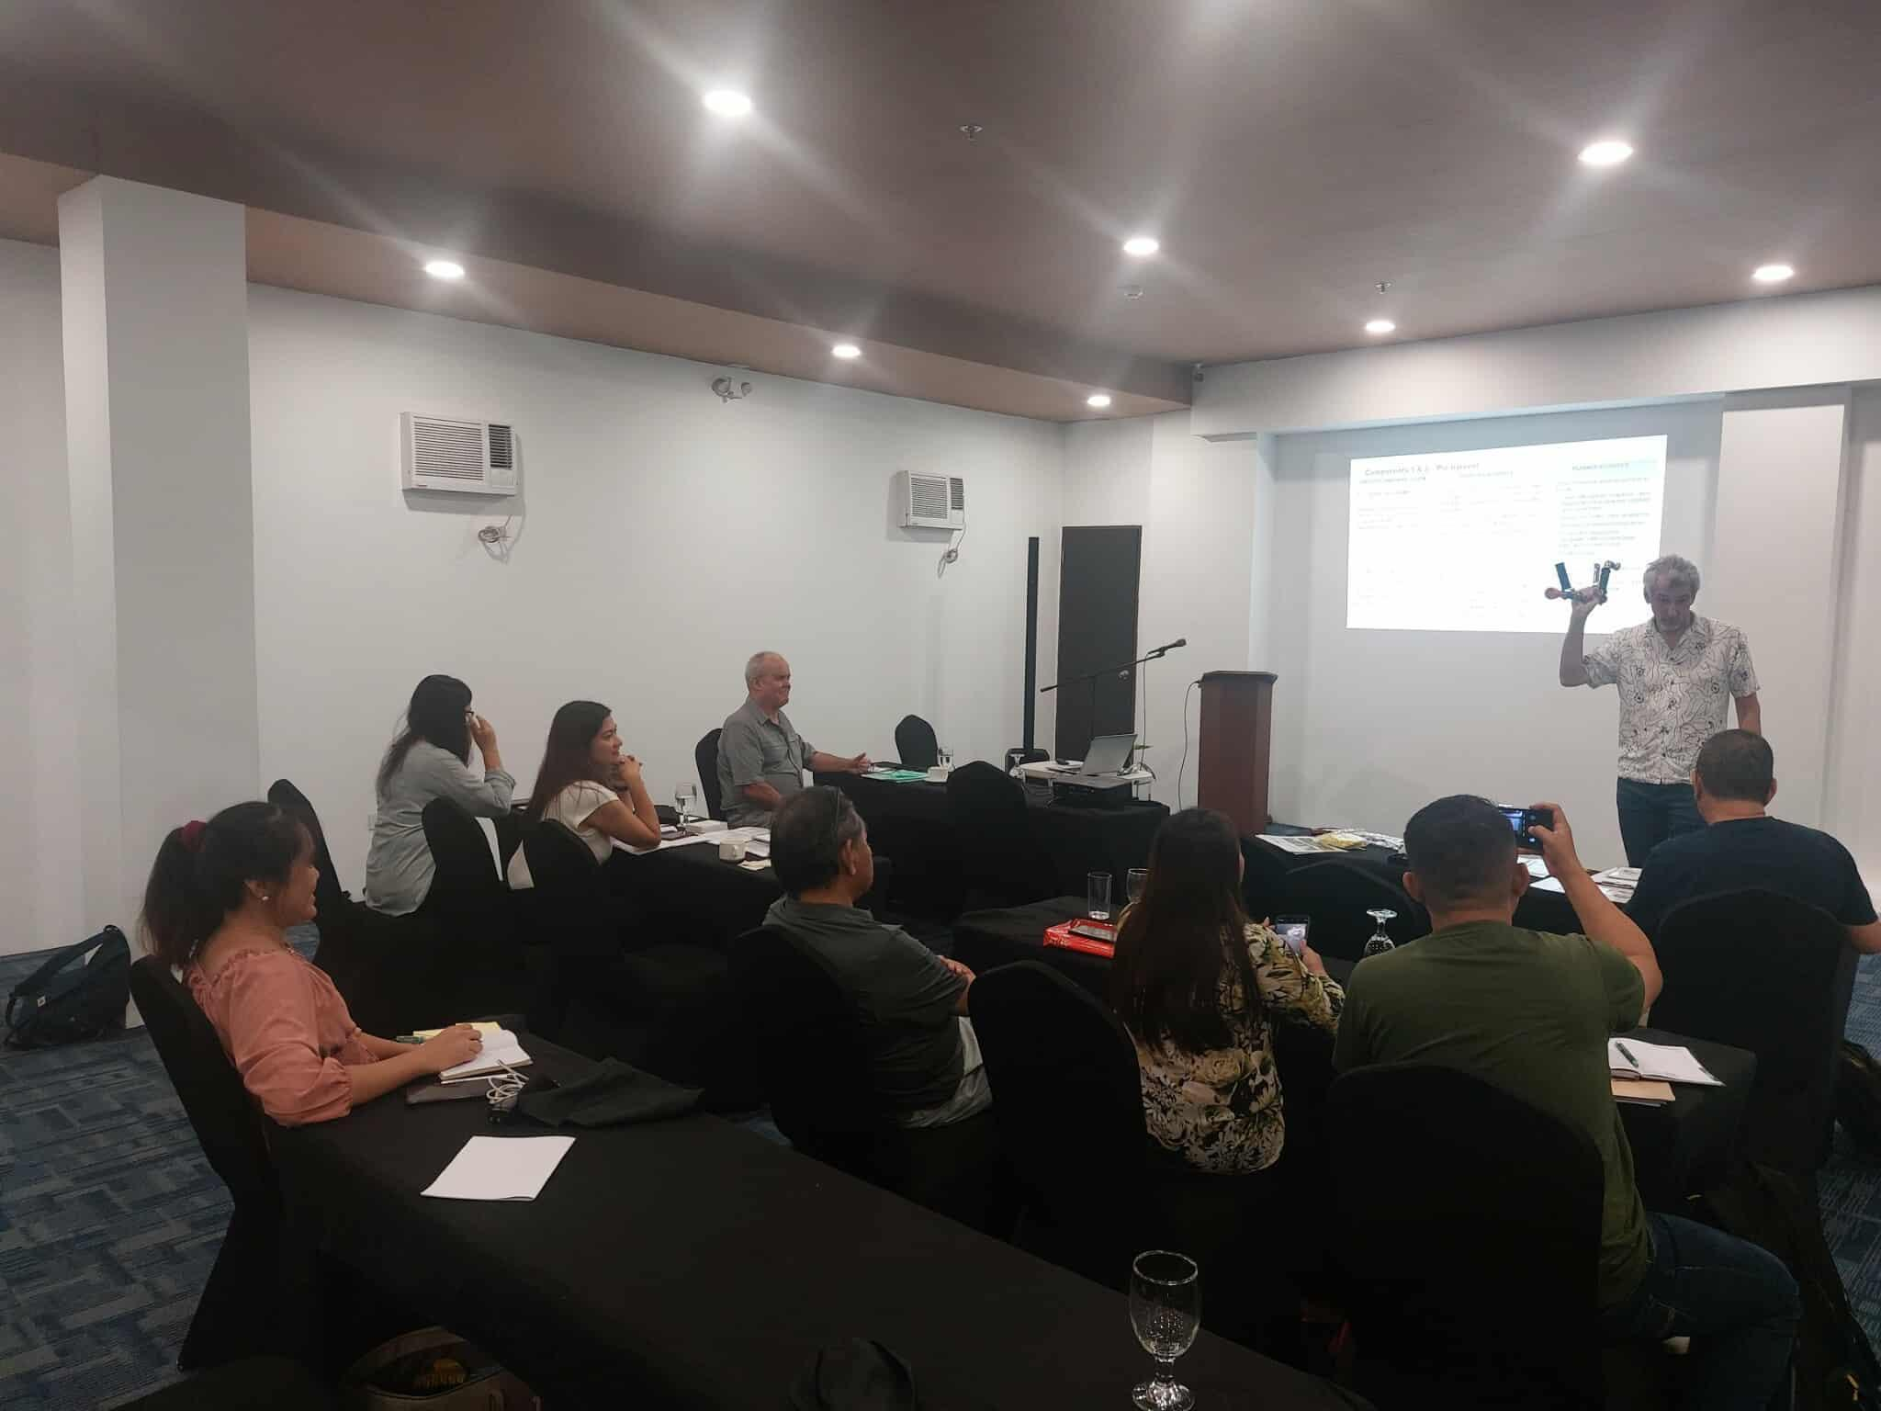
Figure 1. Project Planning with PFR with Dr. Mel Chrisel Sales
(core faculty-MS Horticulture)

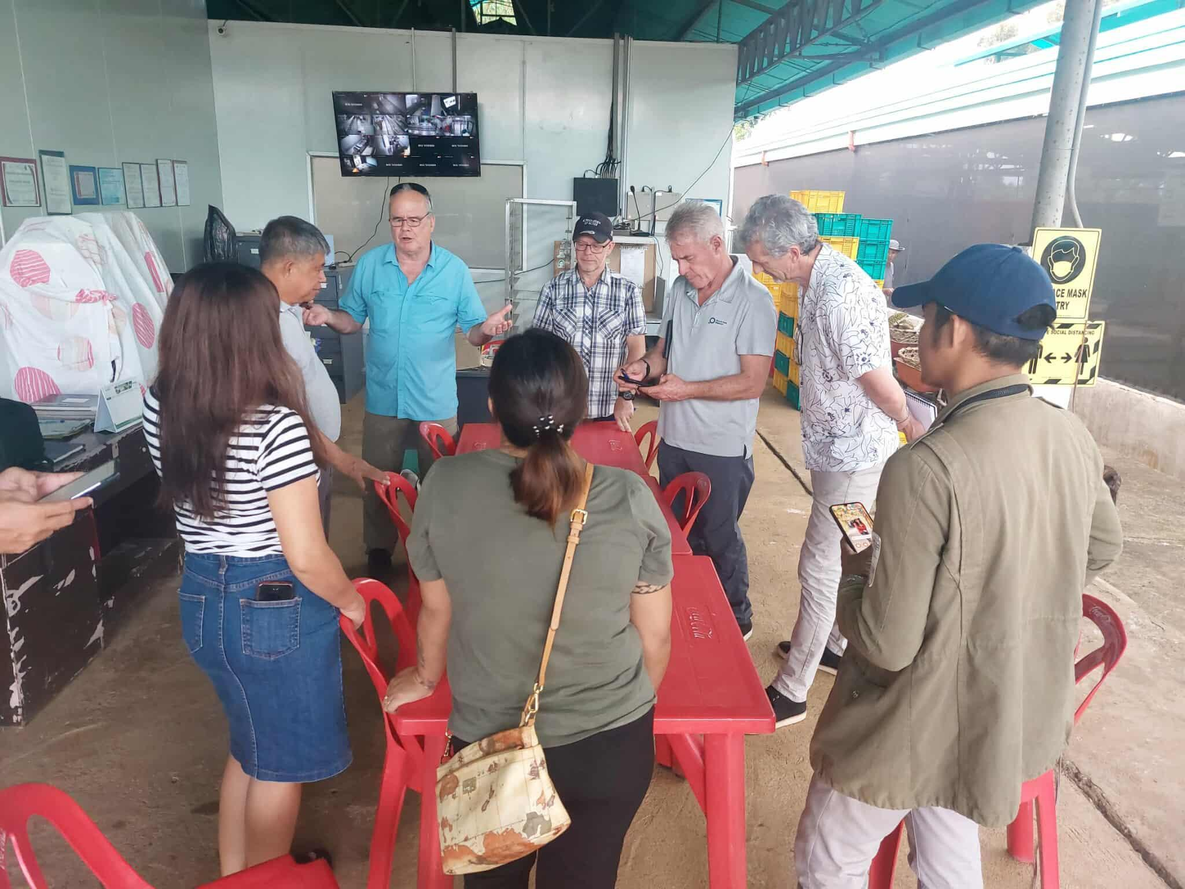
Figure 2. Meeting with PFR and Mango Farmer’s stakeholders.
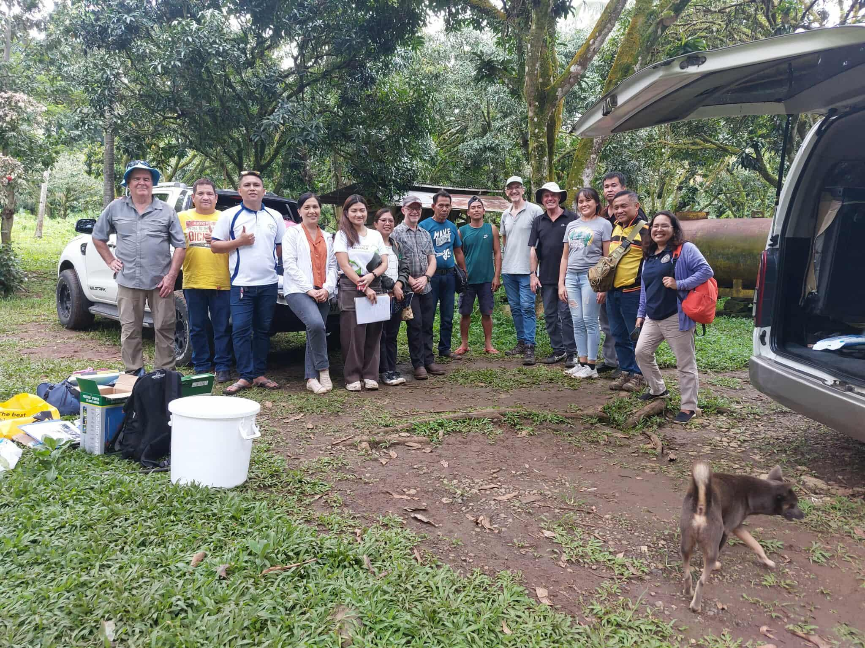
Figure 3. Site visit and Bench marking in Mango’s Farm in Midsayap.

2. Developing Land Management Options for Diverse Cacao-based System in Mindanao. -Global Green Growth Institute-BIMP-EAGA-Republic of Korea Cooperation Fund (GGGI-BKCF), Seoul, South Korea
Project Leader

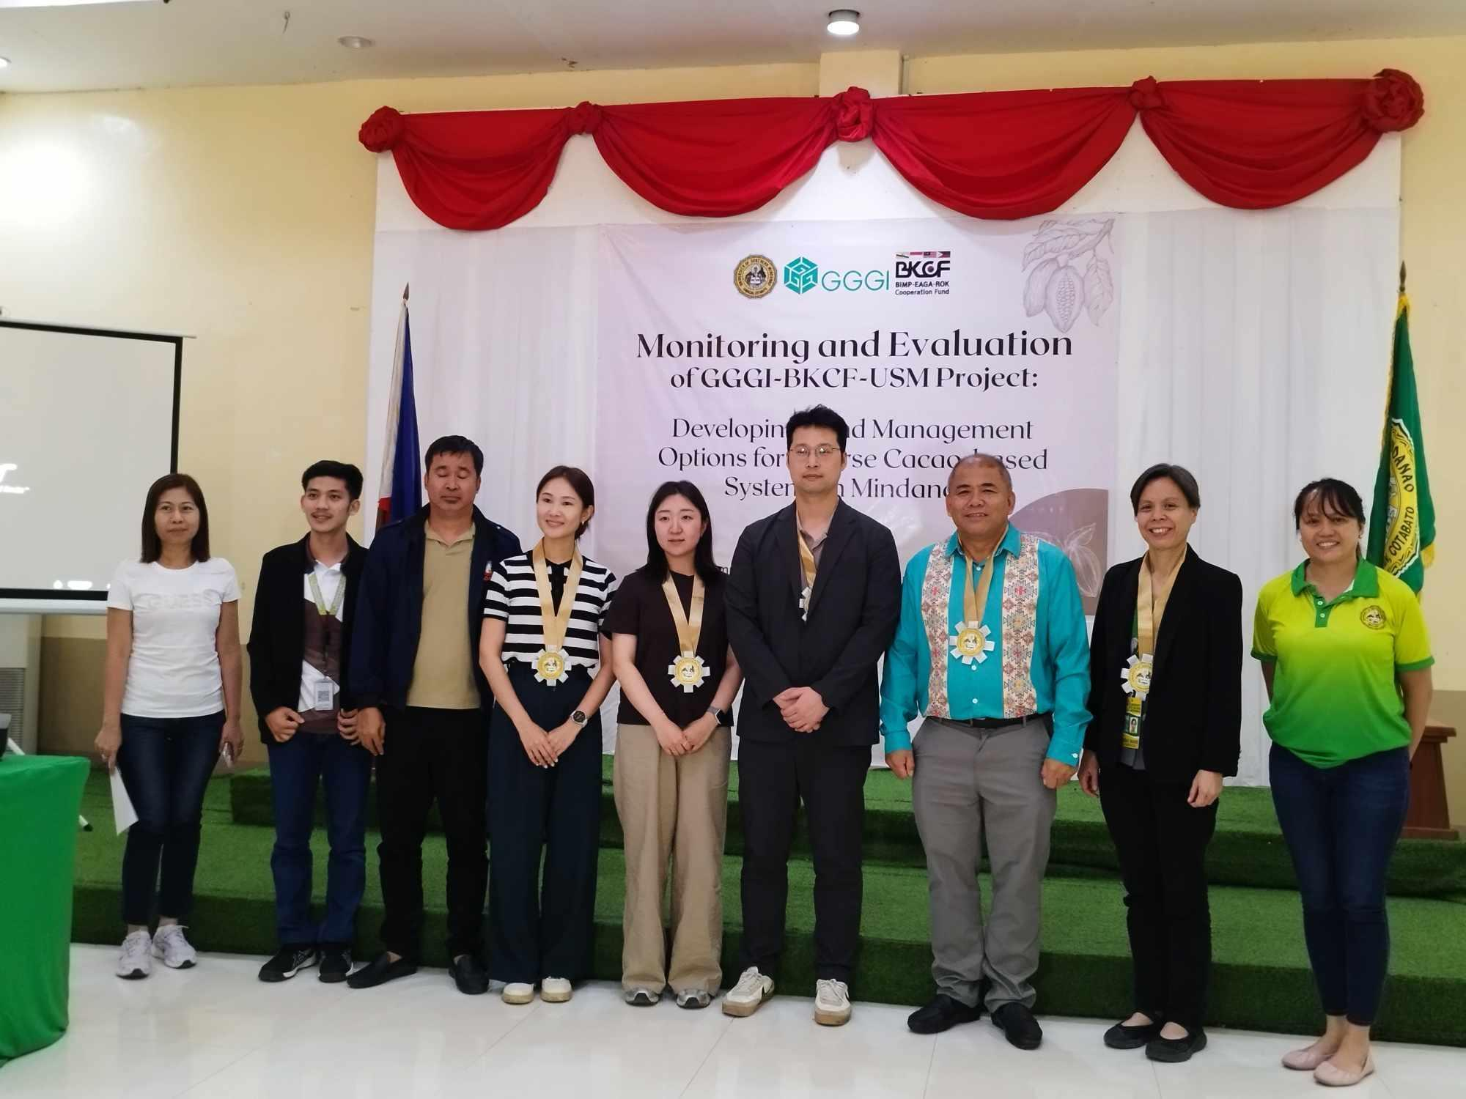
Figure 4. Monitoring and Evaluation of the project of GGGI-BKCF personnel.

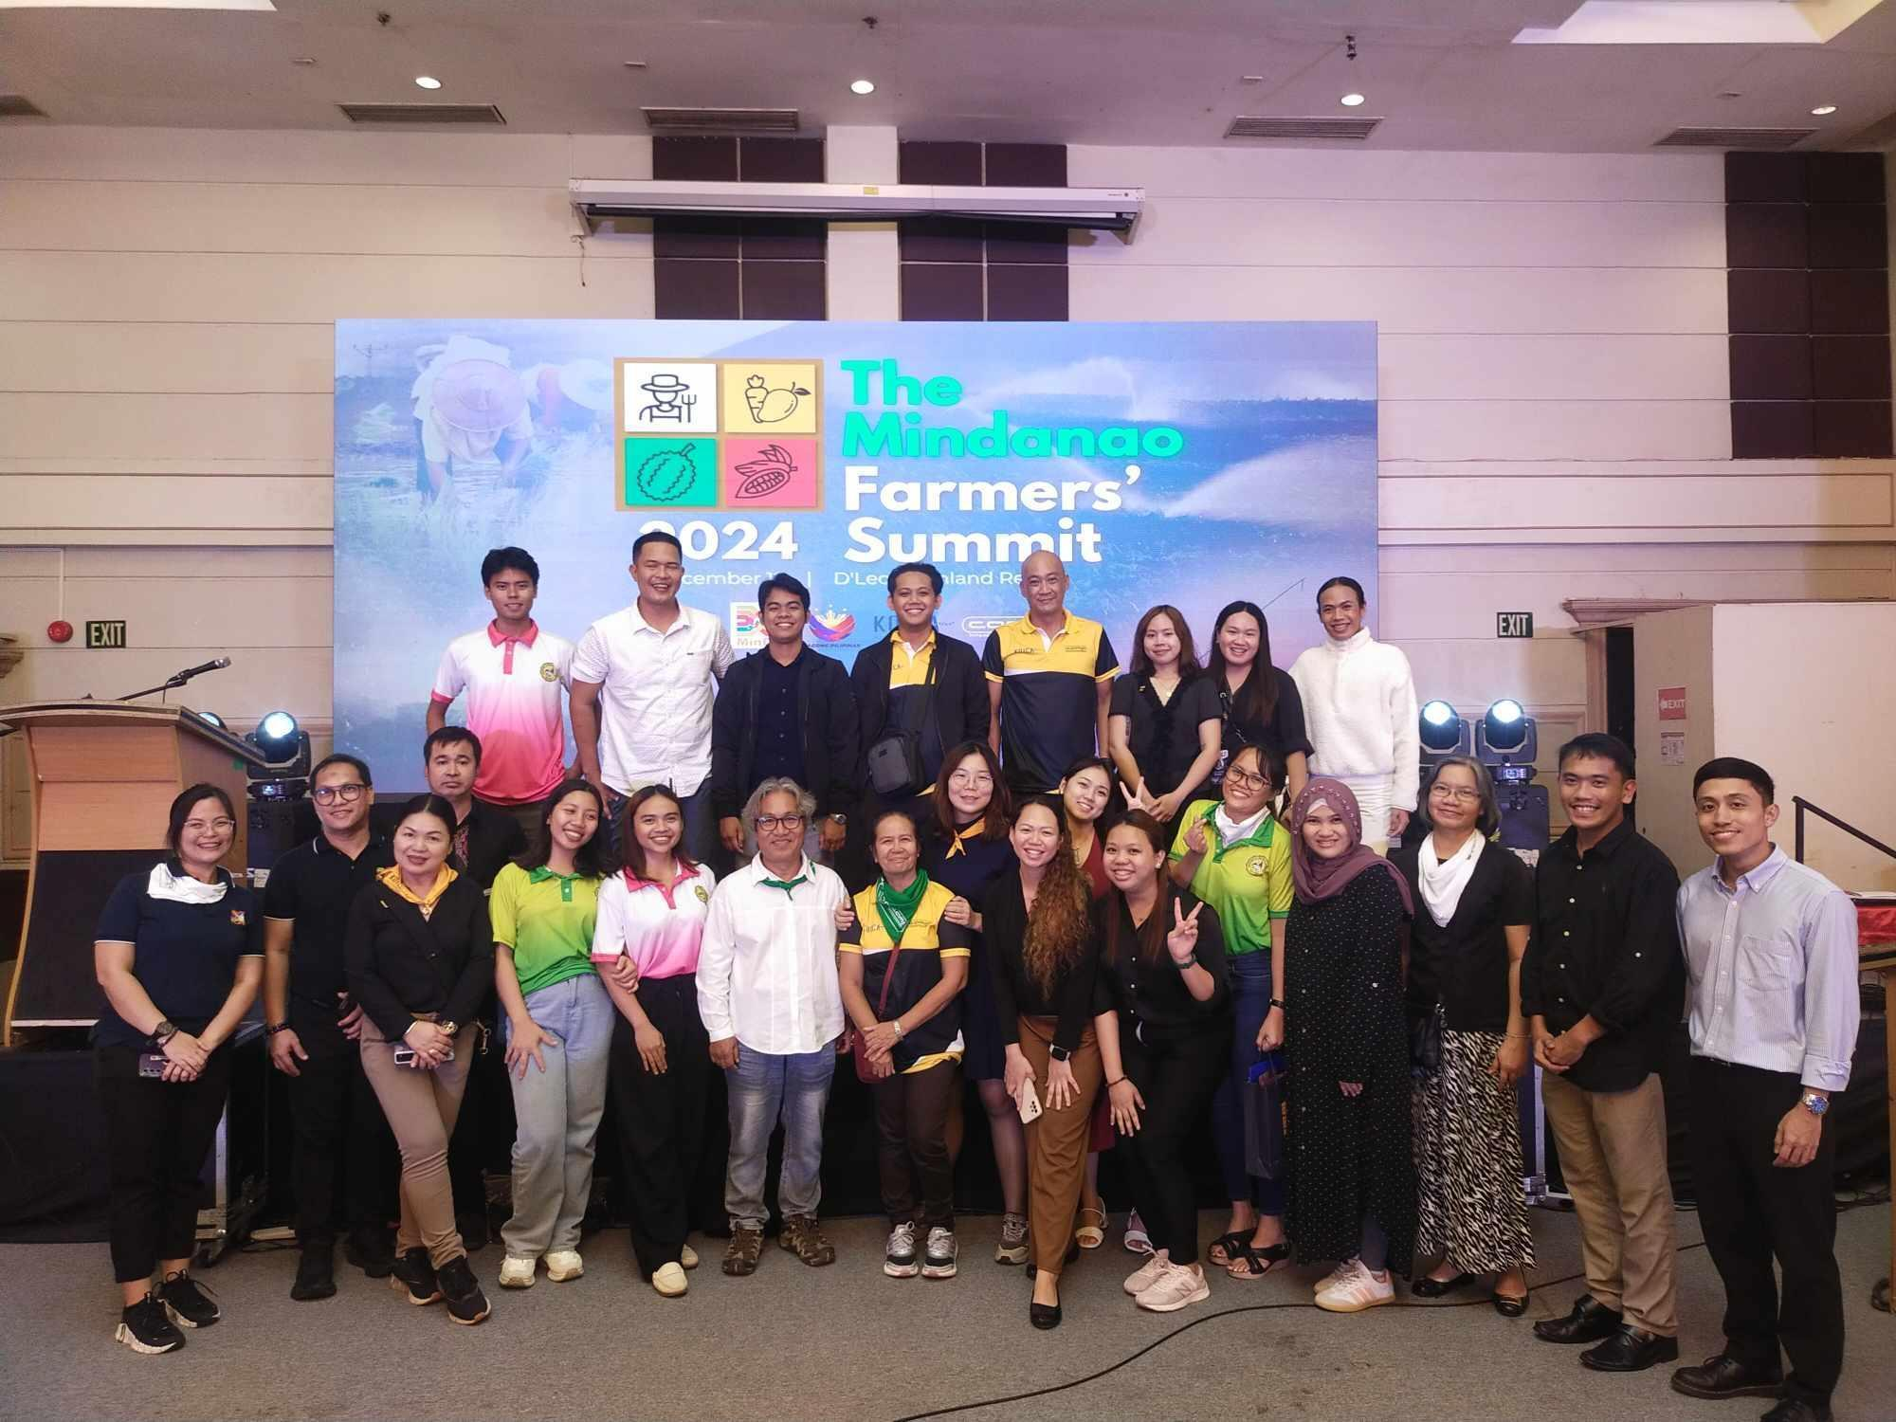
Figure 5. The project organized an event, the Mindanao Farmers’ Summit.

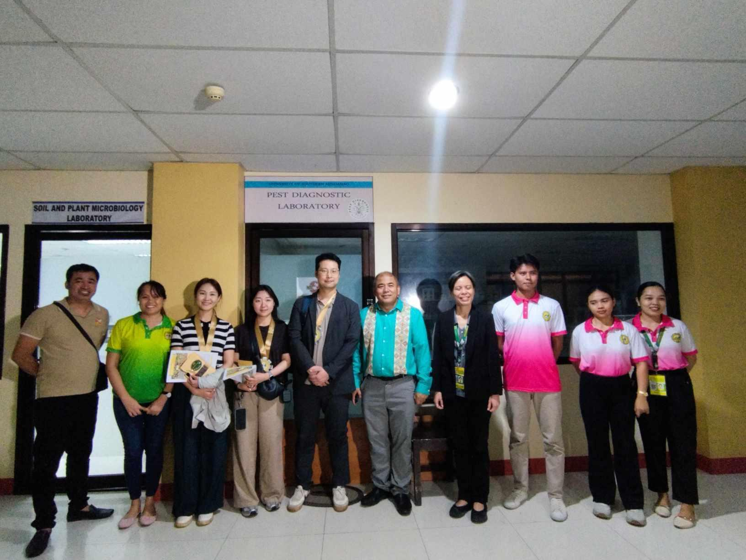
Figure 6. Site visit of Funding Agency at the Soil Science Laboratory.

3. Sustainable Agricultural Environment Through the Organization of Durian Producers in MIndanao, Philippines

Center for ASIAN Mission for the POOR ASIA (CAMP ASIA), Seoul, South Korea
Project Technical Expert

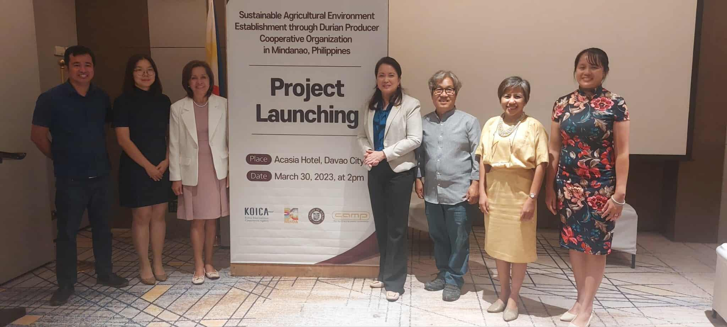
Figure 7. Project Launching with Funding Agency personnel.

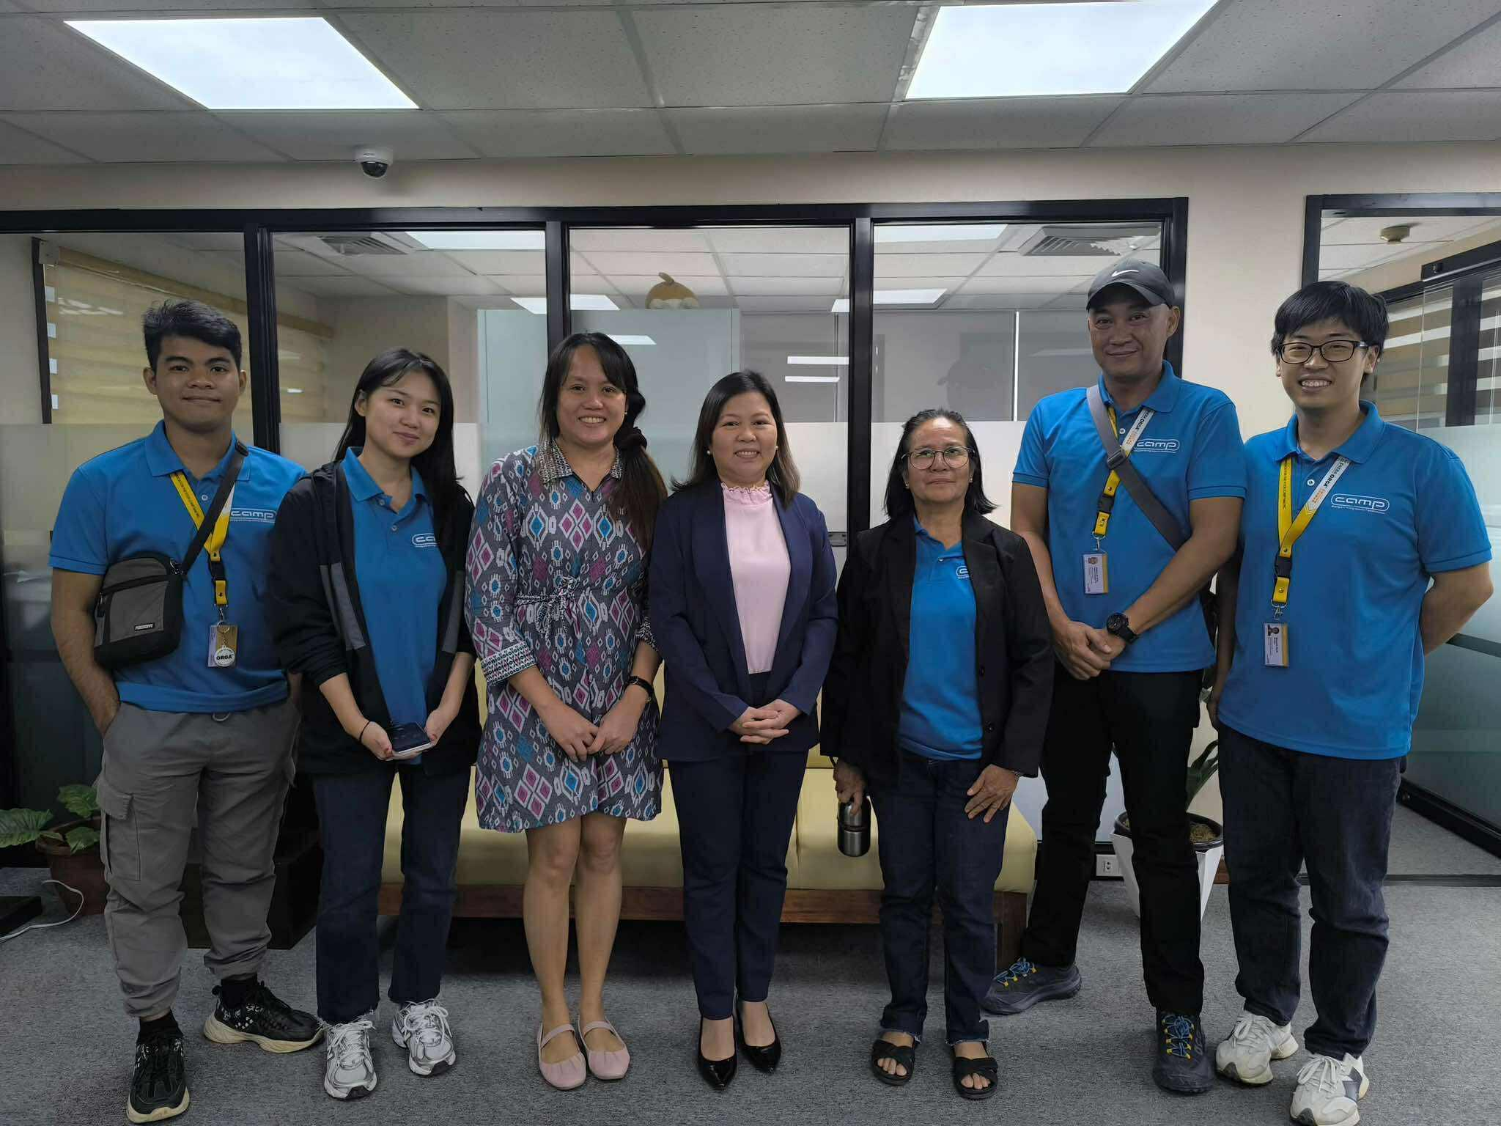
Figure 8. Planning and Evaluation of the Project’s Objective with CAMP ASIA personnel.

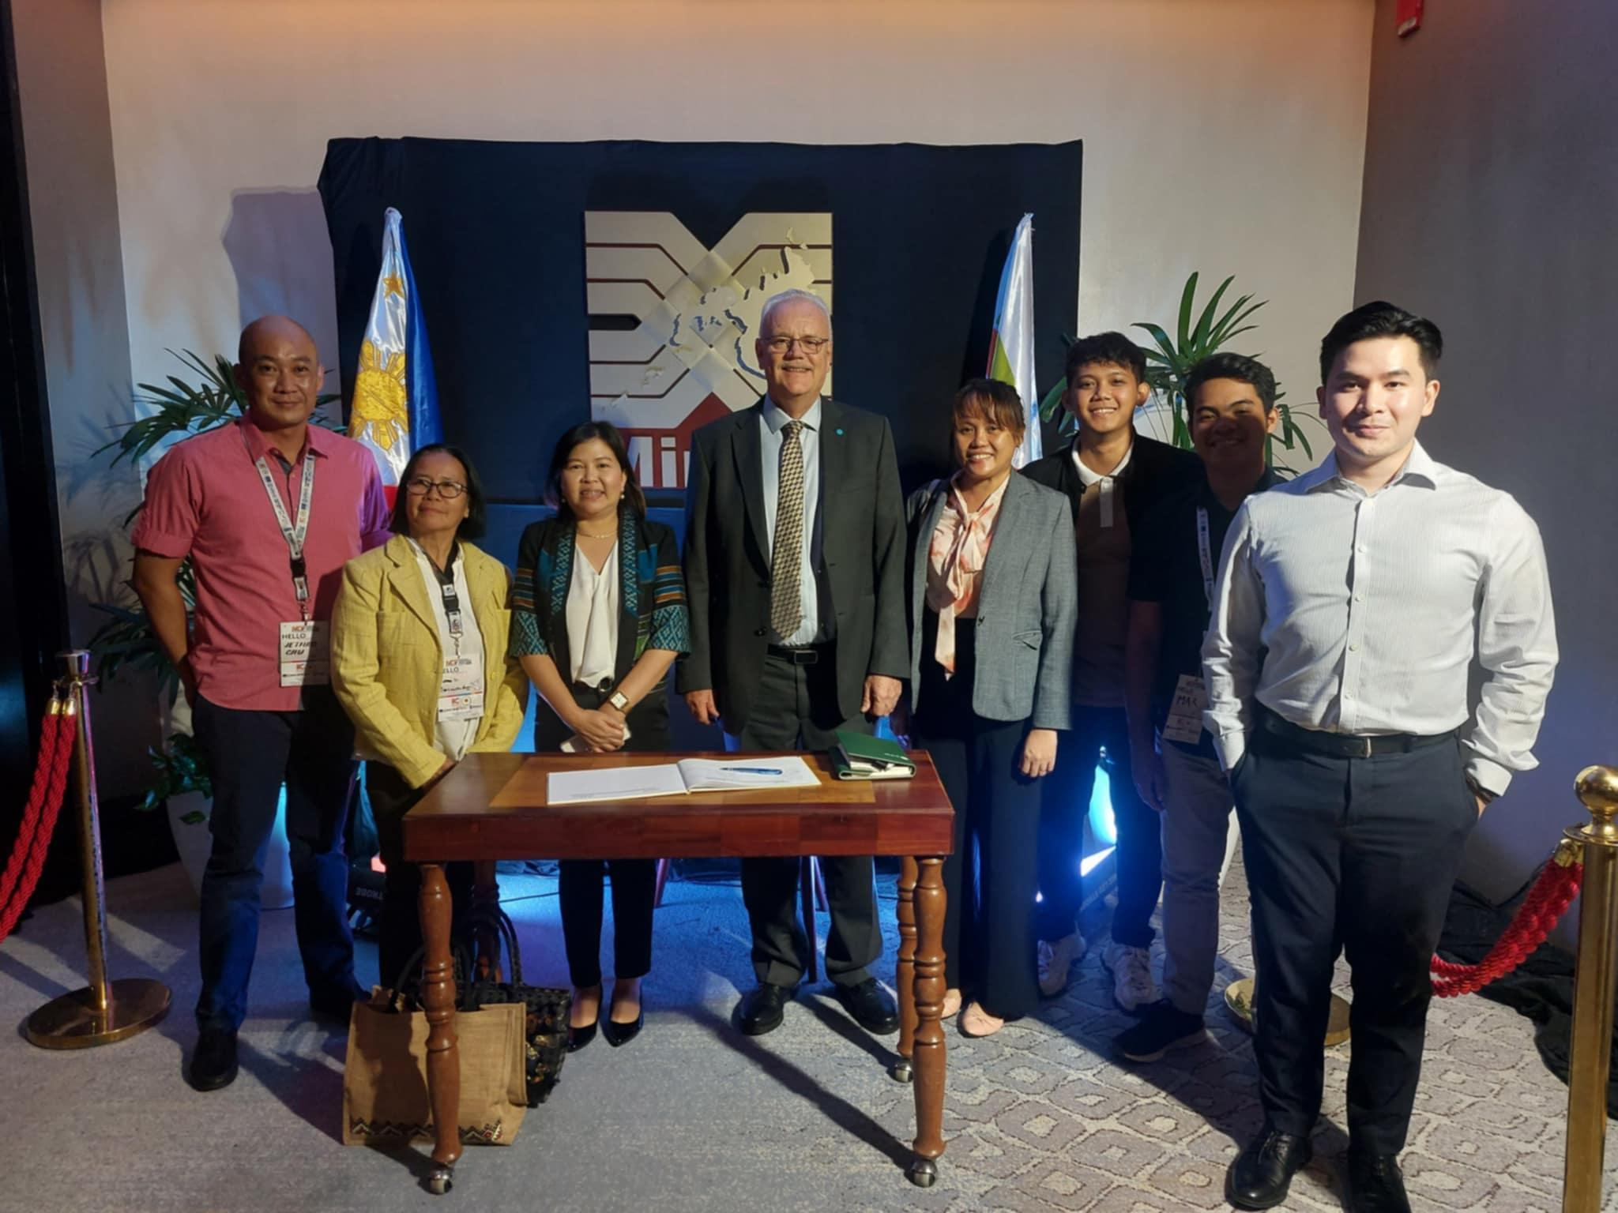
Figure 9. Meeting and Planning with the Funding Agency Head.

4. Visits of Kenya Delegates- FAO-Kenya, Department for Industry, Ministry of Investments, Trade and Industry-Kenya, United Nations Industrial Development Organization, Kenya.

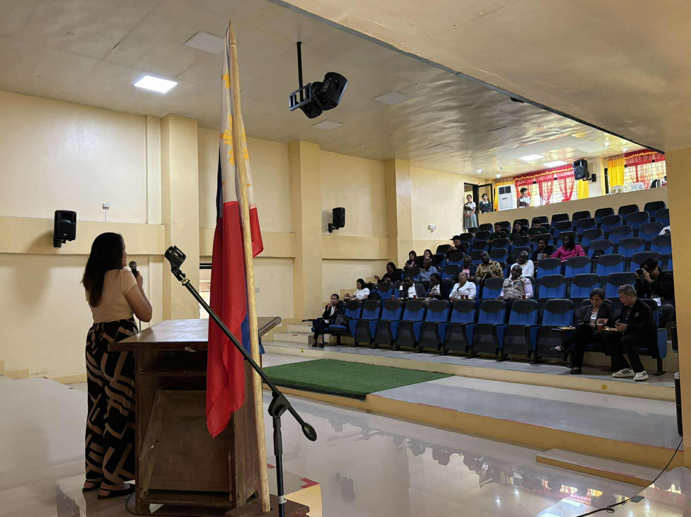
Figure 10. Presentation of Project Accomplishments to Kenya Delegates.

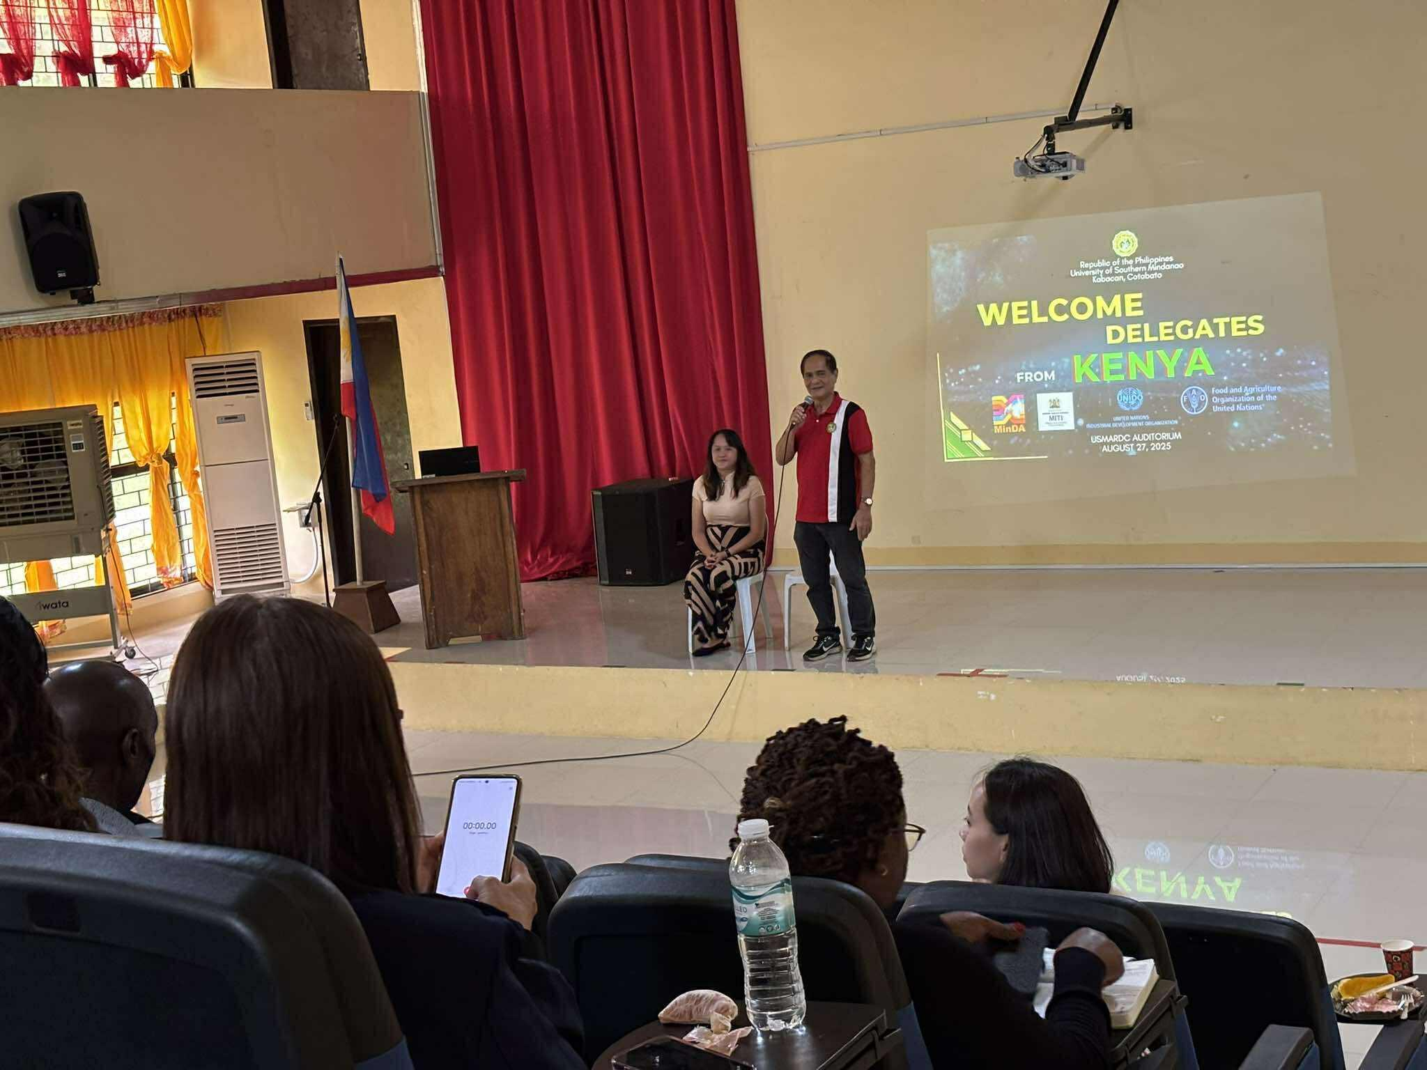
Figure 11. Presentation and open Forum of Presenters and Kenya Delegates.

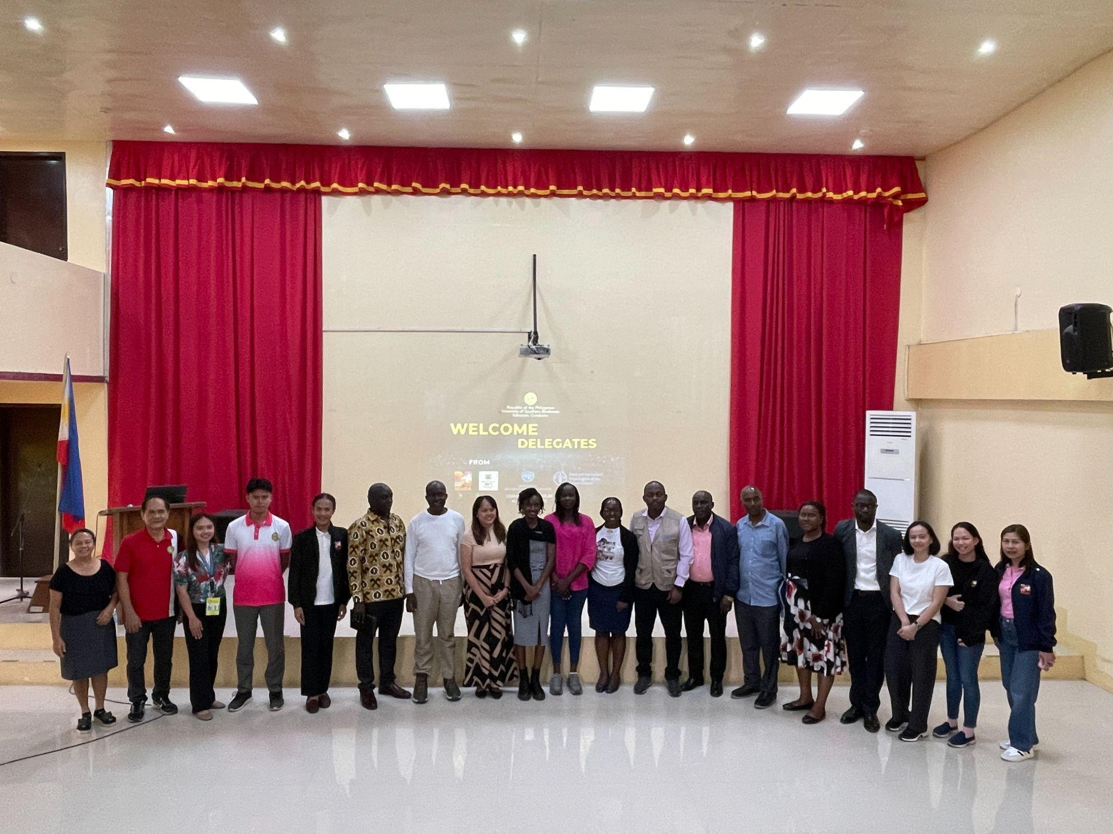
Figure 12. Photo opportunity of USM presenter and Personnel to UNIDO,MiNDA and Kenya delegates.

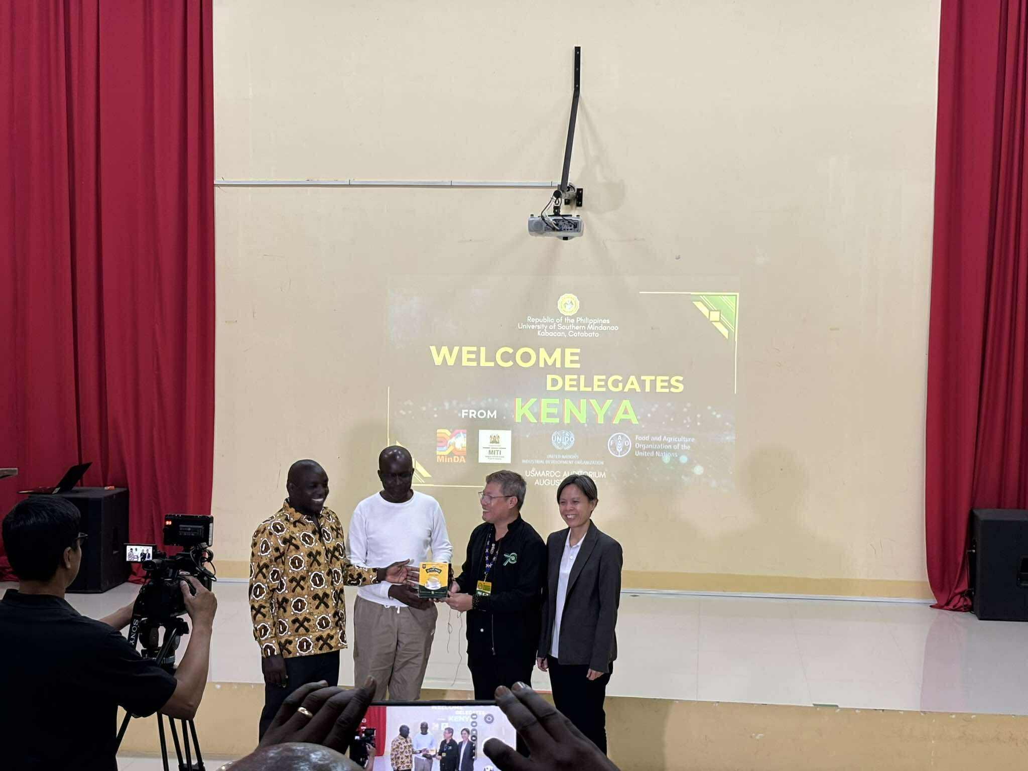
Figure 13. Appreciation and Giving of Token to Kenya Delegates.

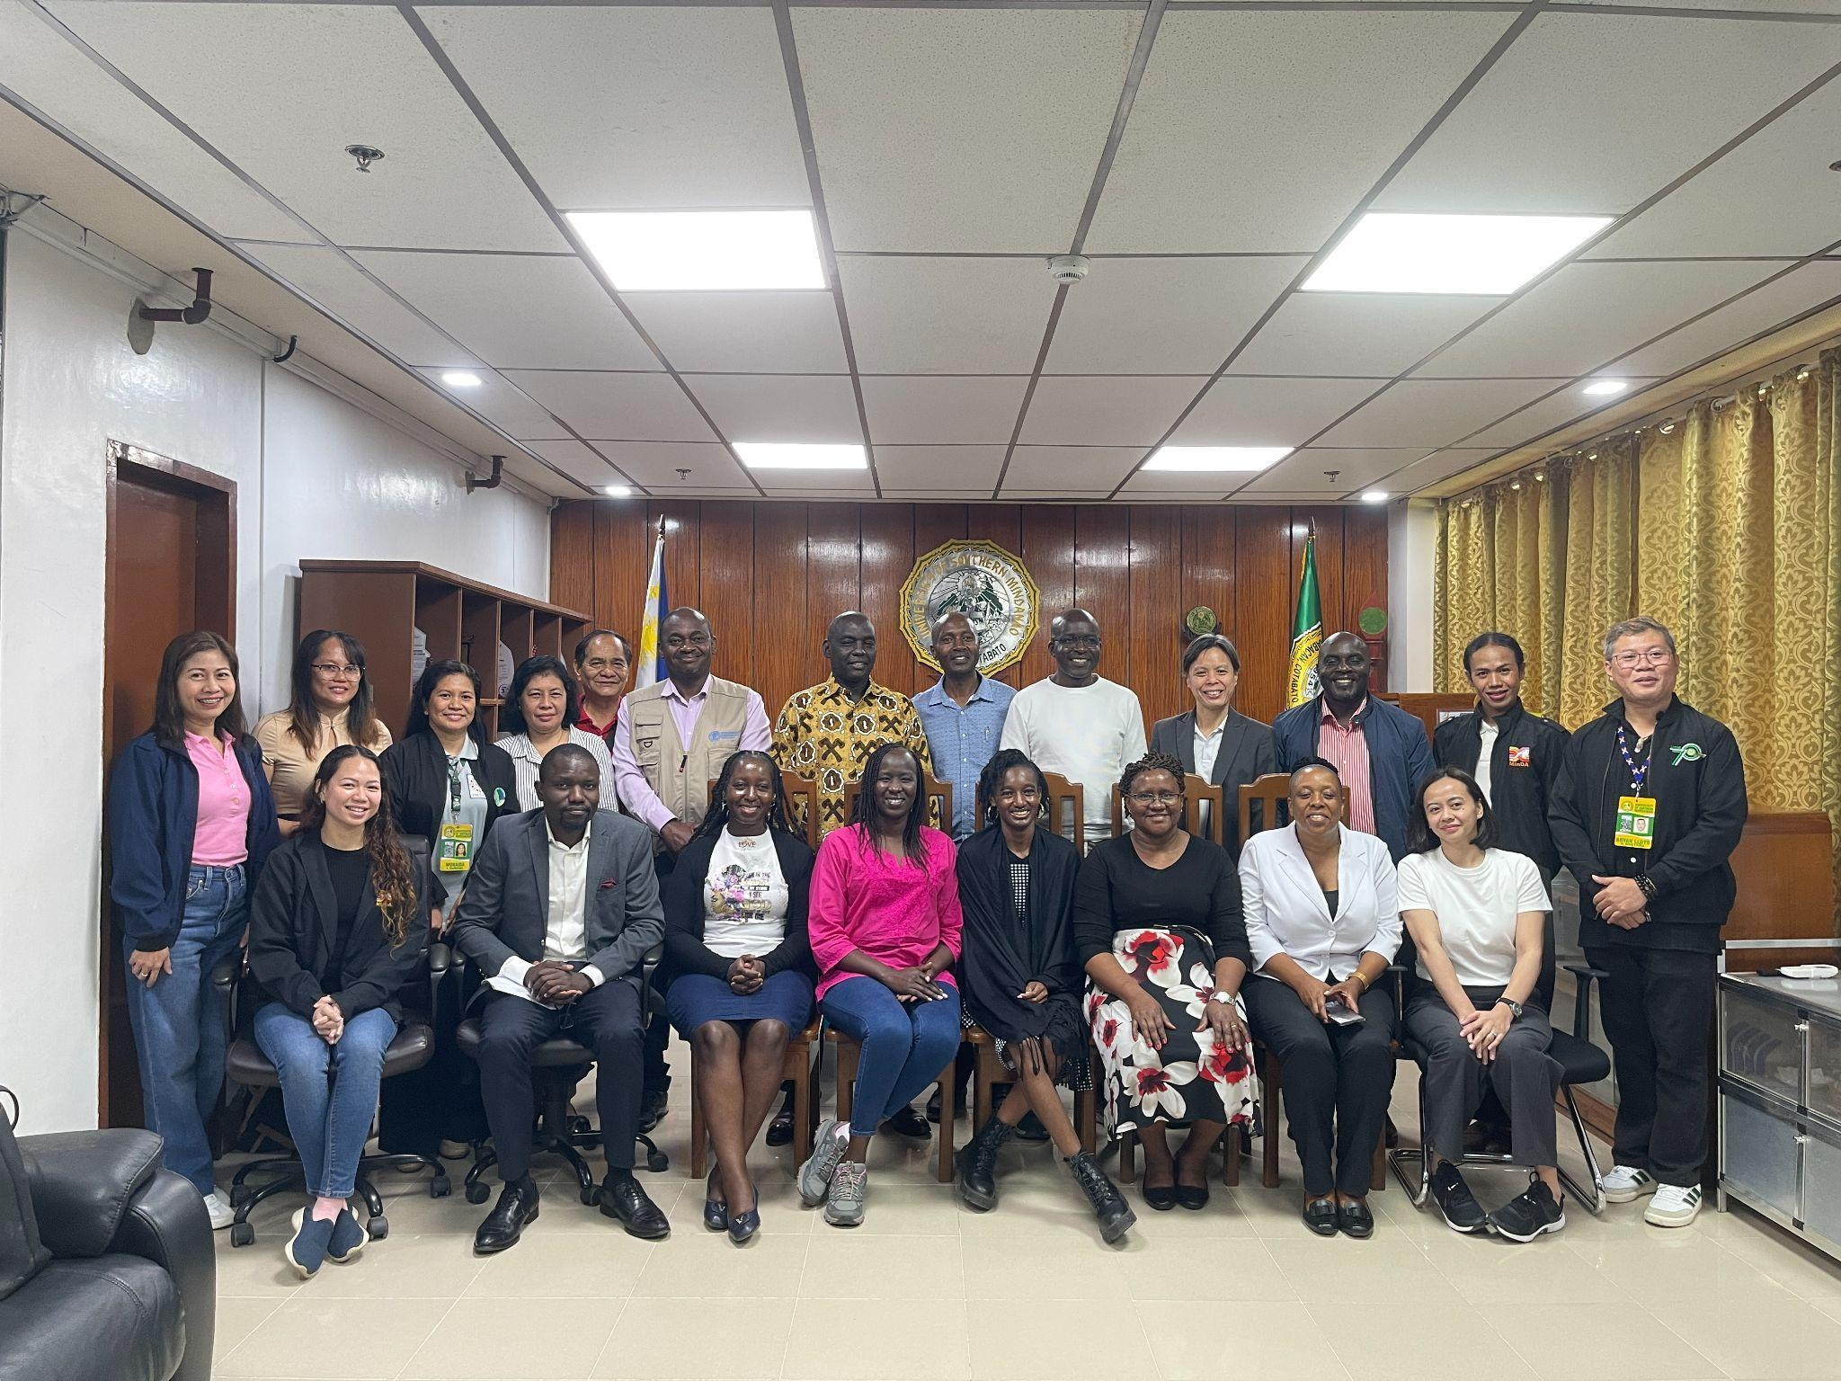
Figure 14. Courtesy visit of Kenya Delegates in the Office of the President of USM.

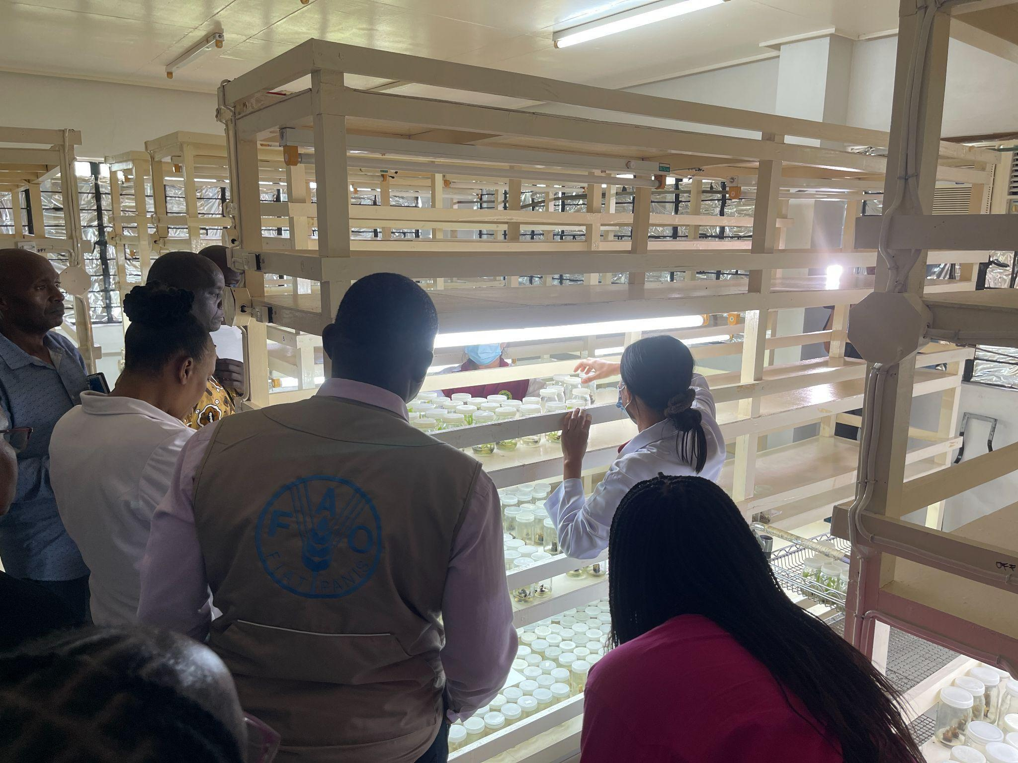
Figure 15. Site visit in Banana tissue culture laboratory.

5. Development of the Second Phase of a Seed Multiplication Pilot Project, International Committee of the Red Cross (ICRC), Switzerland.
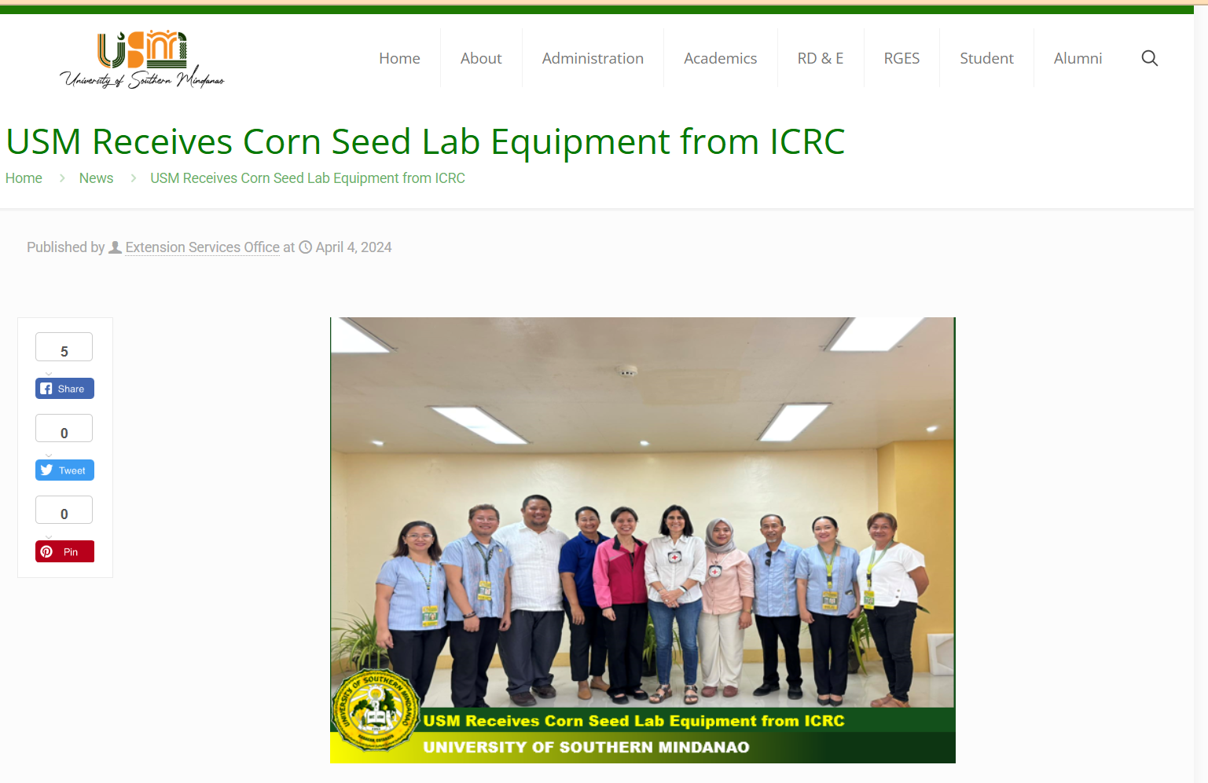
Figure 16. Donation of Corn Seed Lab Equipment From ICRC.

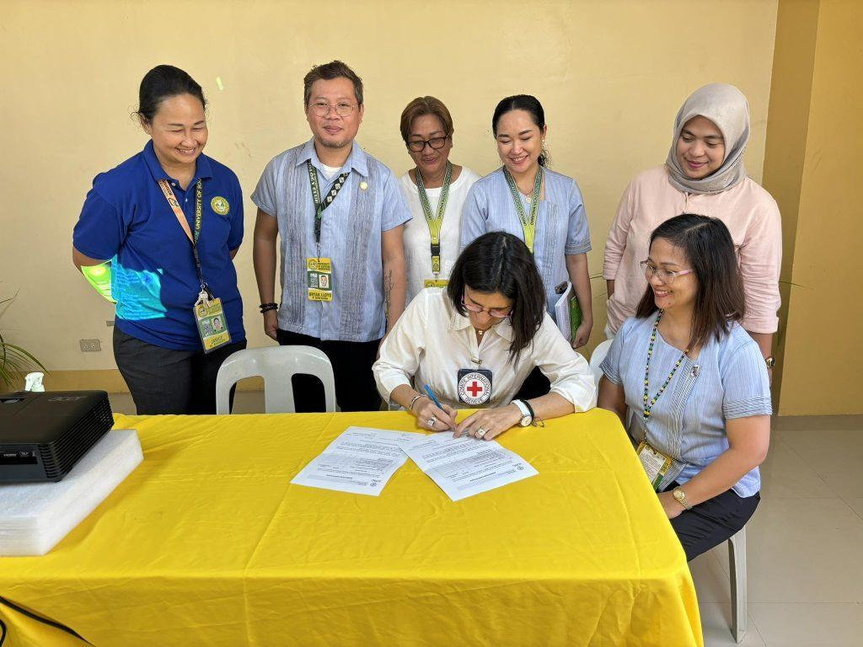
Figure 17. Approbation of Donation of Lab Equipment for USM from ICRC.
6. Developing soil knowledge, information and capacity to improve the productivity and sustainability of key cropping systems in Philippines, Australian Centre for International Agricultural Research, Australia.
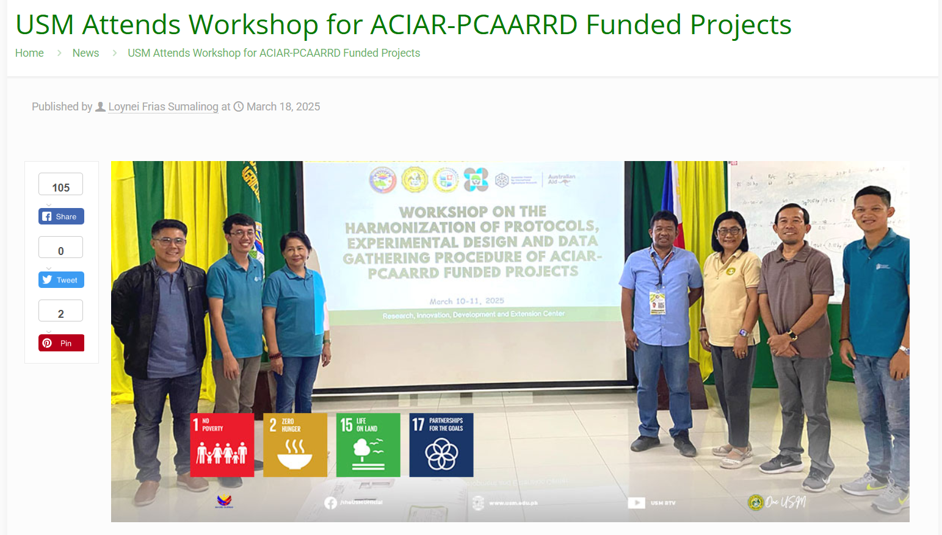
Figure 18. Project Personnel Workshop for ACIAR-PCAARD.

