**E.1. Photographs of Offices and Function Rooms**

Dean’s Office

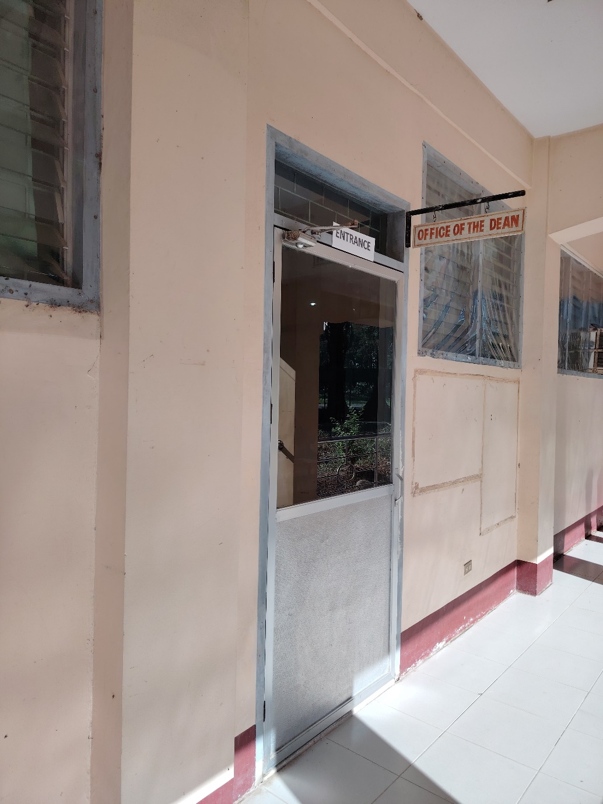

## Faculty Room

## College Academic Heads Office

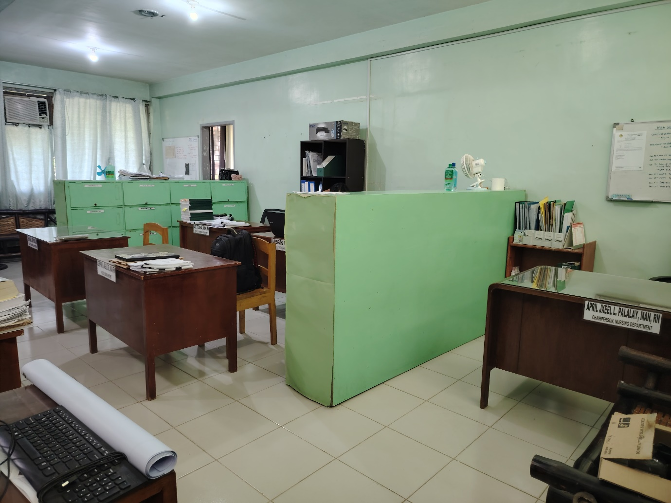

## College Clerk

Research and Extension Office

Accreditation Office

