**C.2. Evidence that Electrical Lines are Safely Installed and Periodically Checked**

Circuit Breakers and Electrical Lines

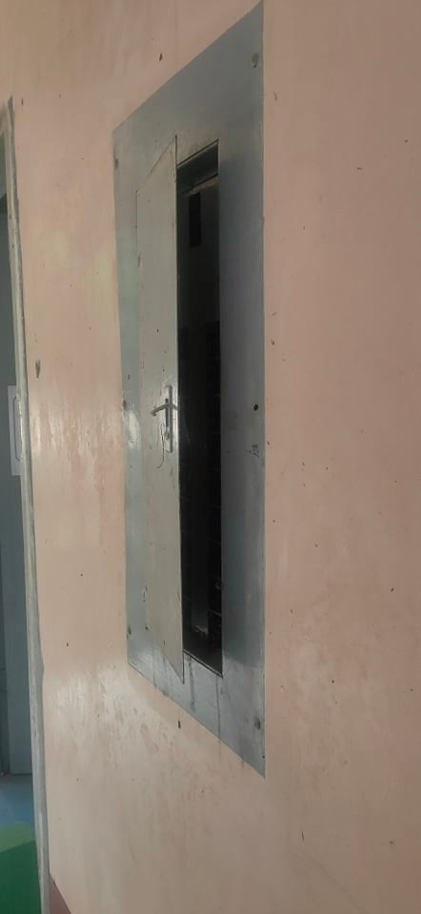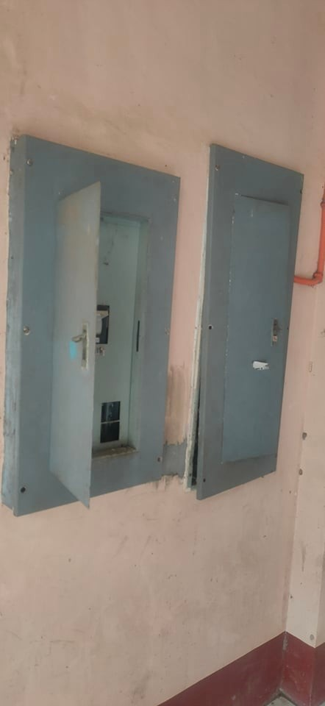

Building Power and Lighting Layout

Evidence that Electrical Lines are Periodically Checked