**B.2.4. cleanliness and orderliness in the campus;**

The university emphasizes campus cleanliness and orderliness as a core component of its waste management and sustainability initiatives.

Routine cleaning schedules, in collaboration with the campus janitorial team, ensure that common areas, walkways, and facilities remain litter-free and orderly.

Dedicated waste disposal areas and visible reminders encourage the campus community to take responsibility for maintaining a clean and organized environment, supporting the university’s commitment to health, safety, and aesthetics.

Machine and Campus Ground Maintenance

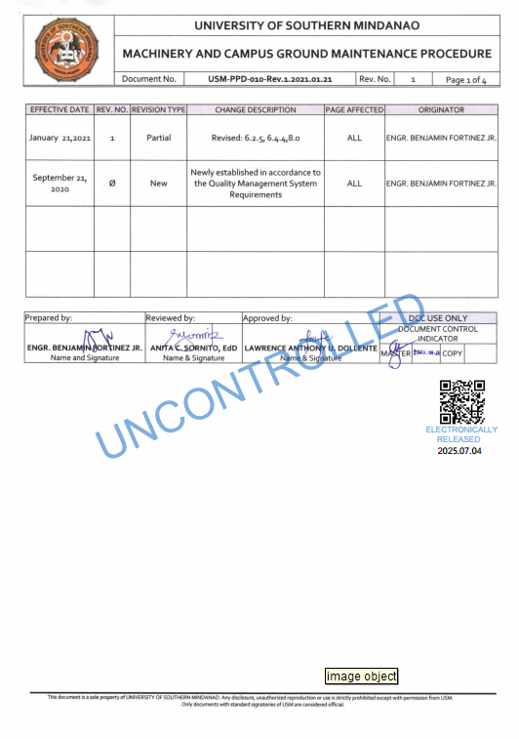

No SUPs Policy