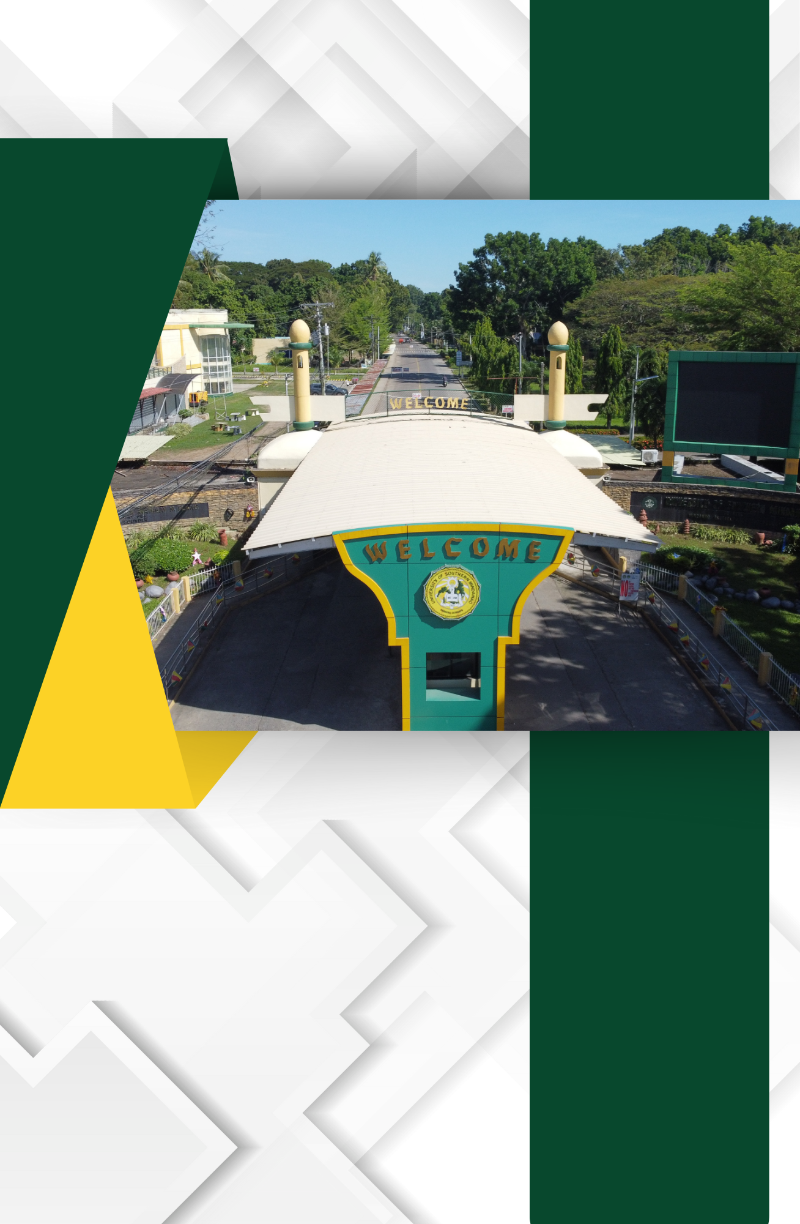

A.1. Site Development Plan/
Physical Plant Map
Displayed Prominently in the Campus

The University of Southern Mindanao (formerly the Mindanao Institute of Technology) is located less than one kilometer from the National Highway in the Municipality of Kabacan, Cotabato Province. Kabacan is nearly at the geographical center of Mindanao and is accessible from any part of the island through the North-South Cagayan de Oro–General Santos City and East-West Davao–Cotabato City national highways, which intersect in the town.
The land on which the University is situated was formerly the Rio Grande Rubber Estate, covering an area of 1,024 hectares. The university’s land grant area is designated for carrying out its mandated functions of instruction, research, extension, and production. The academic zone is strategically located near the center of this land grant area, occupying 88 hectares in a setting conducive to learning. This area houses the various academic buildings, sports complex, administrative offices, hospital, dormitories, cottages, and other facilities.
The University Development Plan (available from S.Y. 2014-15 to 2024-25) outlines the university’s strategic direction for growth and ongoing development. The plan addresses the following goals:
a) Generating additional funds for the university.
b) Offering new educational programs to meet the labor needs of both domestic and international markets.
c) Implementing programs to address the increasing demand for improved information management and communication technologies, and to support government programs aimed at poverty alleviation.
d) Enhancing the university's organizational structure and administrative procedures through the creation of additional offices that cater to specific needs and performance monitoring across various areas.
e) Emphasizing the creation of a conducive study environment by improving security, campus landscaping, installing drinking fountains, enhancing restroom facilities, adding ATM services, and ensuring clearer, well-maintained classrooms.
This development plan underscores the university's commitment to providing quality education and a supportive environment for its students.

Site Development Plan/Physical Plant Map displayed prominently in the Campus
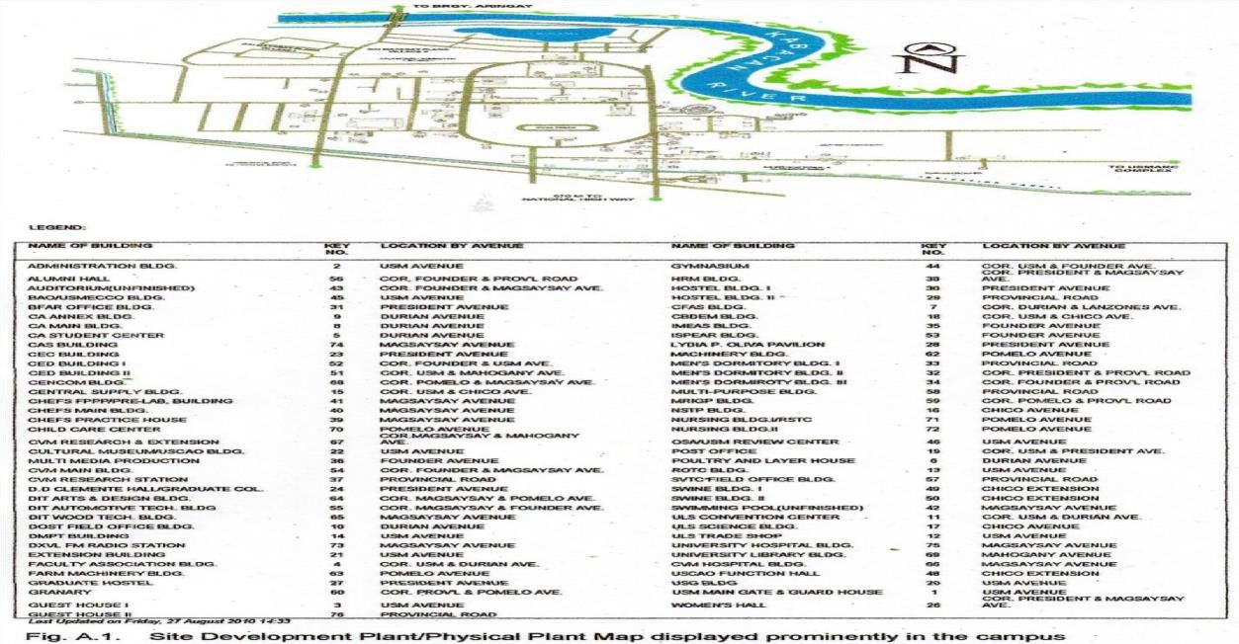

Development Plan
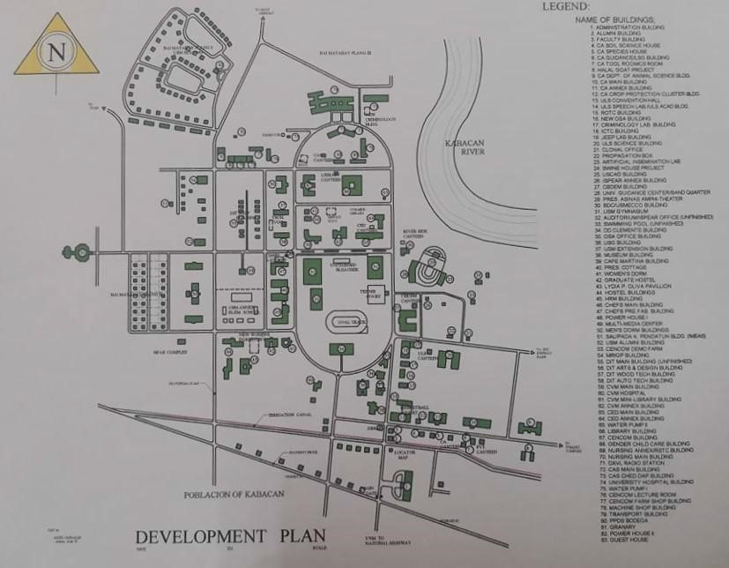

Campus Zoning Map

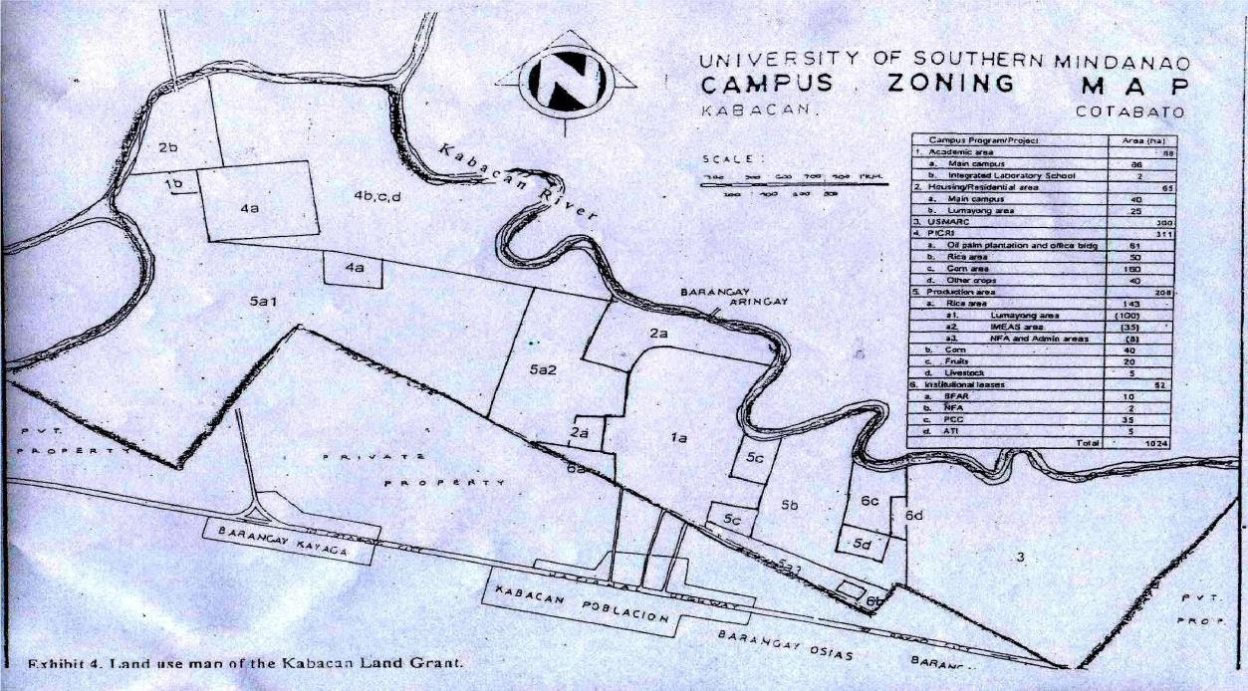

Development Plan Sketch
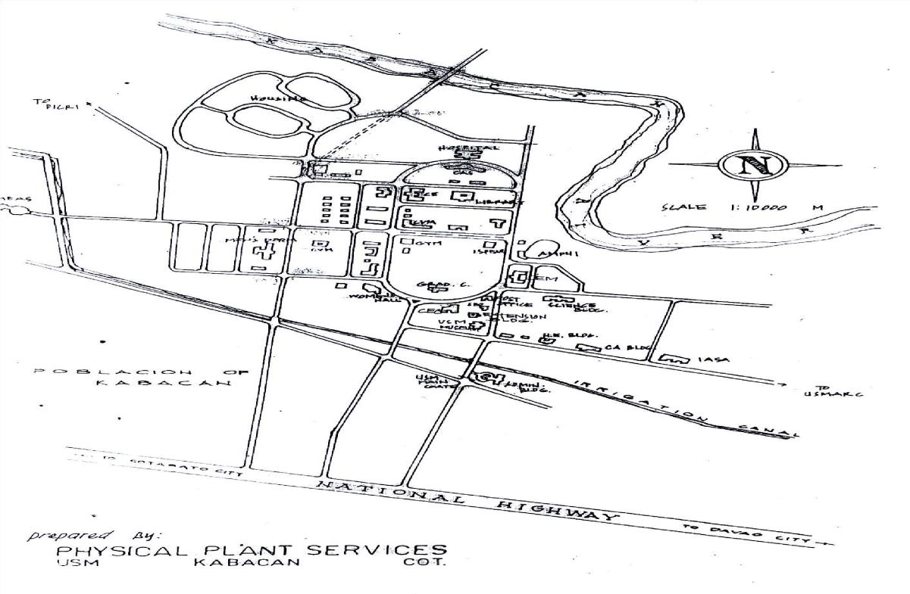

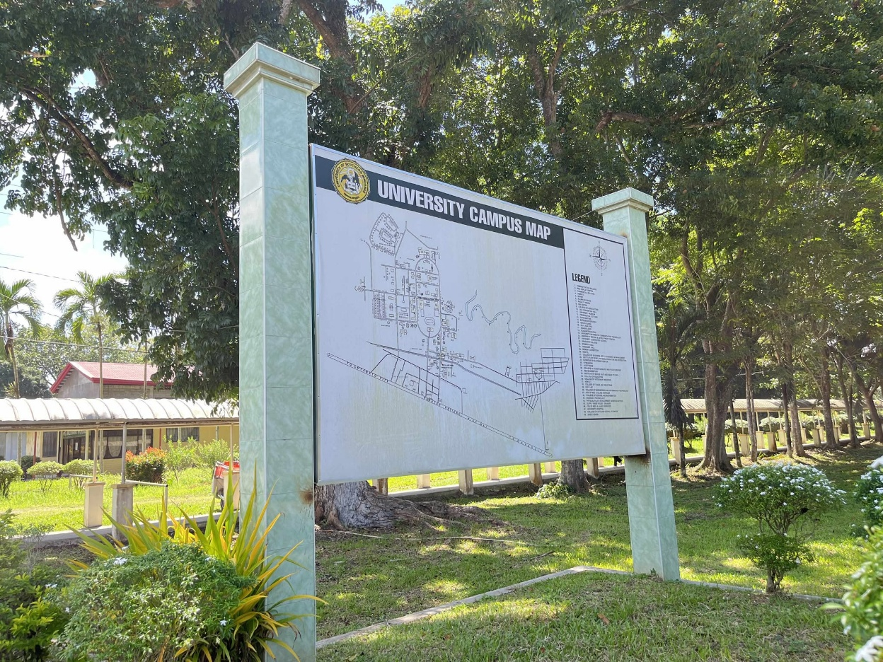
University Campus Map near the Entrance Point
USM LUDIP 2023-2032
