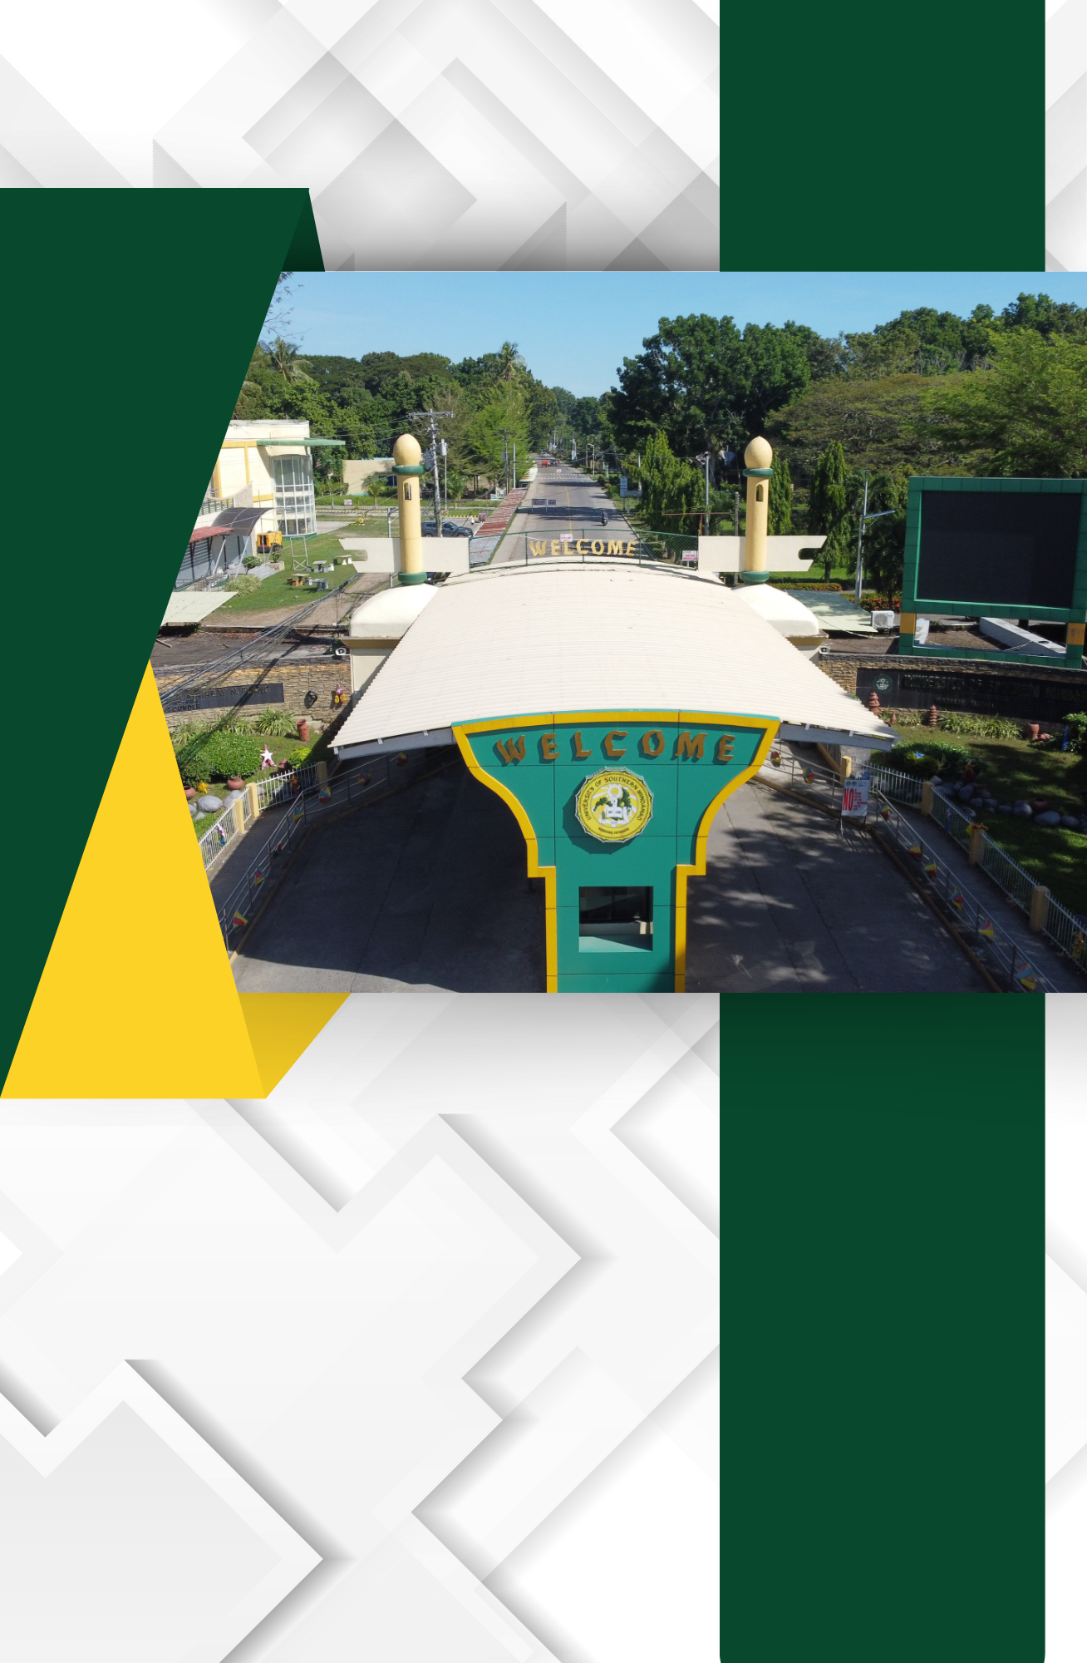

F.3. List of Assembly Halls
Facility | Total Area (Sqm) | Capacity | Acoustics (Please Check) |  | Nature Of Activity That Can Be Accommodated
 |  |  | With | Without
UNIVERSITY GYMNASIUM | 1,577 | 1,500 | / |  | Athletic And Cultural Activities, Meetings, Convocations,  Symposium And Other Academic Related Activities And Events
UNIVERSITY AUDITORIUM | 3, 107.16 | 2,500 |  | / | Athletic And Cultural Activities, Meetings, Convocations,  Symposium And Other Academic Related Activities And Events
PRESIDENT ASINAS AMPHITHEATER | 3, 441 | 3,000 |  | / | Convocations, Athletic And Cultural Activities, Commencement  Exercises
ULS  CONVENTION  HALL | 600 | 800 | / |  | Convocations, Seminars, Meetings And  Conferences
UNIVERSITY TENNIS COURT | 2,148 | 300 |  | / | Sports Activities
ATHLETIC OVAL | 15,000 | 100 |  | / | Sports Activities
PLAYGROUND | 60,000 | 7,000 |  | / | Sports Activities
CAS LOBBY | 328 | 400 |  | / | Seminars, Meetings, Convocations Programs  And Exhibits
CAS STUDENT PARK | 473 | 300 |  | / | Meetings, Outdoor Assembly
D.D.  Clemente  Hall (1st Hall) | 243 | 200 |  | / | Meetings, Seminars Conferences
USM HOSTEL  FUNCTION HALL  I | 84 | 60 |  | / | Seminars, Conferences
USM HOSTEL  FUNCTION HALL  II | 84 | 60 |  | / | Seminar, Conferences
USM HOSTEL PAVILION | 279 | 300 |  | / | Socials, Seminars, Special Occasions
CED- AVR | 190 | 150 |  | / | Seminars, Conferences, Meetings
CAFE MARTINA | 1, 095 | 400 | / |  | Seminars, Conferences, Meetings
CA- AVR | 90 | 200 |  | / | Seminars, Conferences, Meetings
CHS- AVR | 110 | 200 |  | / | Seminars, Conferences, Meetings

Café Martina

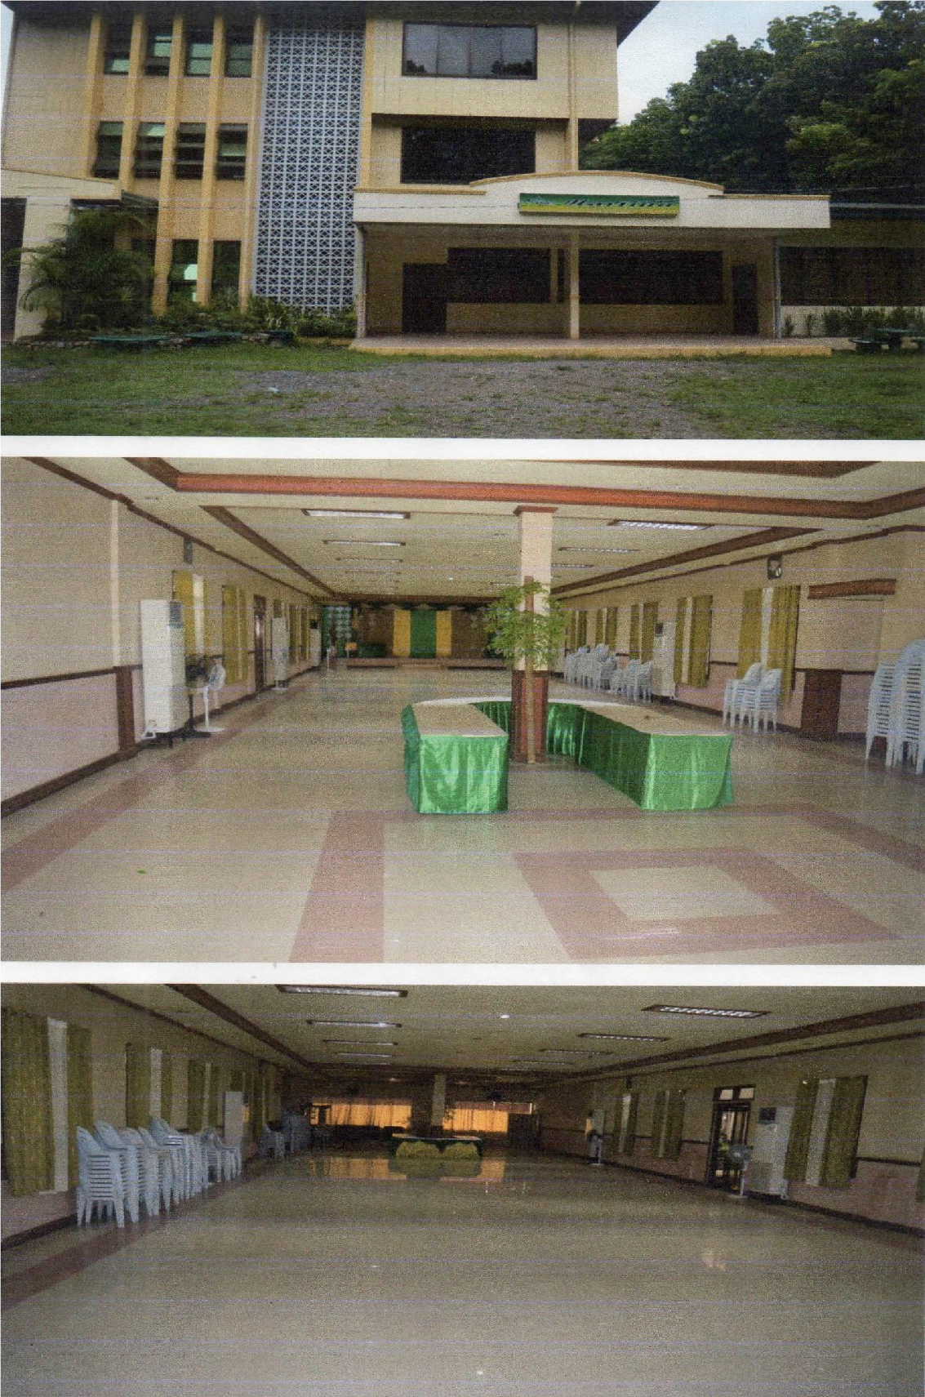

Uls

ULS Convention Center

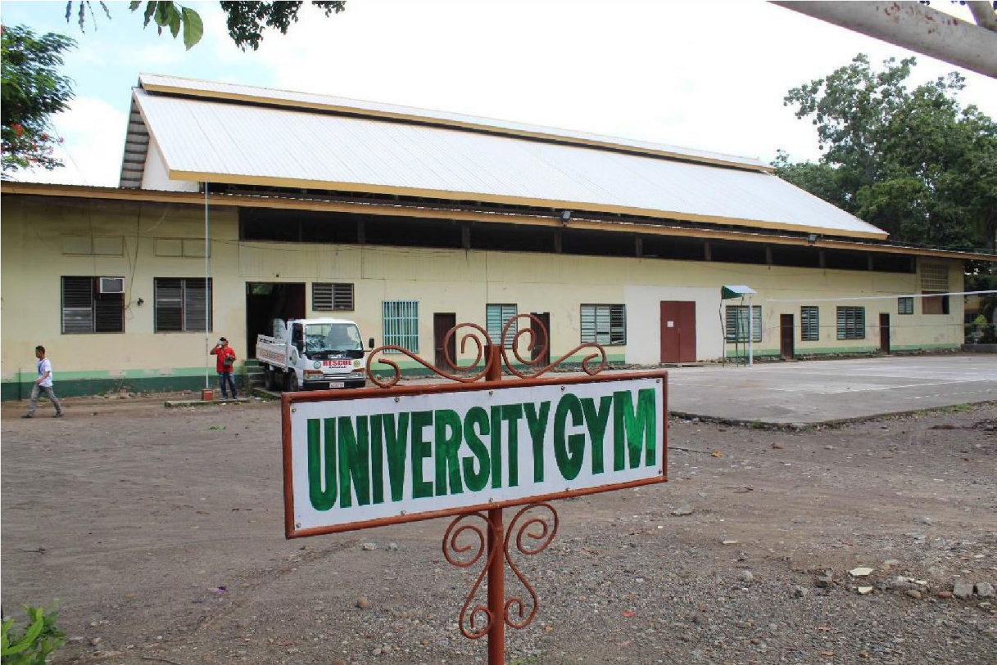
University Gymnasium

USM Auditorium
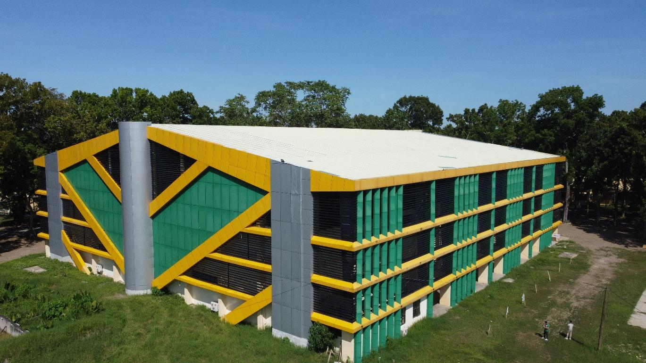

CHS Function Room For Conference Or Small Gatherings
