**B.2.5. security of the academic community inside the campus**

Contract of Security Services

Machine and Campus Ground Maintenance

Security Profile

License to Exercise Security Profession

Campus Security Personnel Deployment

CCTVs Installed in the University

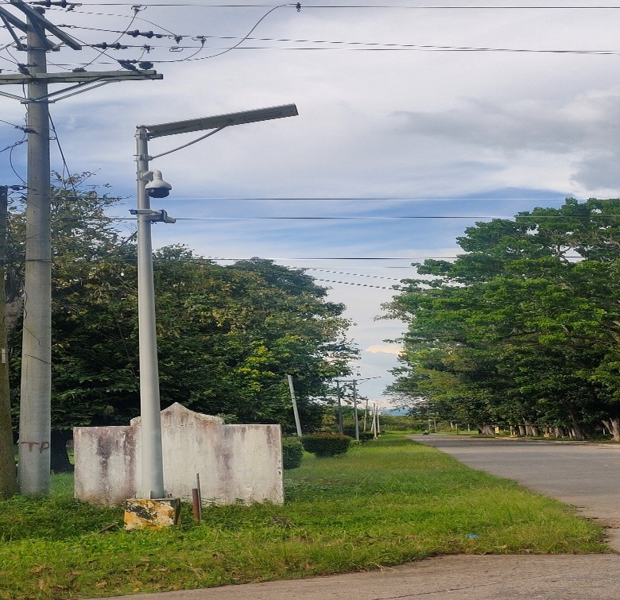

Security Guards undergoing Training

