SOXAARRDEC’S COMMUNITY UPLIFTMENT PROGRAMS & SERVICES (CUPS) 2025
A Regional Community Upliftment Programs & Services of the Consortium’s Priority Commodities

Rationale of the Activity
The Community Upliftment Programs and Services (CUPS) by SOCCSKSARGEN Agriculture, Aquatic, and Natural Resources Research and Development Consortium (SOXXAARDEC) aims to educate and empower farmers in the region, focusing on sustainable farming practices. The Banana Cardava training equips farmers with natural methods for production and disease management.
- Teach natural approach and practices among farmers and banana growers for Banana Cardava production.
- Equip banana growers with knowledge and skills on natural methods for managing and producing Banana Cardava.
- Provide strategies for effective disease control.
- Educate farmers and empower the Agriculture, Aquatic, and Natural Resources (AANR) sectors in the region.

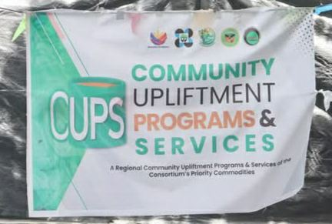
RESOURCE PERSONS PROFILE
Name: Dr. Julius Jerome G. Ele
Professor VI and Director of SOXAARRDEC

EDUCATIONAL BACKGROUND:

ELEMENTARY: SAN SEBASTIAN COLLEGE – RECOLETOS
HIGH SCHOOL: SAN SEBASTIAN COLLEGE – RECOLETOS
COLLEGE: BACHELOR OF SCIENCE IN AGRICULTURE – ANIMAL SCIENCE UNIVERSITY OF THE PHILIPPINES – LOS BAÑOS, LAGUNA
MASTERS: MASTER OF SCIENCE IN ANIMAL SCIENCE ( ANIMAL NUTRITION UNIVERSITY OF GEORGIA ) ATHENS, GEORGIA UNITED STATES OF AMERICA
PHD: PhD IN AGRICULTURAL SCIENCE – ANIMAL SCIENCE UNIVERSITY OF SOUTHERN MINDANAO KABACAN, COTABATO

MEMBERSHIP IN ASSOCIATION/ORGANIZATION:
- FULBRIGHT – PHILIPPINE DEPARTMENT OF AGRICULTURE SCHOLARS
- THE HONOR SOCIETY OF PHI KAPPA PHI, ATHENS, GEORGIA, USA
- PHILIPPINE SOCIETY OF ANIMAL SCIENCE, LIFE MEMBER
- PHILIPPINE SOCIETY OF ANIMAL NUTRITIONISTS, LIFE MEMBER
- WORLD POULTRY ASSOCIATION
- UNIVERSITY OF THE PHILIPPINES LOS BAÑOS ALUMNI ASSOCIATION
- FEDERATION OF INSTITUTIONS FOR MARINE AND FRESHWATER SCIENCES
- UNIVERSITY OF SOUTHERN MINDANAO ALUMNI ASSOCATION
- SAN SEBASTIAN COLLEGE ALUMNI ASSOCIATION
- CHILDREN’S MUSEUM AND LIBRARY INCORPORATED
- U.P AGRICULTURAL SOCIETY
- U.P RANCHERS’ CLUB

TEACHING EXPERIENCE:
November 1998- present
PUBLISHED PAPERS (CO – AUTHOR):
- Performance of Broiler Chickens Fed Diets with Different Levels of Mangosteen (Garcinia mangosteen Linn.) Rind Powder
Julius Jerome G. Ele, Josephine R. Migalbin, Elma G. Sepelagio and Peter Greame F. Lacia
NVSU Research Journal Vol. III No. 2 ( July – December 2016) ISSN No. 1908-3327
Pages 5- 10
- Immune Response of Broiler Chickens Fed Diets with Different Levels of Mangosteen (Garcinia Linn.) Rind Powder – May 2018
Julius Jerome G. Ele , R. Migalbin , Elma G. Sepelagio , Viingelle B. Jimenez and Peter Greame F. Lacia
Published: Asia Pacific Journal of Multidisciplinary Research Vol. 6 No.2, 35-44
May 2018 P-ISSN 2350-7756 E-ISSN 2350-8442 www.apjmr.com

- Performance of Dwarf Napier Grass (Pennisetum purpureum Schumach) as influence by Chicken manure, Vermicompost and Urea Fertilizers – April 2008
F R Amancio III. And JJG Ele

- Published: USM Graduate School Research Journal.Volume 10.No. 1.ISSN – 01197320. pp. 28 – 44

- Evaluation of the operational characteristics of vermicomposting bends at the USM-based Regional Vermicompost and Vermimeal Production Center XII Sheila Griengo, Teresa Lumansoc, Maricar Rose Organas, Willie Jones B Saliling, Joy Sharon B. Gamido and Julius Jerome G. Ele

- Published: USM R & D 16(2): 105-112 (2008)ISSN 0302-7937

Name: Dr. Tamie C. Solpot
Professor II
Department of Crop Protection/Division of Plant Pathology
College of Agriculture
University of Southern Mindanao

EDUCATIONAL BACKGROUND:
Doctorate: Degree Program: DOCTOR OF PHILOSOPHY IN PLANT PATHOLOGY
UNIVERSITY OF THE PHILIPPINES – LOS BAÑOS (LAGUNA)
Master of Science: Degree Program: MASTER OF SCIENCE IN PLANT PATHOLOGY
UNIVERSITY OF THE PHILIPPINES – LOS BAÑOS (LAGUNA)
Baccalaureate: BS Degree Program: BS IN AGRICULTURE (MAJOR IN PLANT PATHOLOGY)
UNIVERSITY OF SOUTHERN MINDANAO

MEMBERSHIP TO ORGANIZATIONS:
- PHILIPPINE PHYTOPATHOLOGICAL SOCIETY
- MYCOLOGY SOCIETY OF THE PHILIPPINES
- PHILIPPINE AGRICULTURE ECONOMICS AND DEVELOPMENT ASSOCIATION
- INTERNATIONAL SOCIETY FOR SOUTHEAST ASIAN AGRICULTURAL SCIENCES- PHILIPPINES
- ORGANIC AGRICULTURE SOCIETY OF THE PHILIPPINES
- CROP SCIENCE SOCIETY OF THE PHILIPPINES (CSSP)

WORK EXPERIENCE:
- Professor II (May 13, 2024-present), Associate Professor I (January 2022- May 12, 2024), Assistant Professor IV(July 11, 2020 to December 2021), Division Head, Plant Pathology (July 2020 to present), College Extension Coordinator- CA (July 2020 to present), Assistant Professor III (January 2020- July 2020), Instructor III (March 2018 to June 2020), Instructor II (January 2016 to March 2018), College Socio-Cultural Coordinator- CA (June 2015 to July 2020), DSWD-USM Extension Project (Project Leader- June 2015 to July 2016), Instructor I (November 2008 to January 2016), Science Research Assistant (Biotech, USMARC- August 2005 to October 2008).

PUBLICATION
- Journal of Rubber Research 1-10
- Nigrospora sphaerica causing Leaf Blight Disease of Cacao in the Philippines. India Phytopathology, 76(3), 915-922
- First report of Neopestalotiopsis clavispora causing foliar disease of rubber (Hevea brasiliensis) in the Philippines. Journal of Phytopathology, 172(1), e13238.
- Phylogenetic analyses and cross-infection studies of Phytophthora species infecting cacao and durian in South-Central Mindanao, Philippines. Journal of Phytopathology, 170(1), 41-56
- First report of Pythium cucurbitacearum causing fruit rot of durian in the Philippines. Journal of Plant Pathology, 103(3), 1085-1085.
- Cacao (Theobroma cacao) diseases: threats to the Philippines cocoa industry. Philippine Plant Disease Bulletin 1(1): 2-4.
- Exploring environment determinants of Fusarium wilt occurrence on banana in South Central Mindanao, Philippines. Hellenic Plant Protection Journal, 12(2), 78-90.

Community Upliftment Program and Services
(CUPS) MAP in Brgy. Pacao, Alamada

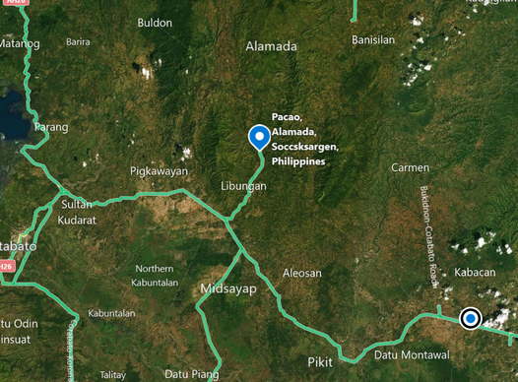

LEGEND:
 - Place where the CUPS has been conducted.
LEGEND:

Distributed IEC Materials - Posters/Leaflets/Stickers/Calling Cards
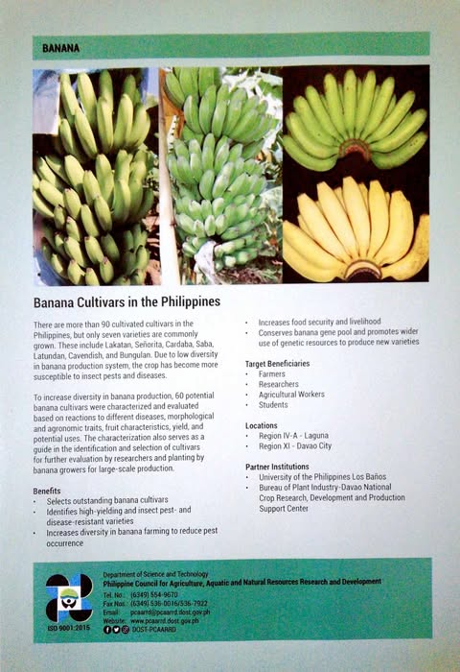

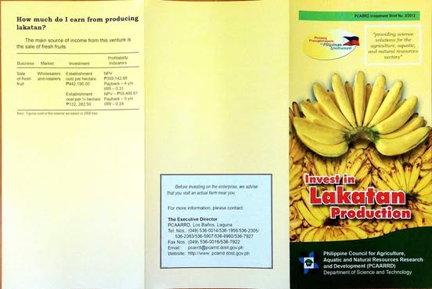

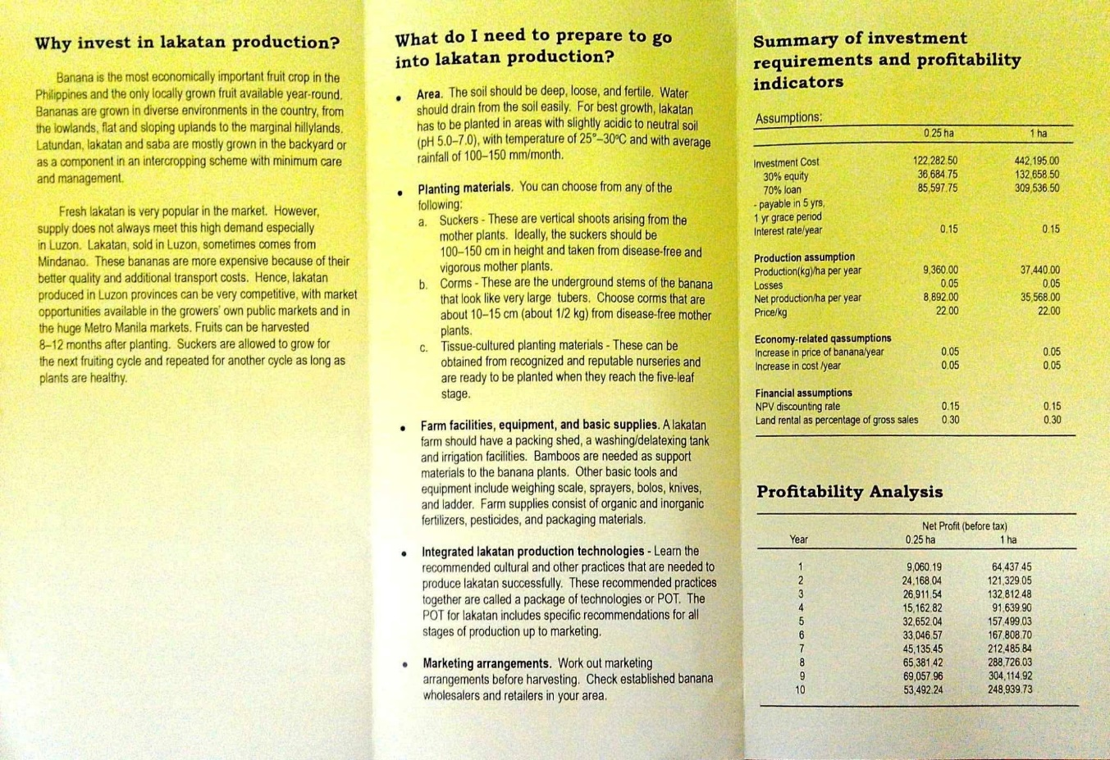

Photos from Cups

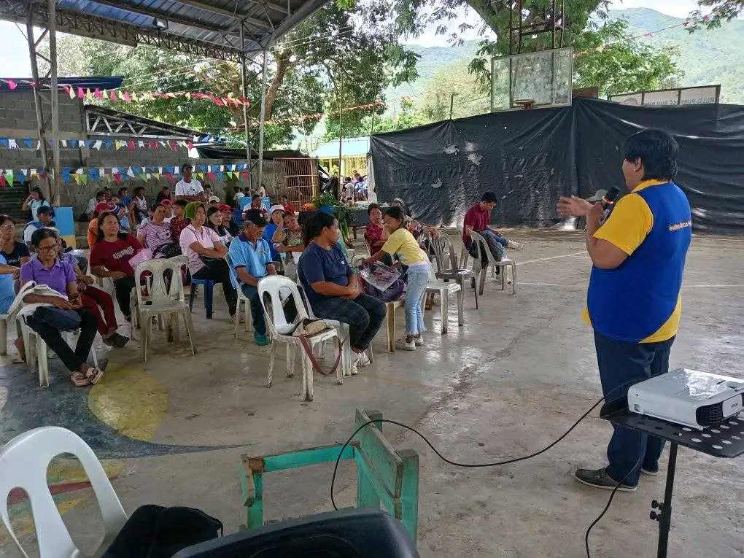
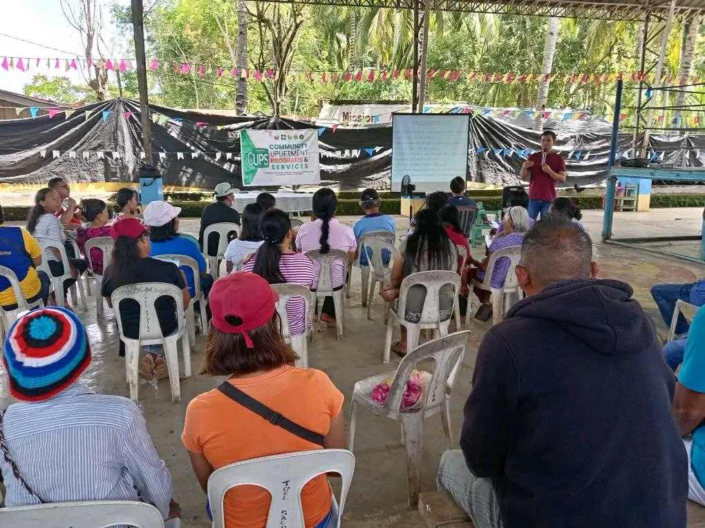

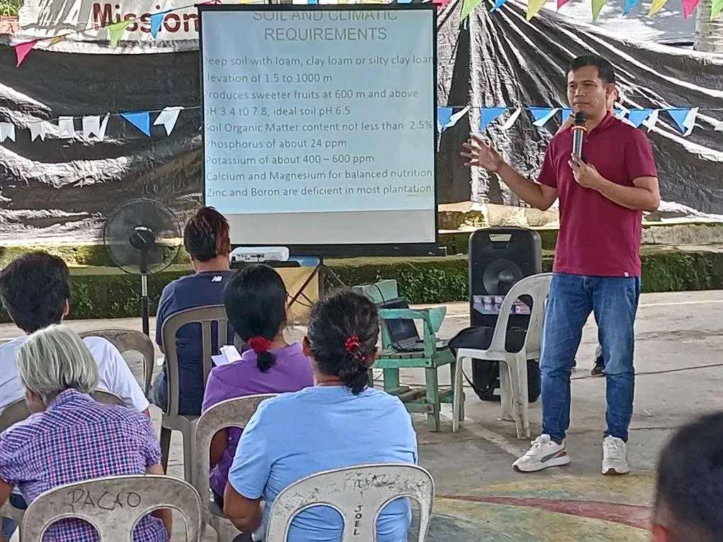
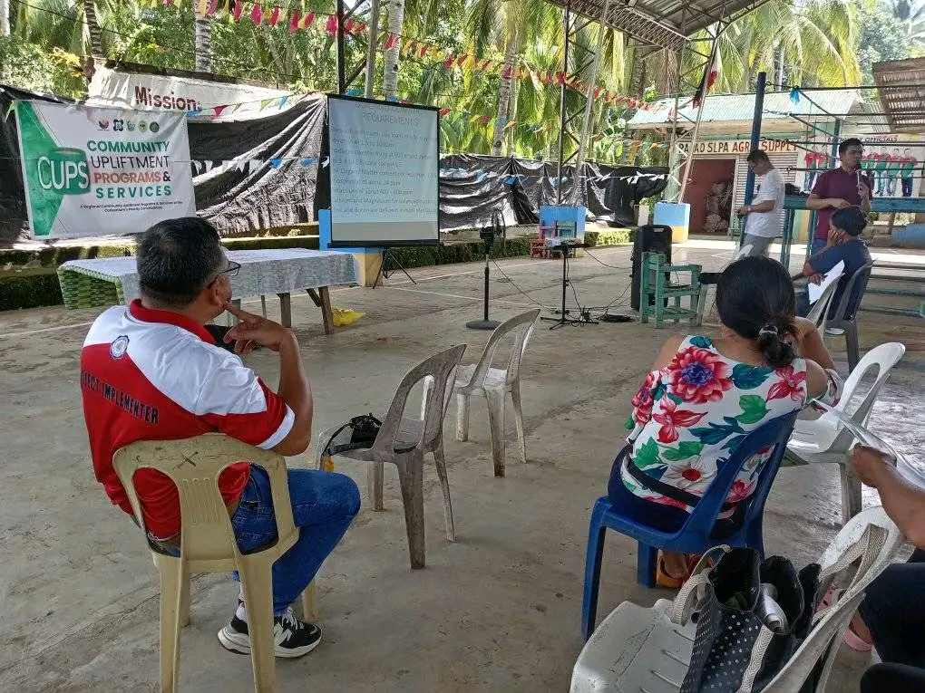

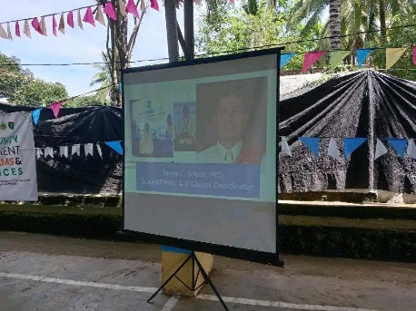
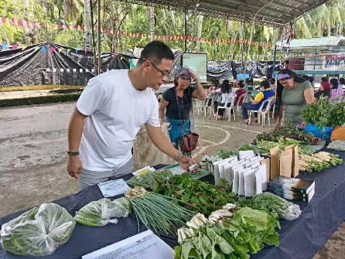

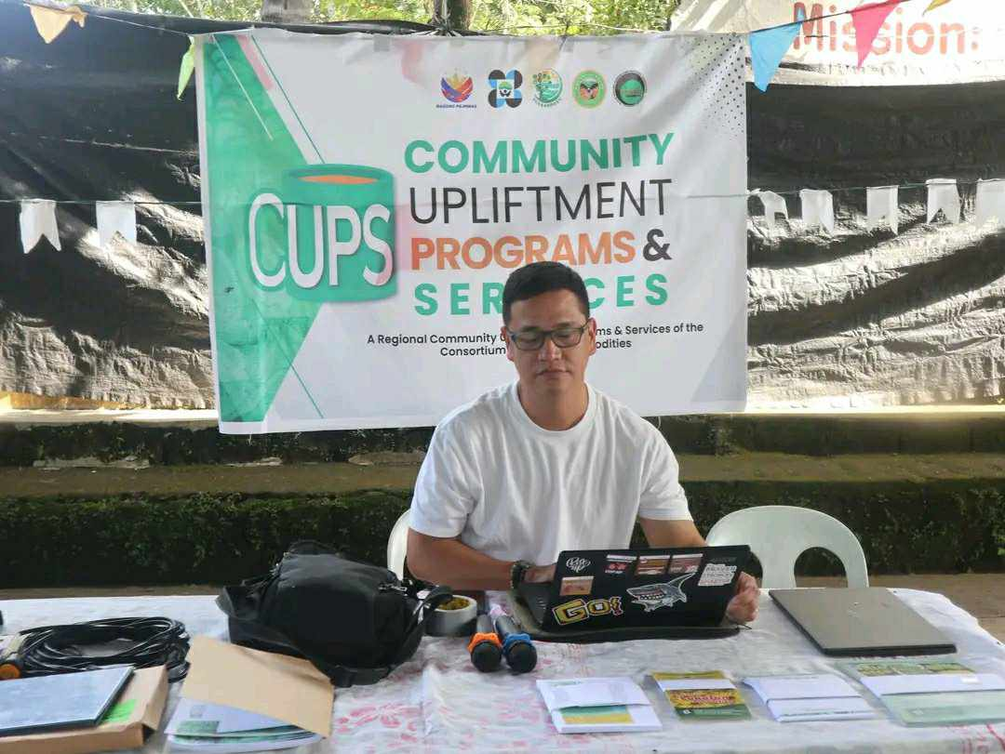
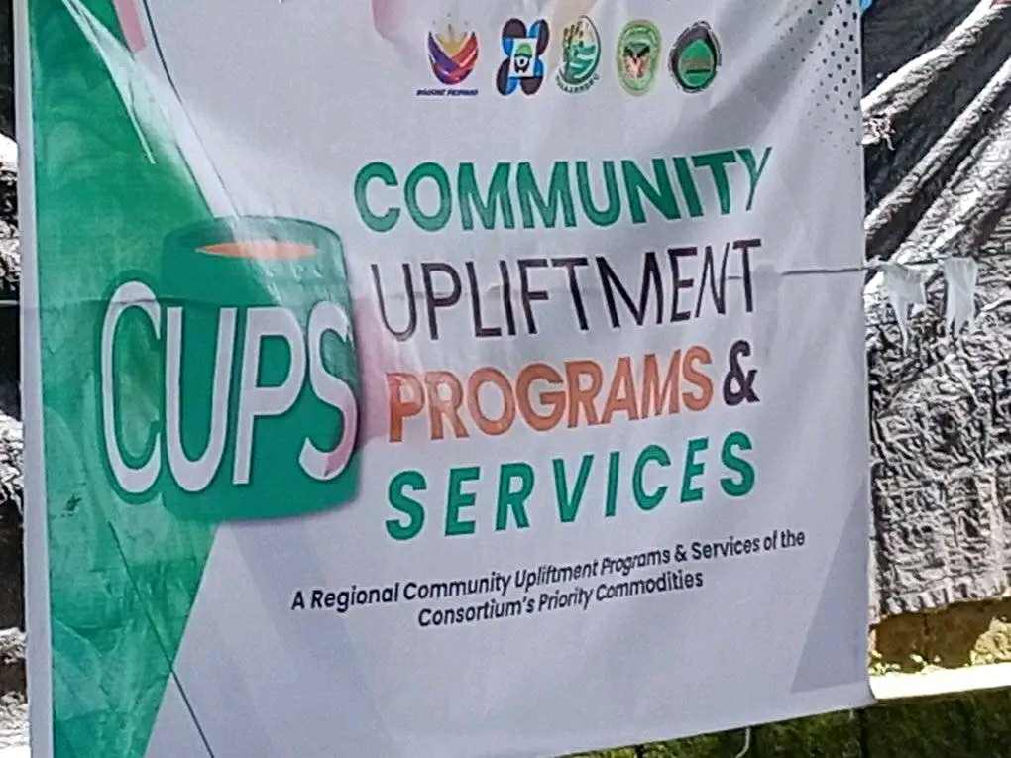

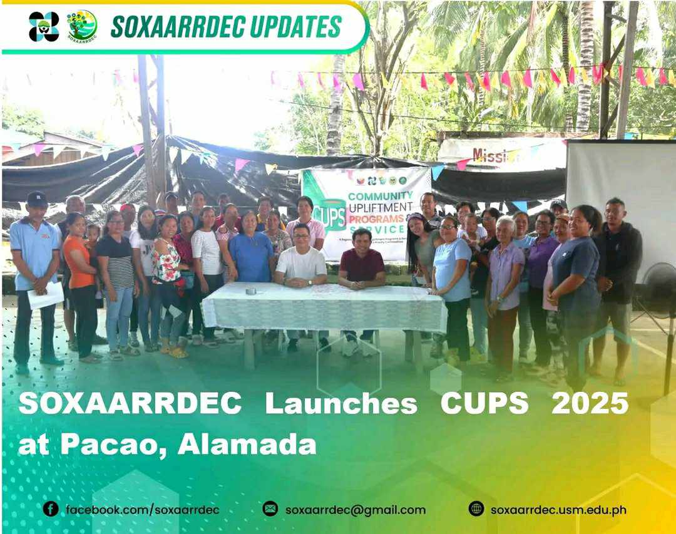
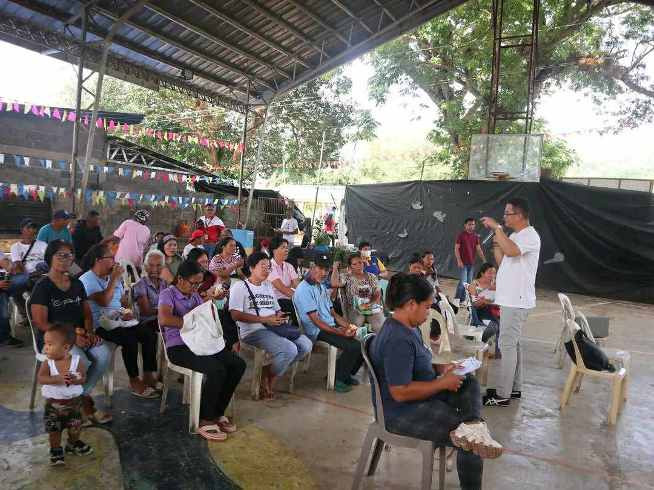

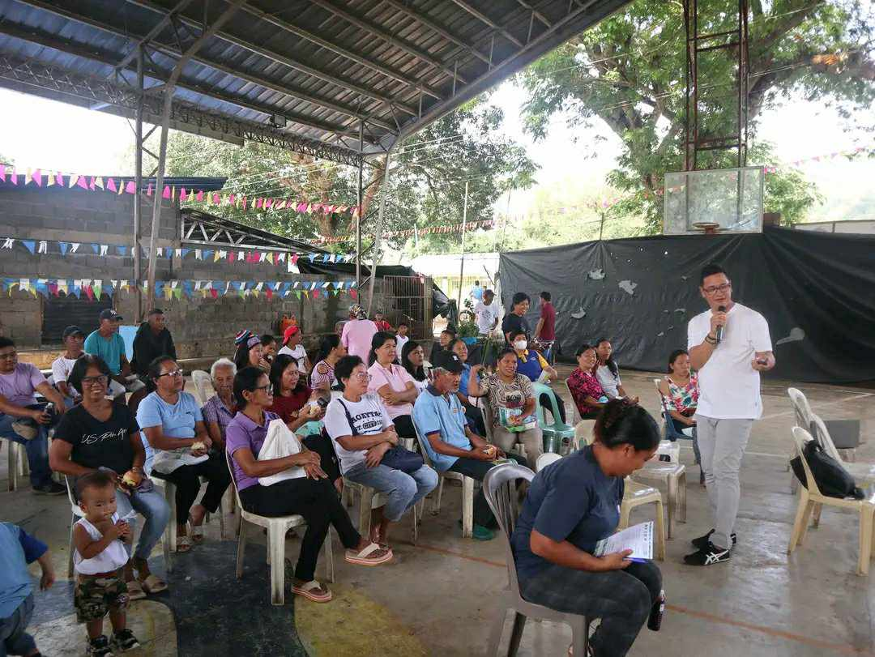
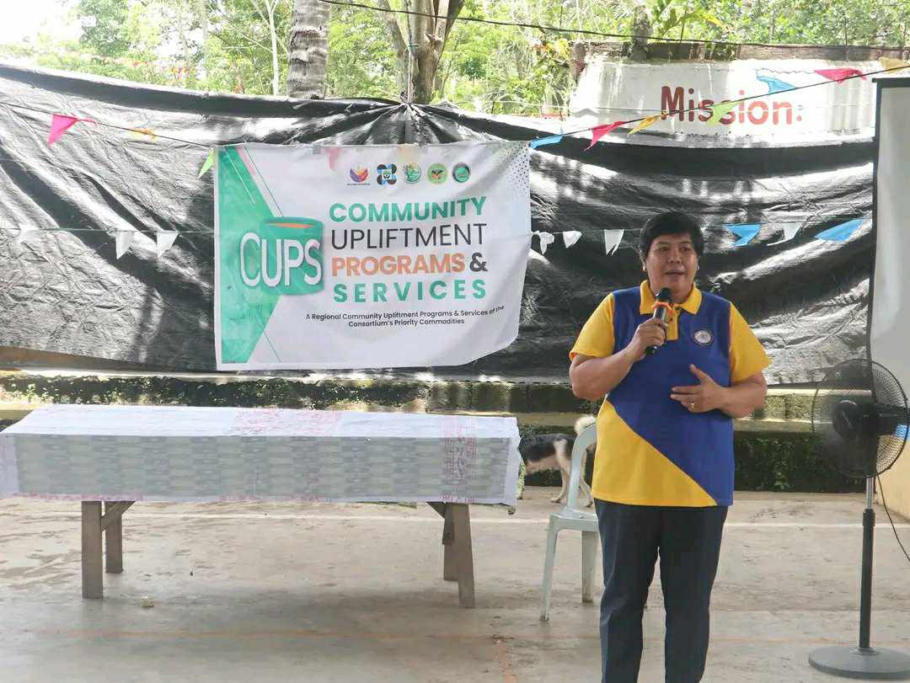

CUPS AT BRGY. PACAO, ALAMADA COTABATO

Invitation Letter – sent through e-mail and its response – such as NOTED/APPROVED

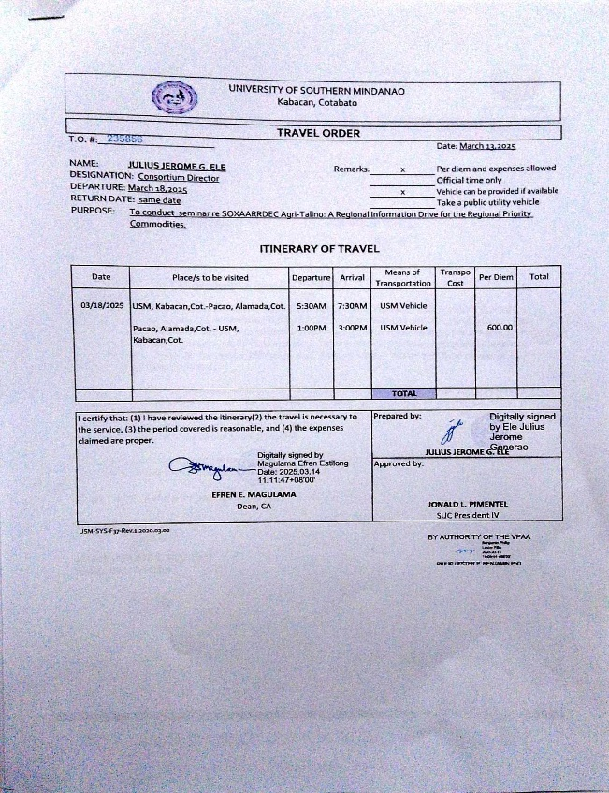
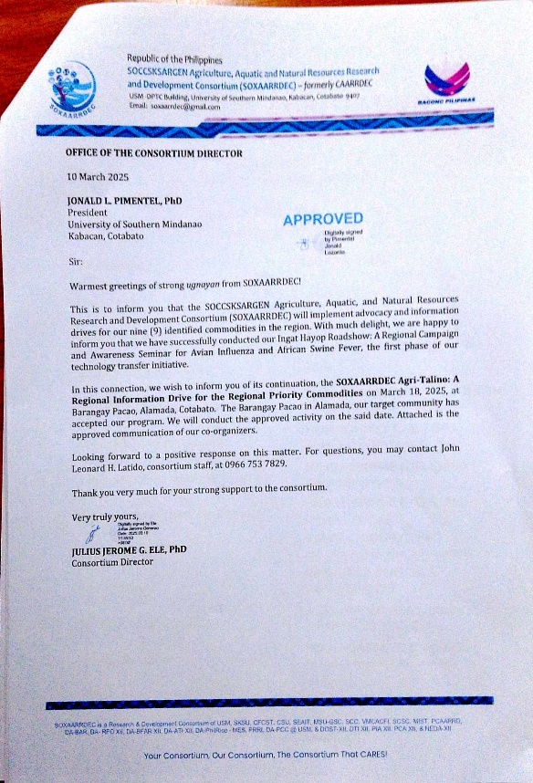

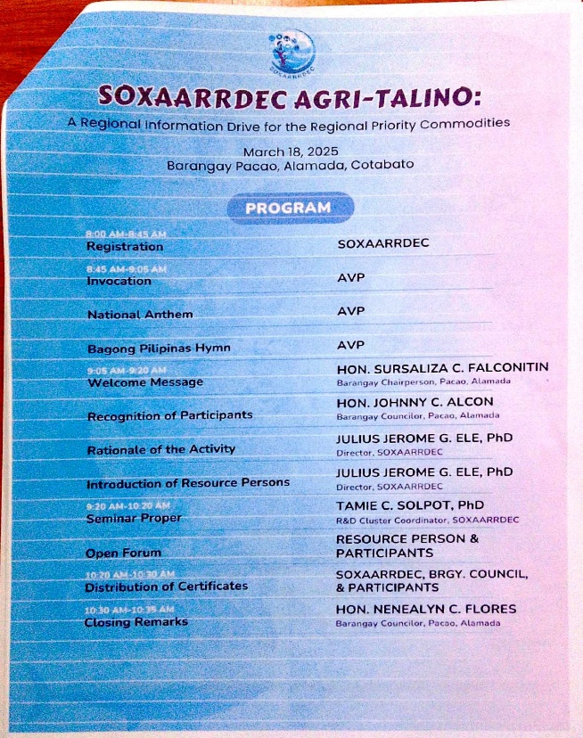
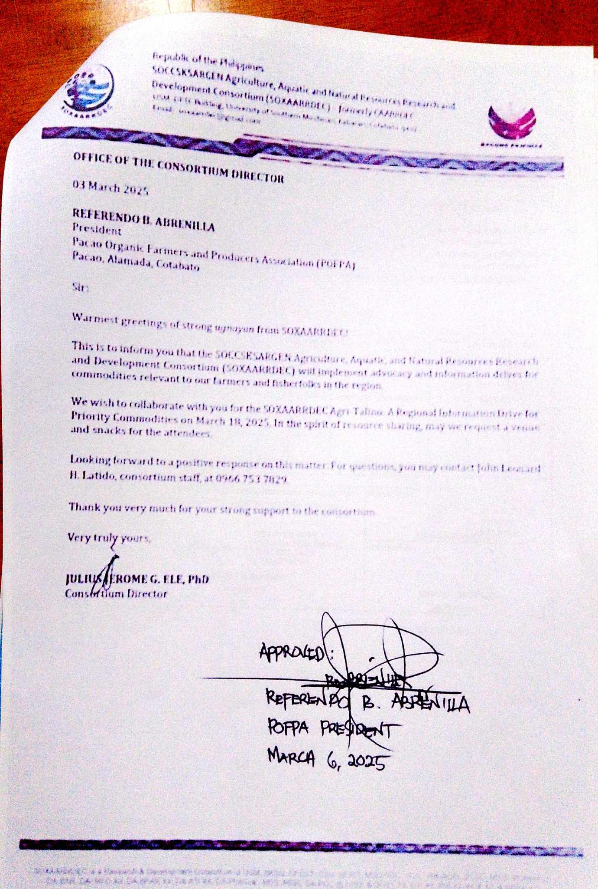

Where – Google Maps – Coordinates

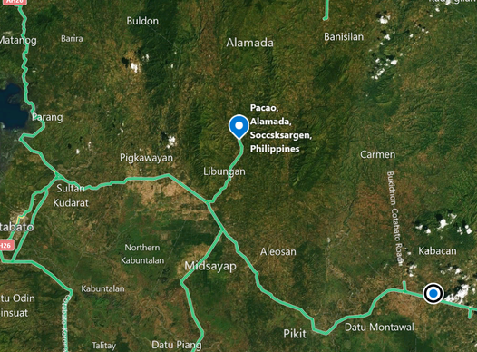
CUPS Program
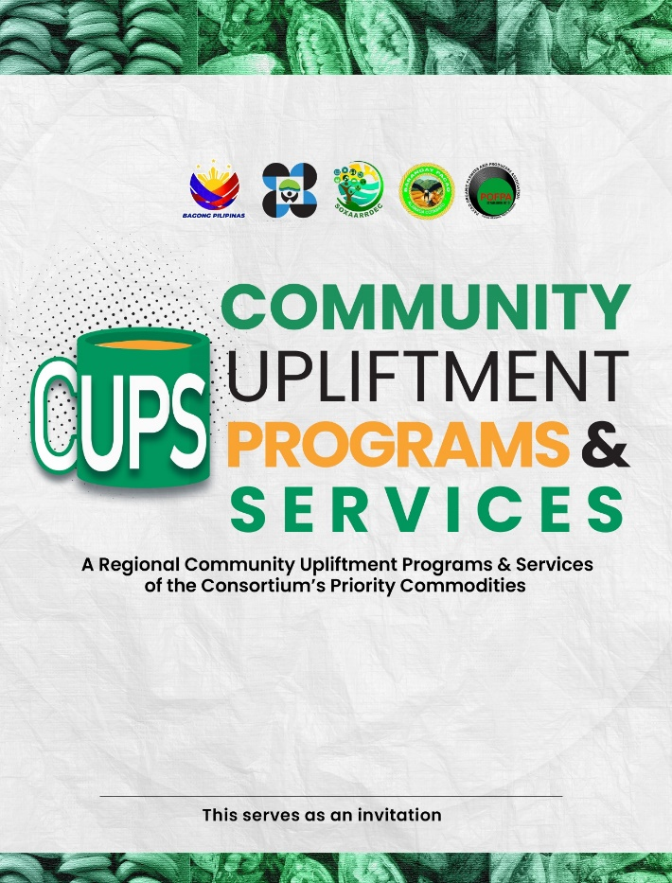
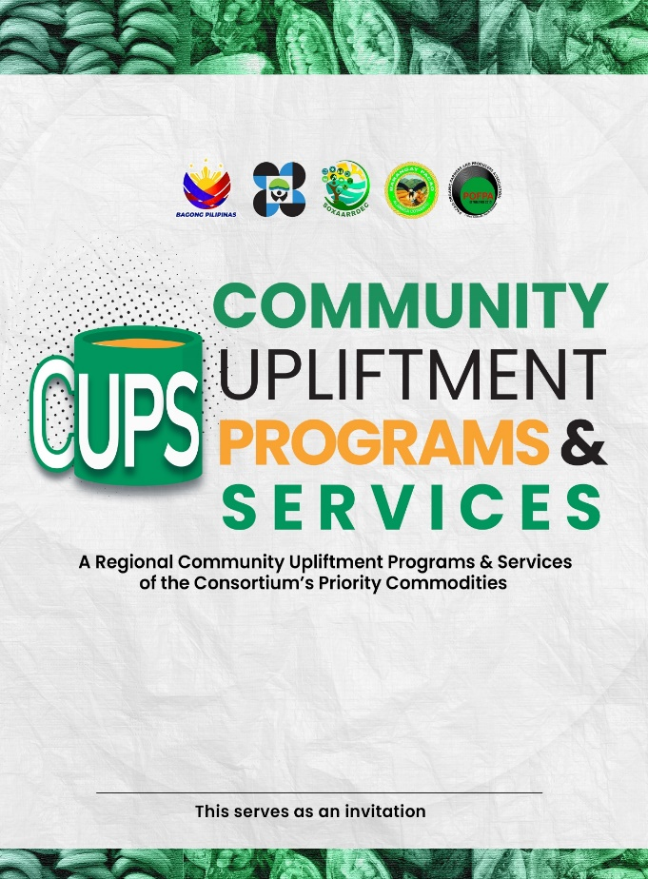

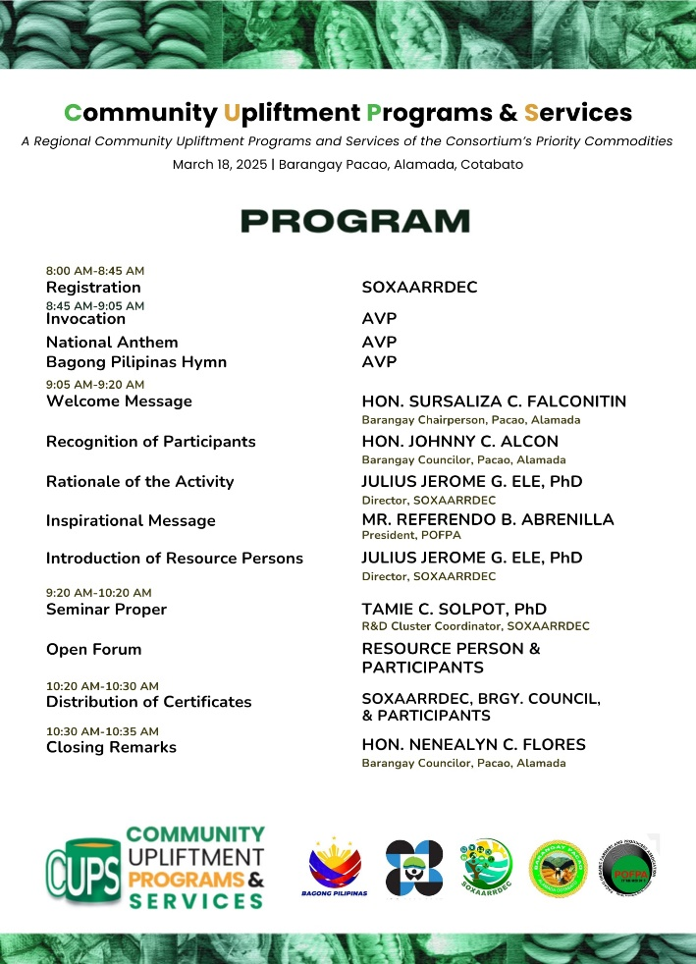
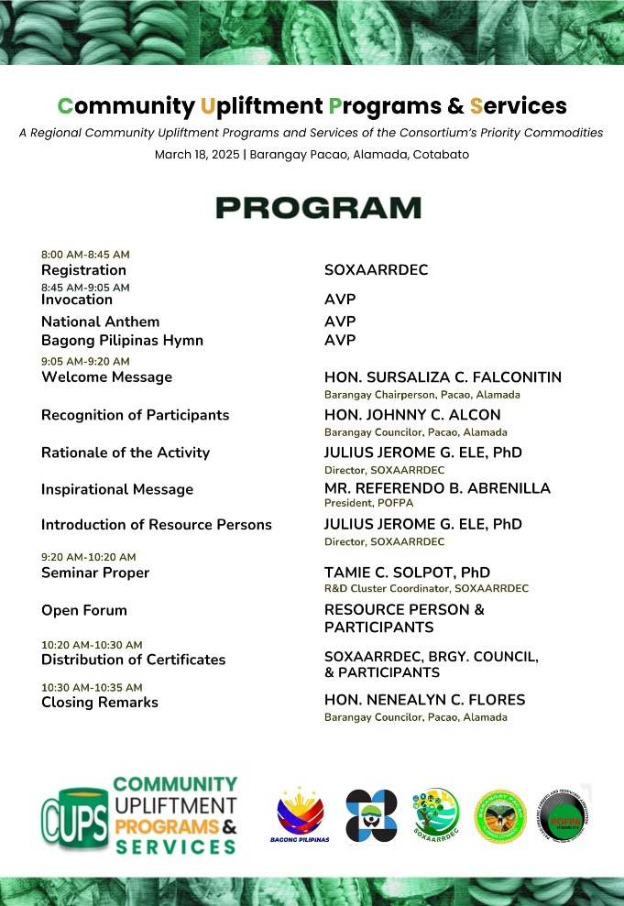

Attendance - Participants – Profile and Number of Participants

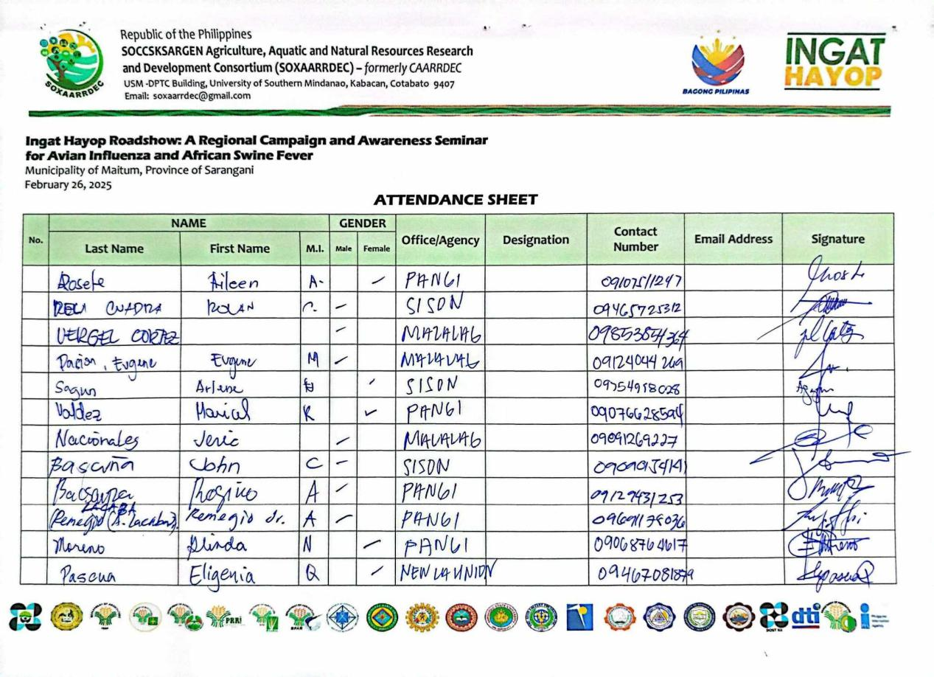

Distributed IEC Materials- Posters/Leaflets/Stickers/Calling Cards

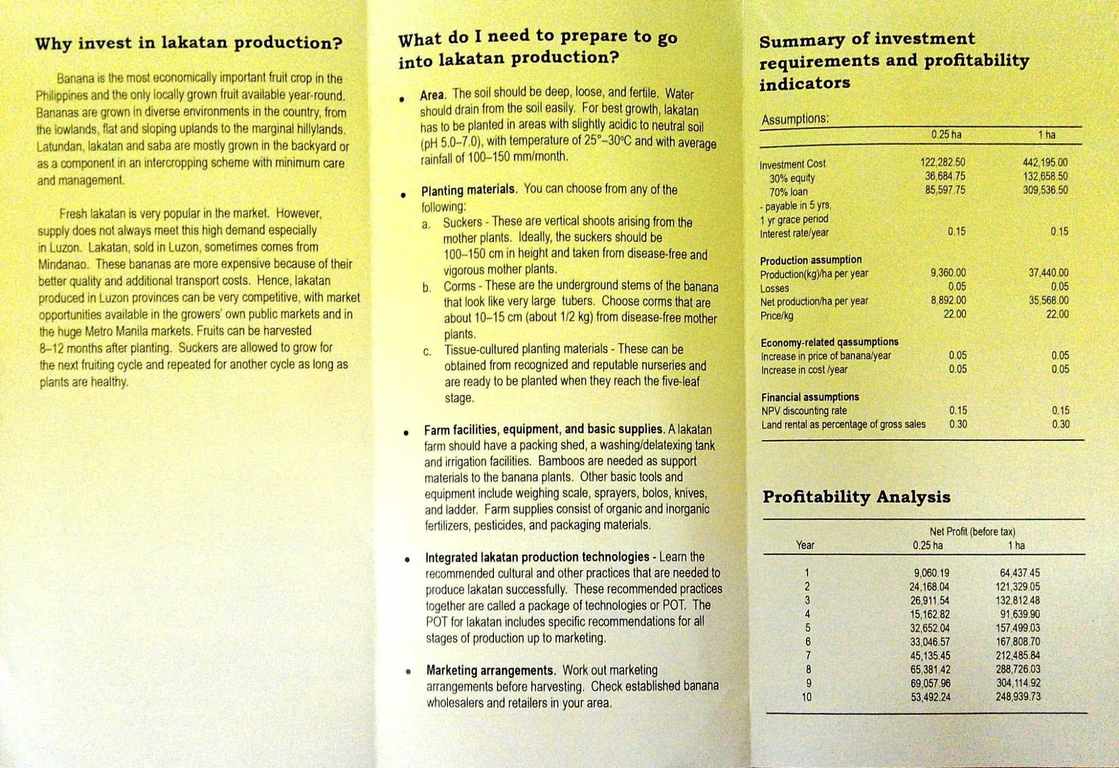
Lecture/Discussion

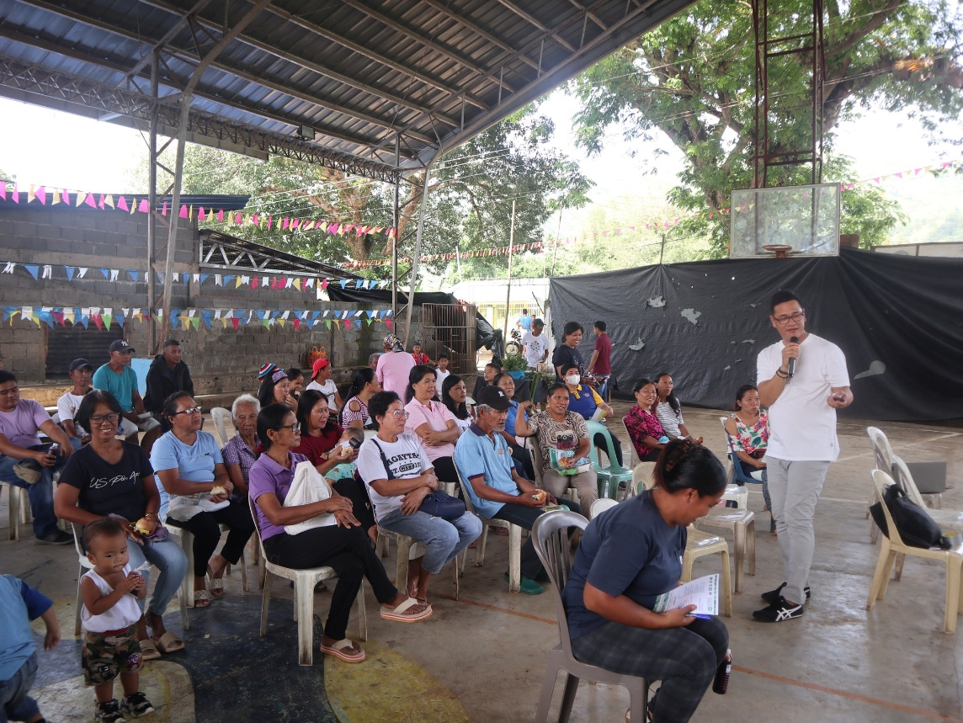
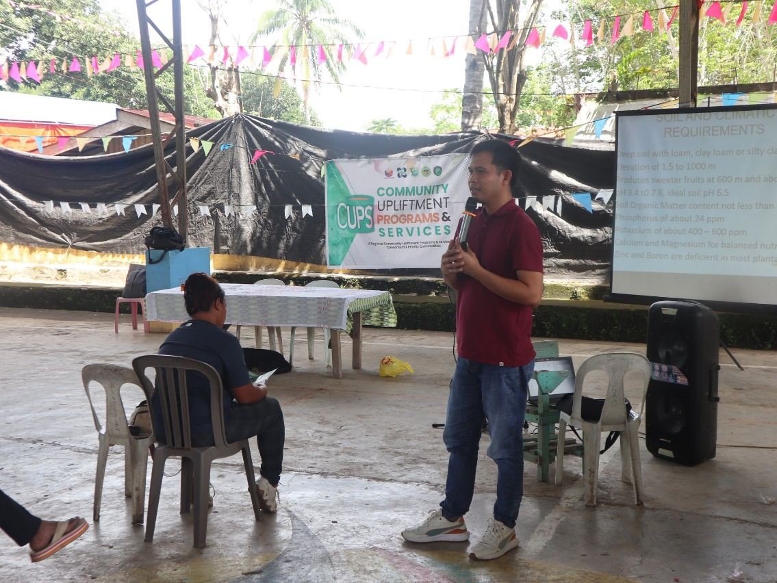

Question and Answer/Open Forum

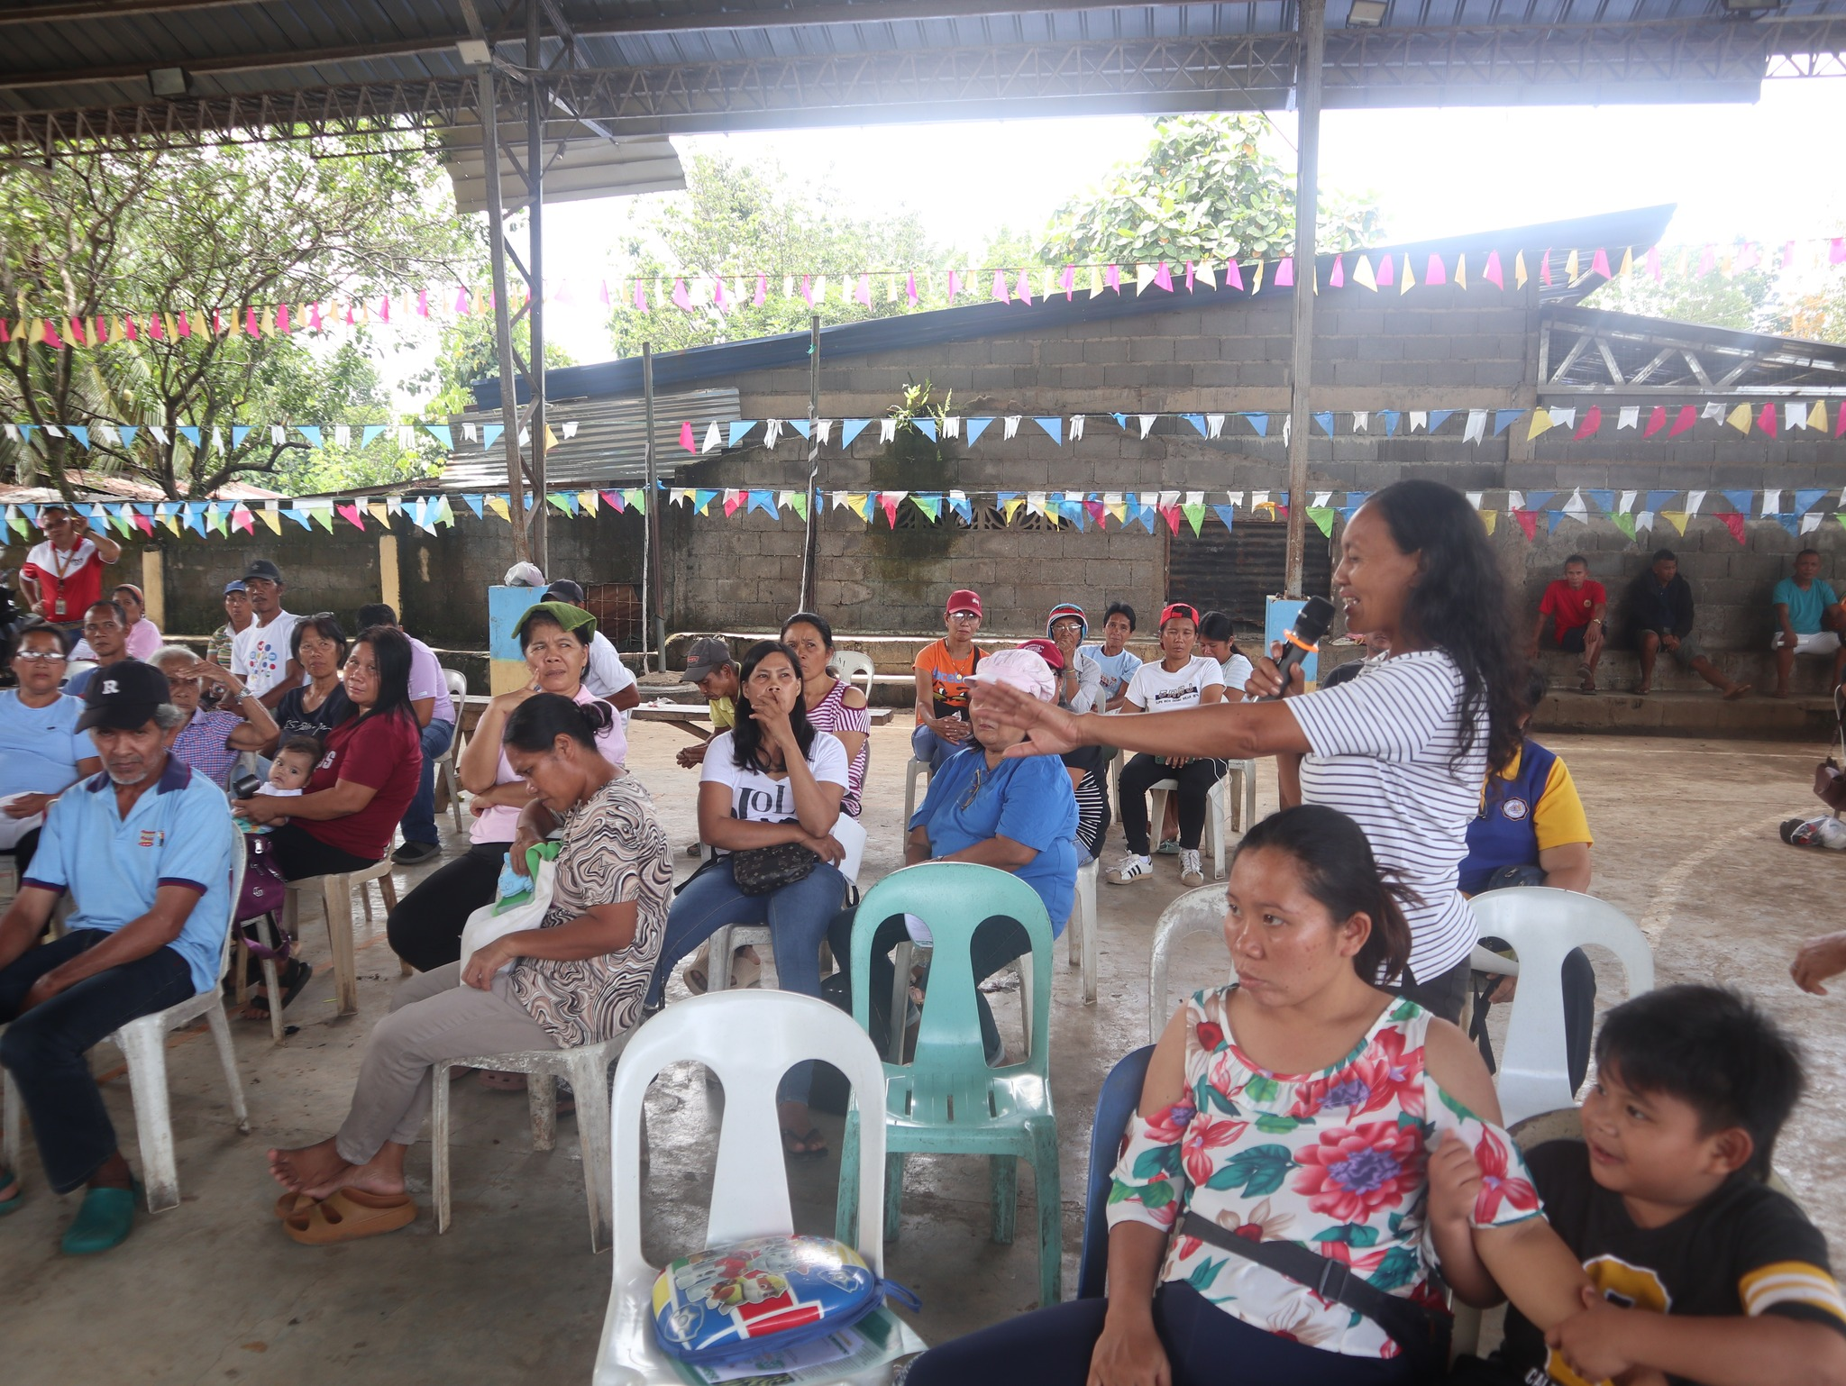

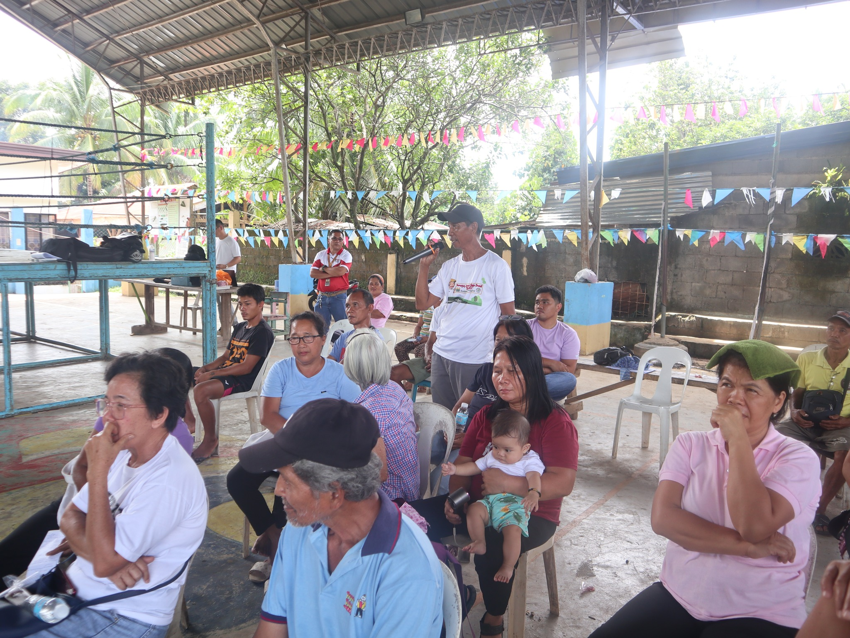

News of the Institution on CUPS

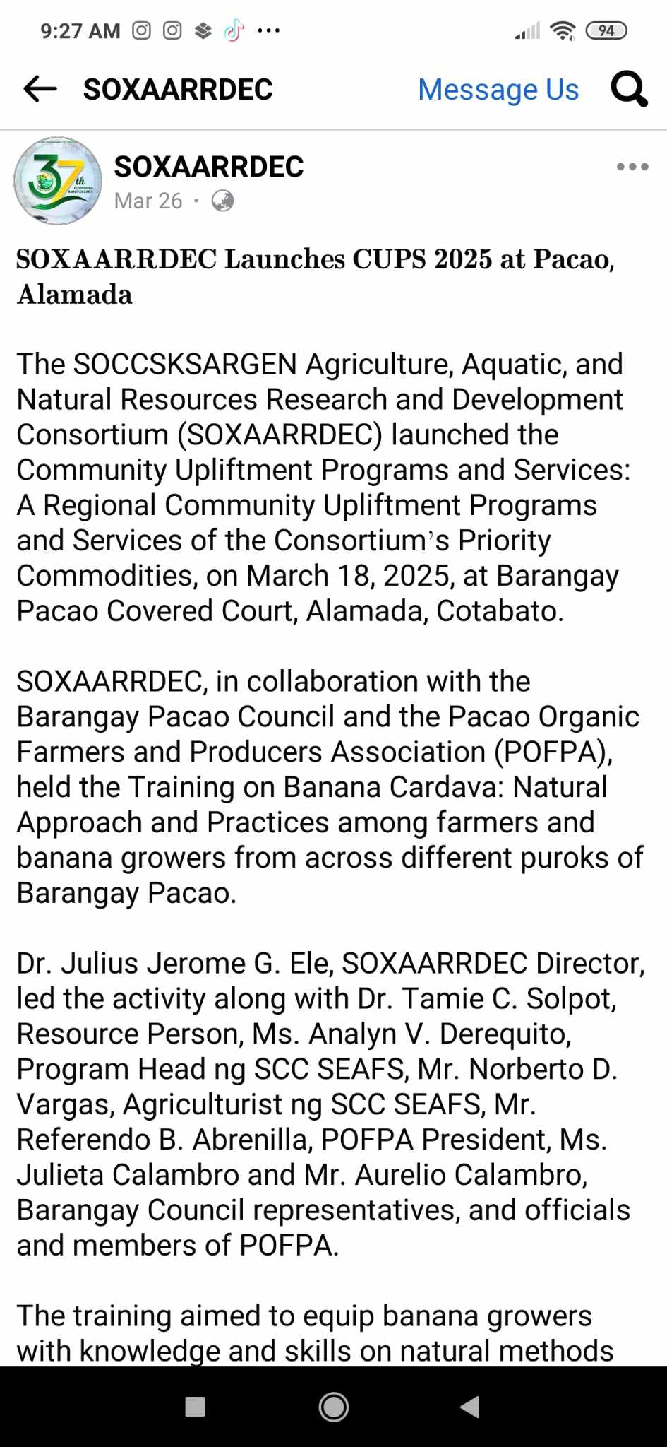

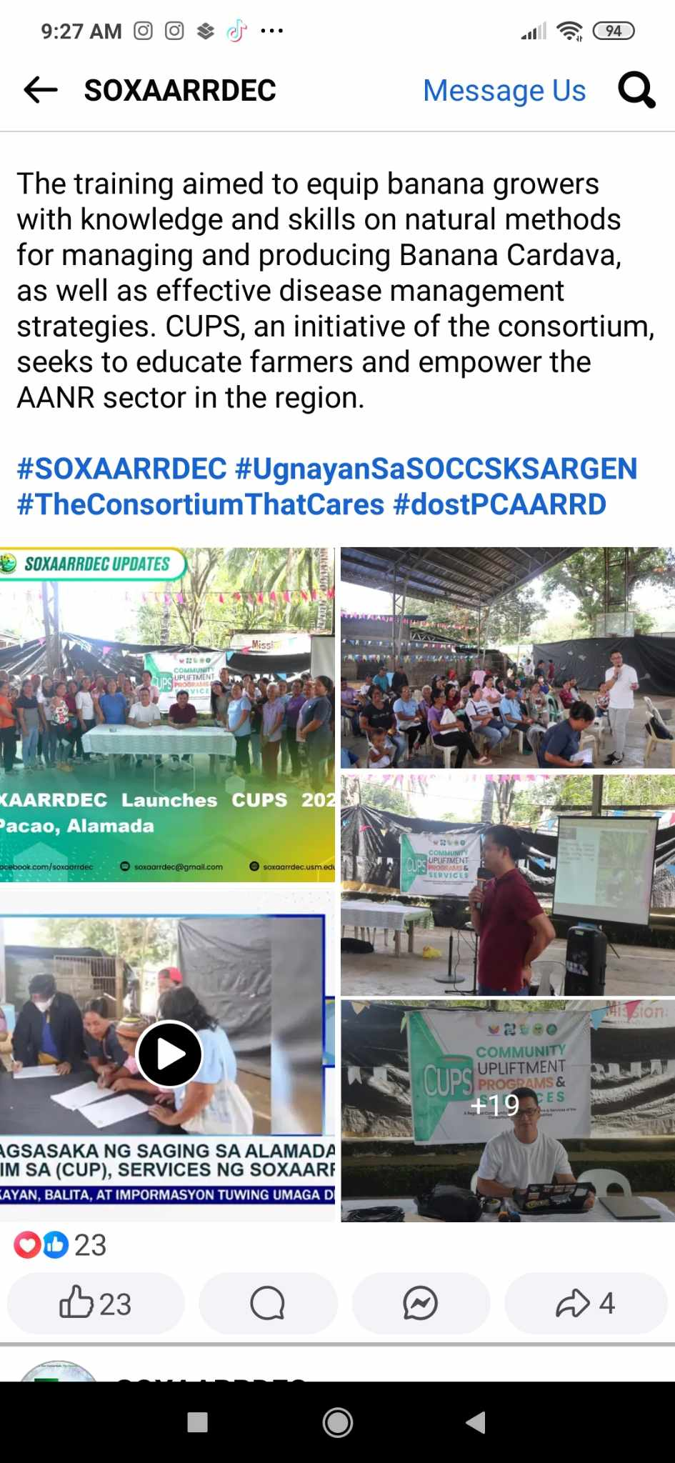

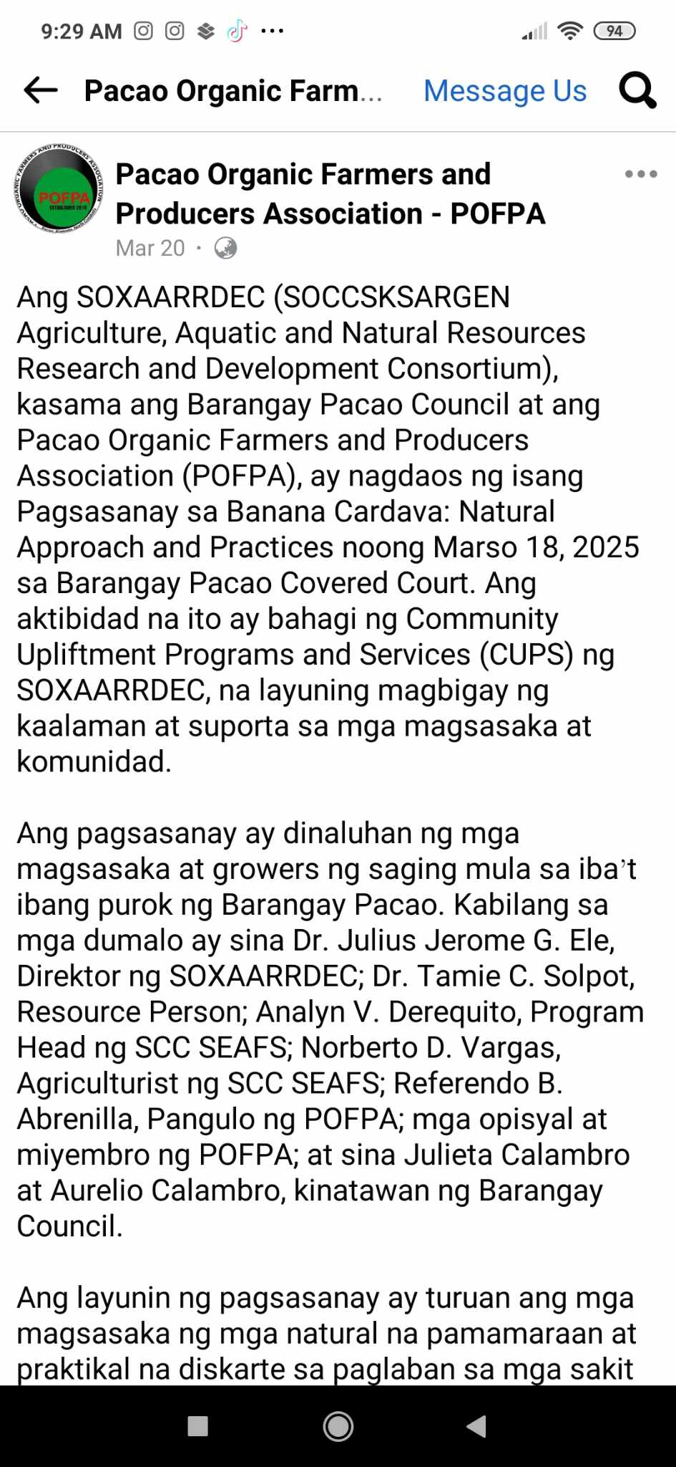
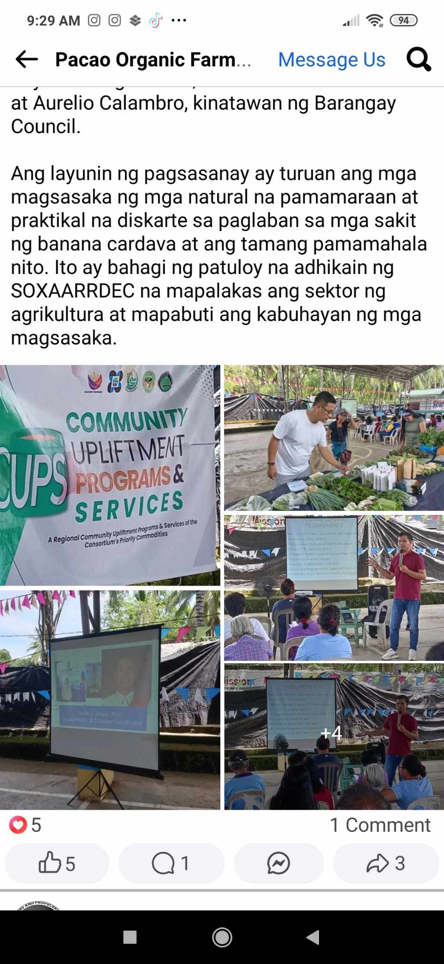

Shares- Facebook
