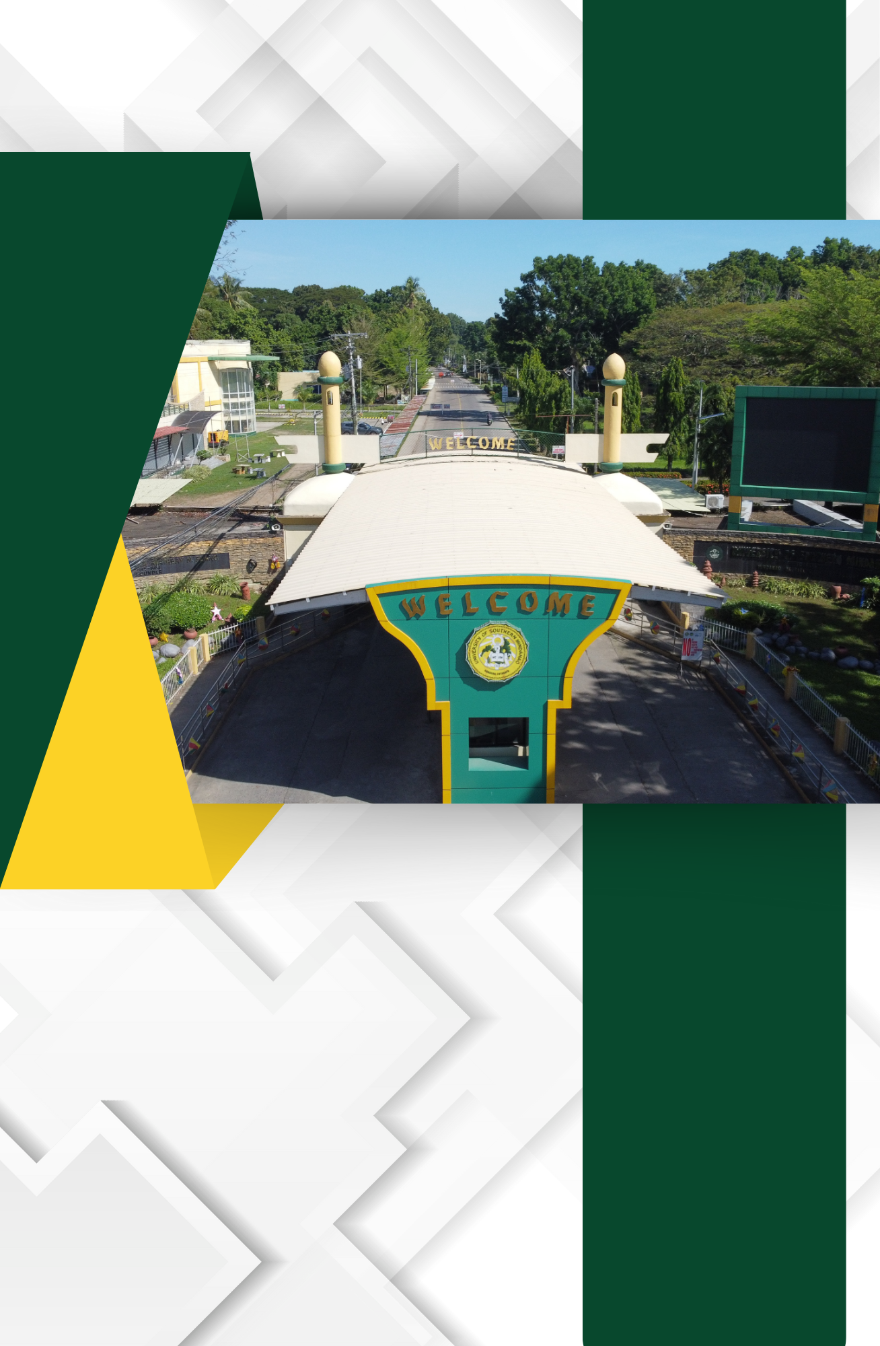

B.2.3. maintenance, repair and upkeep of property;
The University of Southern Mindanao (USM) Repair and Maintenance Program is managed by the Physical Plant Development Office (PPDO), a dedicated team responsible for ensuring the safety, usability, and longevity of all campus buildings and infrastructure. The program encompasses regular inspections, timely repairs, preventive maintenance, and upgrades to create a functional, safe, and aesthetically pleasing environment for students, faculty, staff, and visitors.
Key Responsibilities of the Physical Plant Development Office (PPDO)
- Routine Inspections and Assessments
- Inspections cover essential structural elements, electrical systems, plumbing, HVAC (heating, ventilation, and air conditioning) units, and fire safety systems to identify issues before they escalate.
- A detailed report is generated after each inspection to prioritize repairs, allocate resources, and set timelines for maintenance tasks.
- Preventive Maintenance Program
- The office implements a preventive maintenance schedule to keep facilities in optimal condition and extend the lifespan of campus infrastructure.
- Key systems, such as electrical and plumbing, are serviced periodically to minimize the risk of unexpected failures, reduce repair costs, and ensure uninterrupted campus operations.
- Emergency Repair Services
- The PPDO is equipped to handle urgent repair needs to ensure the immediate resolution of safety hazards or disruptions in facility operations.
- A response team is on standby for high-priority repairs such as structural damages, electrical malfunctions, water leaks, and broken fixtures, providing swift action to maintain a safe campus environment.
- Renovation and Modernization Initiatives
- To keep up with the changing needs of the university, the PPDO undertakes renovation projects aimed at modernizing old facilities, improving accessibility, and enhancing campus functionality.
- Upgrades include energy-efficient lighting, sustainable building materials, and ergonomic classroom and office designs that improve the user experience and support the university’s environmental goals.
- Health and Safety Compliance
- Safety features such as fire alarms, emergency exits, sprinklers, and signage are routinely checked and maintained to ensure compliance and readiness for emergencies.
- PPDO also oversees accessibility modifications, such as ramps, handrails, and elevators, to create an inclusive environment for individuals with disabilities.
- Facility Upkeep and Aesthetic Maintenance
- Beyond functional repairs, the PPDO is responsible for the overall appearance of campus facilities, including landscaping, painting, and general cleanliness.
- Aesthetic maintenance contributes to a welcoming and inspiring campus environment that aligns with the university’s standards of excellence.
- Communication and Coordination with University Departments
- The PPDO works closely with university departments, faculty, and student organizations to address specific facility needs and communicate ongoing repair schedules or temporary closures.
- A clear communication system is in place to ensure that maintenance activities are well-coordinated, minimizing disruptions to academic schedules and campus events.

Building Repair Management
