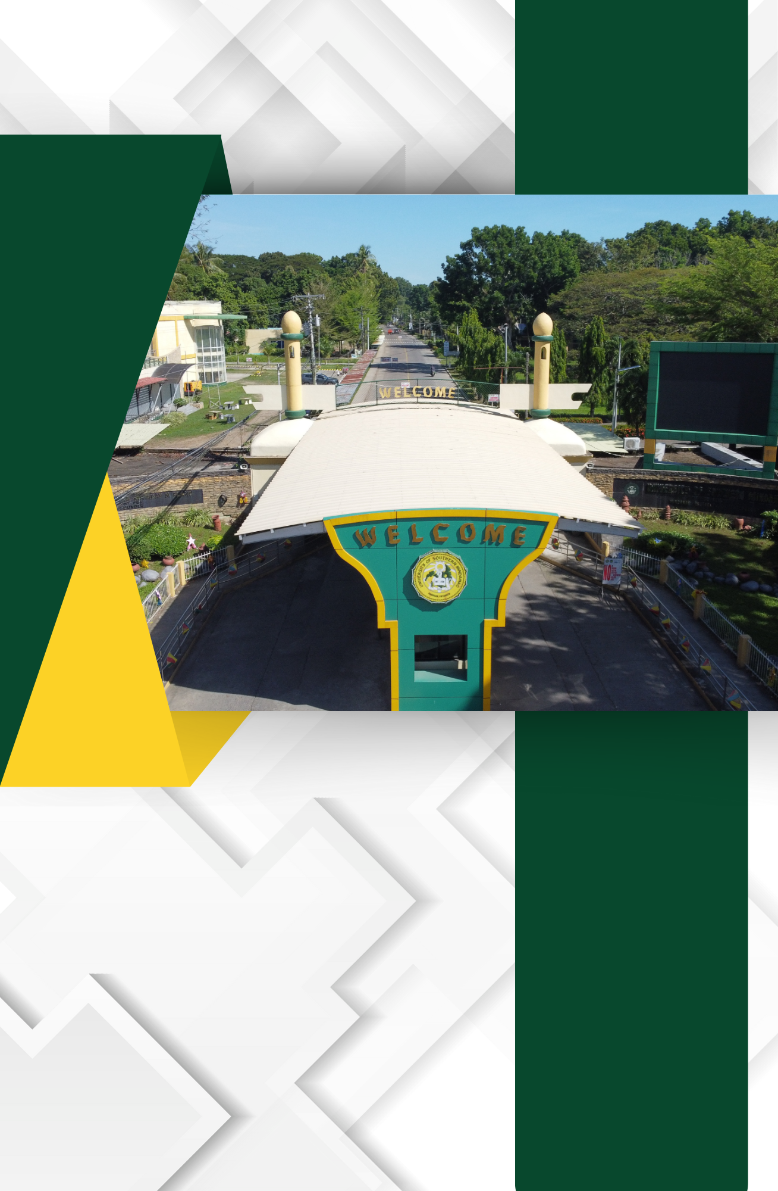

C.1. Approved Building Plan, showing the Location of the Different Buildings in the Campus

(P.D.) NO. 1096 ADOPTING A
NATIONAL BUILDING CODE OF THE PHILIPPINES (NBCP) THEREBY
REVISING REPUBLIC ACT NUMBERED SIXTY-FIVE HUNDRED FORTY-ONE
(R.A. No. 6541)

SECTION 103. Scope and Application
(a) The provisions of this Code shall apply to the design, location, siting, construction, alteration, repair, conversion, use, occupancy, maintenance, moving, demolition of, and addition to public and private buildings and structures, except traditional indigenous family dwellings as defined herein.
(b) Buildings and/or structures constructed before the approval of this Code shall not be affected thereby except when alterations, additions, conversions or repairs are to be made therein in which case, this Code shall apply only to portions to be altered, added, converted or repaired.

SECTION 104. General Building Requirements
(a) All buildings or structures as well as accessory facilities thereto shall conform in all respects to the principles of safe construction and must be suited to the purpose for which they are designed.
(b) Buildings or structures intended to be used for the manufacture and/or production of any kind of article or product shall observe adequate environmental safeguards.
(c) Buildings or structures and all parts thereof as well as all facilities found therein shall be maintained in safe, sanitary and good working condition.

SECTION 105. Site Requirements
The land or site upon which will be constructed any building or structure, or any ancillary or auxiliary facility thereto, shall be sanitary, hygienic or safe. In the case of sites or buildings intended for use as human habitation or abode, the same shall be at a safe distance, as determined by competent authorities, from streams or bodies of water and/or sources of air considered to be polluted; from a volcano or volcanic site and/or any other building considered to be a potential source of fire or explosion

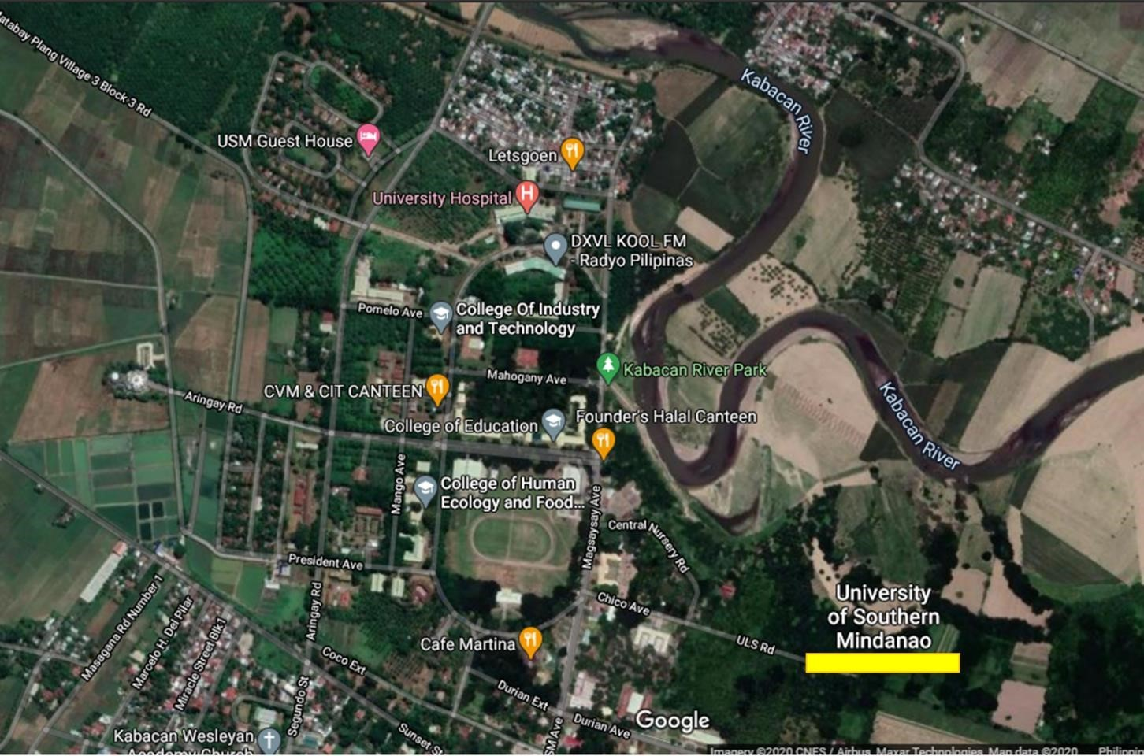

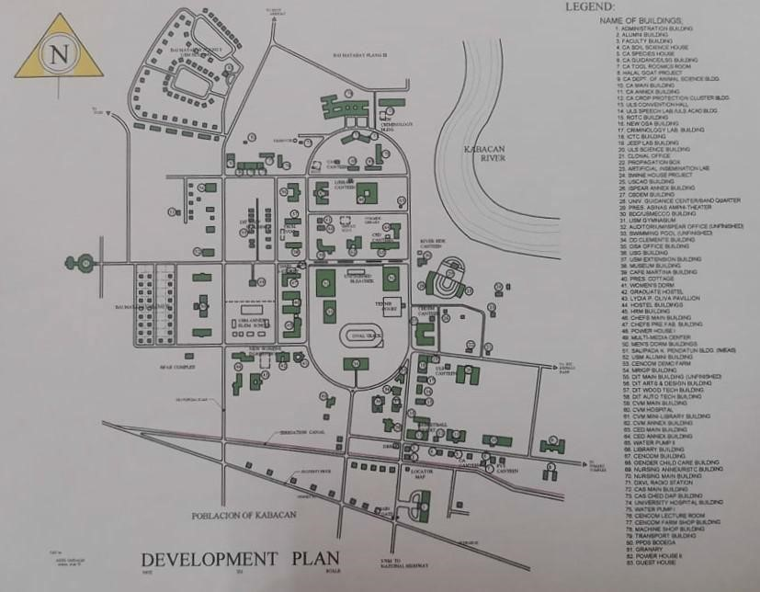

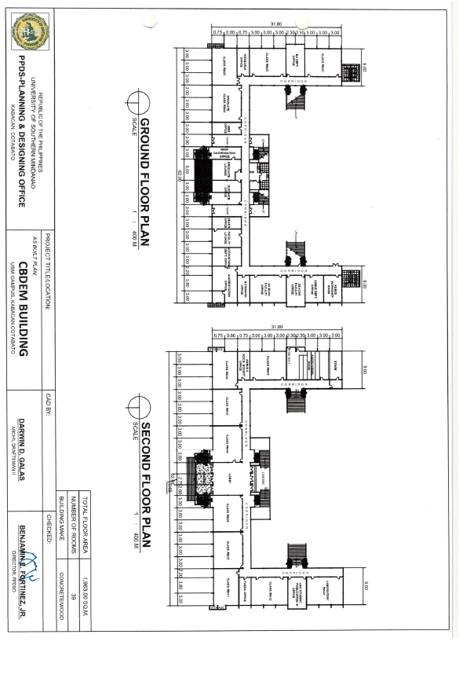
Building Plan of the College

