**A.3. Vicinity Map**

USM is situated in the Municipality of Kabacan, Cotabato Province, less than one kilometer from the National Highway. Kabacan lies near the geographical center of Mindanao and serves as a major crossroad, being accessible through the Cagayan de Oro–General Santos City (North–South) and Davao–Cotabato City (East–West) national highway routes. This central and accessible location enhances the University’s connectivity to various parts of the island, making it a viable institution for students, faculty, and stakeholders from diverse regions.

The attached vicinity maps provide a clear visual reference of the University's position within the region and its proximity to major transport networks, supporting its role as a key educational and research institution in Mindanao.

Campus Vicinity Map

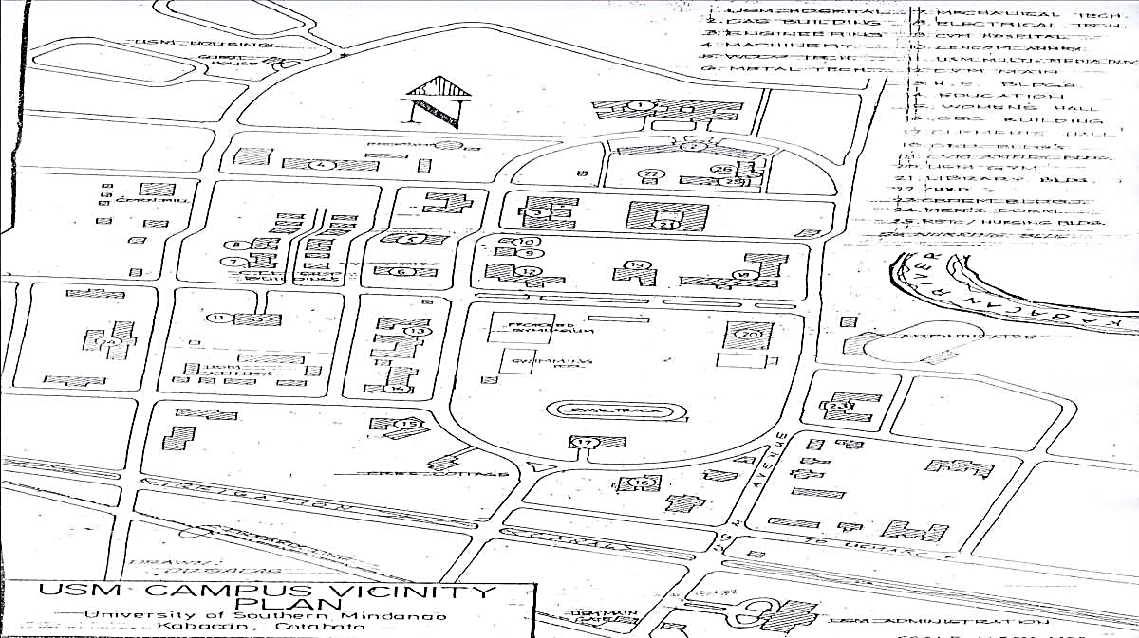

Campus Vicinity Plan

University Campus Map near the Entrance Point