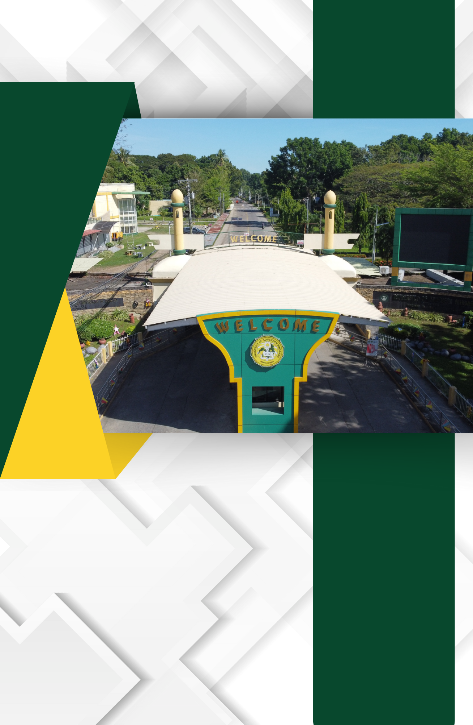

**A.2. Evidence of Land Ownership**

To substantiate the legal ownership and secure the tenure of its landholdings, the University of Southern Mindanao (USM) maintains essential legal documents, namely:

* Transfer Certificates of Title (TCT) – These documents serve as official proof that the land has been legally conveyed and is duly registered under the name of the University. The TCT affirms USM’s full ownership and vested rights over the property.
* Certificates of Occupancy – These certificates validate the University’s lawful possession and authorized utilization of its academic, administrative, and operational facilities situated within the land grant area.

Collectively, these legal instruments constitute conclusive evidence of the University’s ownership and institutional stability. They ensure that USM is fully empowered to pursue its core mandates of instruction, research, extension, and production, in accordance with its charter and development goals.

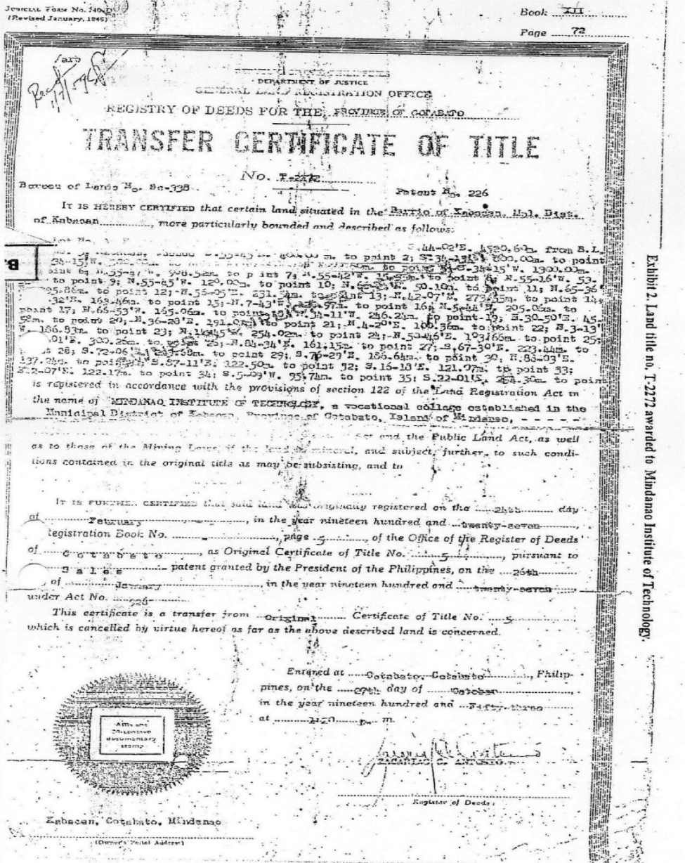

Transfer Certificate of Title of the University

Certificate of Final Inspection and Certificate of Occupancy

