**H.1. Floor Plan of the Student Center Showing the Location of Different Offices**

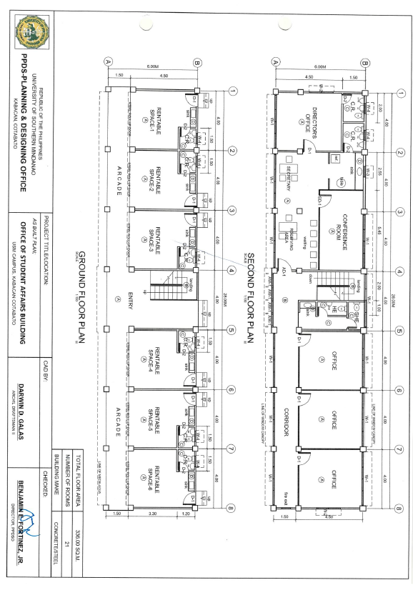

Floor Plan of the Office of Student Affairs

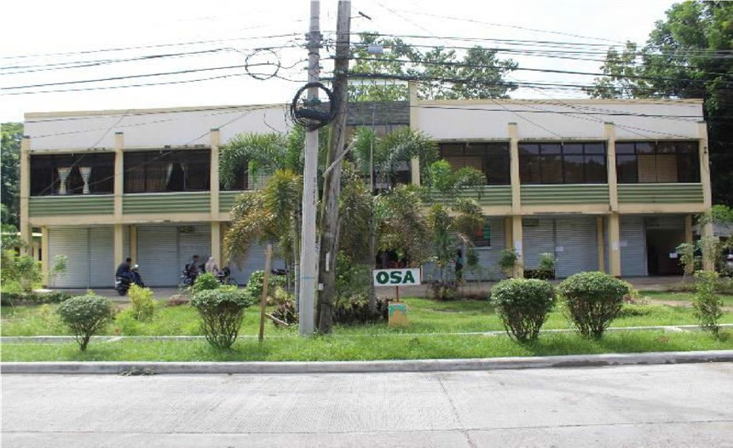

Floor Plan of the Office of the University Student Government

