

B.1. A Copy of the Campus Development Plan

The Campus Development Plan of the University of Southern Mindanao (USM) provides a detailed illustration of the University’s land area, indicating the location and distribution of key facilities, buildings, and structures within its 1,024-hectare land.

The map highlights its academic zone, centrally situated within the land area, where academic buildings, administrative offices, dormitories, sports facilities, and other institutional infrastructure are located. This spatial representation supports the University's efforts in campus planning, land use management, and infrastructure development.

This also serves as a reference for current and future physical developments aligned with the University’s strategic goals of providing a safe, organized, and conducive environment for instruction, research, extension, and production functions.

Development Plan

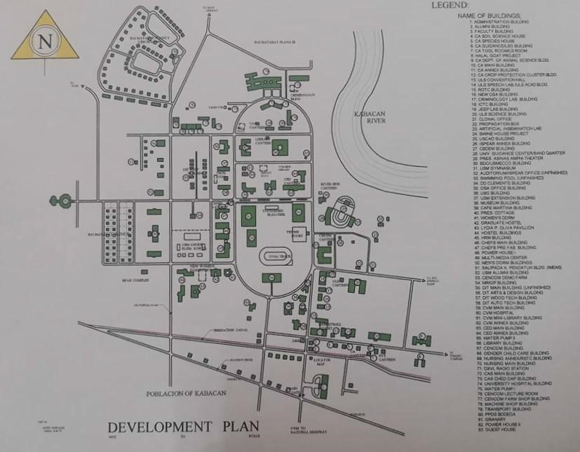

Campus Zoning Map

