**B.2. Description of a mechanism to ensure the following:**

**B.2.1. traffic safety in and out of the campus;**

The University of Southern Mindanao (USM) has established mechanisms to ensure traffic safety within and around the campus premises, recognizing the importance of a secure and orderly environment for students, employees, and visitors.

Key measures implemented include the following:

* Designated Entry and Exit Points – The campus has clearly marked entry and exit gates managed by uniformed security personnel. These gates help control vehicle flow and prevent congestion, especially during peak hours, with gate pass used for tracking
* Gate Pass System – All vehicles entering the campus are required to present a valid gate pass, issued by the Security Services and Management Office. This system ensures proper documentation and regulation of vehicles accessing university property, enhancing overall safety and accountability.
* Campus Security Vehicles – The University maintains security patrol vehicles used to monitor campus roads and enforce traffic rules. These vehicles allow for timely response to any incidents and regular patrolling of the entire campus to ensure orderliness and immediate intervention when needed.
* Campus Security Personnel Deployment – Trained security staff are strategically assigned to key road junctions within and near the campus to monitor vehicular movement, assist in traffic direction, and ensure compliance with traffic regulations.
* Installation of CCTV and Traffic Signages – CCTV and Traffic signs, including speed limits, pedestrian crossings, directional signs, and no-parking zones, are installed at critical points within the university grounds to guide drivers and pedestrians alike.
* Pedestrian Safety Measures – Designated walkways and crossing lanes are in place to protect students and personnel moving between buildings and facilities.
* Coordination with LGU and PNP – The University maintains close coordination with the Local Government Unit (LGU) and the Philippine National Police (PNP) to ensure traffic order and respond to external traffic concerns affecting the immediate vicinity of the campus.

Designated Entry Point

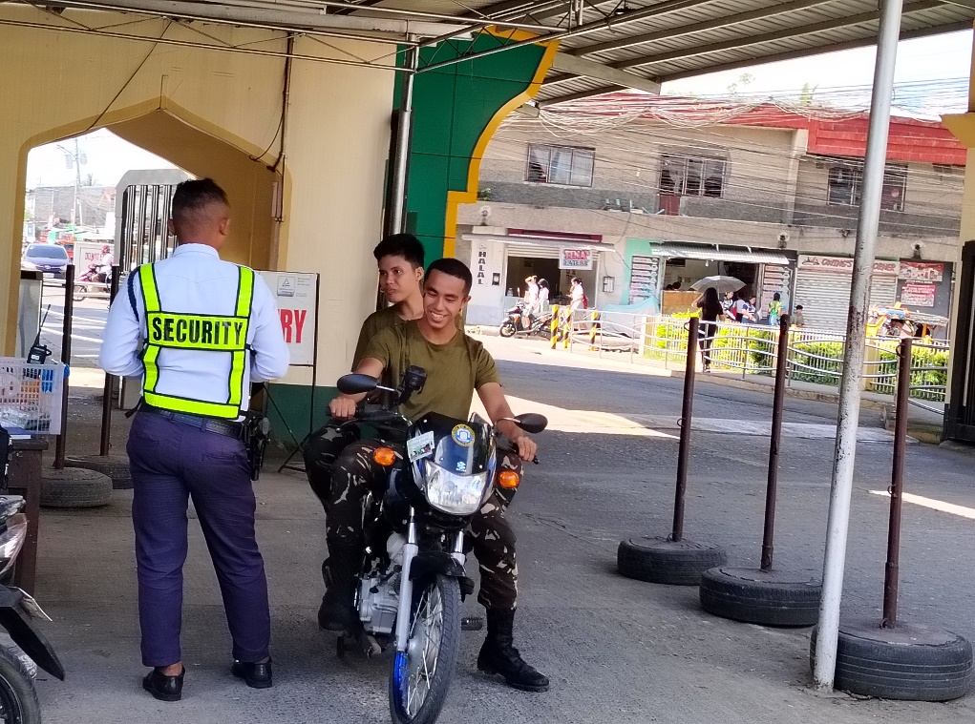

Campus Security Personnel

Gate Pass System

Security Vehicles

CCTV, Speed Humps and Pedestrian Lanes

Speed Limit

Designated Exit Point

Traffic Signages