ABSTRACT

Capacity Building on Fish Processing Food Safety at Ligawasan Marsh Community
Mary Joy S. Cañolas, Carlo Q. Reston, and Pia Amabelle M. Flores

Pikit is one of the municipalities in Cotabato that shared the abundance of flora and fauna of Ligawasan Marsh. A variety of inland fish is caught by the tons every day with which mudfish (Channa striata) being the most abundant. Hot smoking of mudfish is one of the prominent enterprises along the national highway of Pikit, Cotabato. Thus, this component project aimed to (1) increase the capacity of the fish processor-entrepreneurs on fish processing food safety, (2) increase awareness of the techniques of fish smoking using wood chips, and (3) develop IEC print materials as a ready reference. Social preparation includes coordination and inception meetings, translation, and conduct of Training Needs Assessment (TNA) and validation, organizing, and profiling of the target beneficiaries. Training methodology includes lecture-discussion, techno-demo, and participatory sensory evaluation of smoked mudfish using hot and cold smoking techniques using different combusting materials. Distribution of certificates of completion and TeknoGiya leaflets were the highlights of the Closing Program. TNA results revealed that they had little/no knowledge of the brining and drying process in fish smoking, and packaging. Post-test results increased while Excellent results were obtained for the resource persons and overall training activity evaluations. Significant differences (P<0.05) were observed in terms of firmness, taste, and general acceptability of smoked mudfish in favor of the cold smoking technique using wood chips. Majority of the beneficiaries were willing to buy cold smoked mudfish if available in the market.

Keywords: Cold smoking, capacity-building, food security, futures thinking, mudfish

CAPACITY BUILDING ON FISH PROCESSING FOOD SAFETY AT LIGAWASAN MARSH COMMUNITY

MARY JOY S. CAÑOLAS
Study Leader

Funded by:

FUTURES THINKING PROJECT

TERMINAL REPORT

UNIVERSITY OF SOUTHERN MINDANAO
Kabacan, Cotabato



November 2022



UNIVERSITY OF SOUTHERN MINDANAO
Kabacan, Philippines
- BASIC INFORMATION
- Title | Capacity Building on Fish Processing Food Safety at Ligawasan Marsh Community
- Status | ☐ Ongoing ☒ Completed
- Study Leader  (Indicate College/Unit ) | Mary Joy S. Cañolas  College of Agriculture
Email Address | mscanolas@usm.edu.ph
Contact Number | 09296972985
- Lead Unit/College | College of Agriculture
Collaborating Unit/College | Department of Fisheries and Animal Science
- Category | ☐ Program ☐ Project ☒ Component
- Classification | ☐ Research | ☐ Development ☒ Extension
 | ☐ Basic  ☐ Applied | ☐ Pilot Testing  ☐ Prototype Development  ☒ Tech. Promotion/Commercialization
- Thematic Area | ☒ Quality Learning, Skills Development, and Literacy  ☐ Social Development, and Strong Institutions  ☐ Preservation of Culture  ☐ Environmental Protection, Conservation, and Risk Reduction  ☒ Food Security and Poverty Reduction  ☒ Good Health and Well-being  ☐ Innovations in Science, Engineering, and Technology  ☐ Sustainable Entrepreneurship and Management
- Project Duration | January to June 2022
- Project Location | Pikit, Cotabato
- Total Budget Requested (Php) | Php 84,000.00
NARRATIVE REPORT

- TECHNICAL DESCRIPTION
- Rationale / Significance
When the 17 Sustainable Development Goals (SDGs) came into force in 2016 during the historic United Nations Summit, all countries are expected to mobilize efforts to end all forms of poverty, fight inequalities, and tackle climate change, while ensuring that no one is left behind [1]. Although the SDGs are not legally binding, governments are expected to take ownership and establish national frameworks for the achievement of the 17 Goals.

The University of Southern Mindanao (USM) was tapped by the Office of Senator Pia Cayetano, Chair, Committee on Sustainable Development Goals, Innovation, and Futures Thinking to develop alternative futures for the Philippine Food Systems in support to the government efforts to attain the 17 Sustainable Development Goals (SDGs) of the United Nations. With the Philippine Futures Thinking Society (PhilFutures) as resource persons, a series of workshops were conducted including a Master Class to equip USM Futurists to create alternative futures for cereals, high-value crops, halal, and protein sources [2].

The Ligawasan Marsh as source of protein was considered by the protein sources (Protein for Peace Group) as the focal point. It is the biggest swampland in Mindanao supporting 112,000 Maguindanaon families whose primary means of livelihood are fishing when water levels are high and agriculture when they are low [3]. The marsh is home to 92 species of birds, dozens of fish species, six species of reptiles, and five species of amphibians, with its very rich wildlife, the marsh has considerable potential for nature tourism [4] which could give alternative source of income for the inhabitants; however, the area is a stronghold of insurgents, and access is restricted. That is why through futures thinking (back casting) the Group envisions of a developed Ligawasan Marsh where the residents have abundance of food and livelihood opportunities so there could be peace.

The Project developed by the Protein for Peace Group was titled “USM LIFER Project: USM & Ligawasan Marsh Innovative Fish and Meat-based Enhanced Ready-to-Eat (RTE) Products”. It considered the utility of inland fish and meat based Ready-To-Eat (RTE) food technologies to address food security and sustainability in the area while maintaining the supply of inland fish. It has seven components: 1) Stock Assessment of Inland Fish Catch in Ligawasan Marsh, North Cotabato; 2) Assessment of Socio-political Structure in Ligawasan Marsh for Fish Catch Policy Development; 3) Enhanced Packaging and Shelf- Life Evaluation of Inland Fish- based Ready-to-Eat (RTE) Smoked Fish and Fish Cracker Products; 4) Development of Pre-processing Treatment for Inland Fish Raw Material for RTE Products; 5) Assessment of Quality Assurance of Inland Fish- based RTE Products; 6) Capacity- building on Fish Processing Food Safety at Ligawasan Marsh Community; and 7) Development and Sensory Evaluation of Ready-to-Eat (RTE) Sausage, Luncheon Meat, Bacon, and Corned Pork Meat Products.

This report is focused on the Component 6 of the Project: Capacity-building on Fish Processing Food Safety at Ligawasan Marsh Community.

The service area of Component 6 is the Municipality of Pikit, Cotabato. It is one of the municipalities under the Cotabato Province that surround the Ligawasan Marsh alongside M’lang, Tulunan, and Kabacan [5]. A variety of inland fish is caught by the tons every day with which mudfish (Channa striata) being the most abundant. These catches are processed into different fish products and one of those is smoked fish. Hot smoking of mudfish is one of the prominent enterprises along the national highway of Pikit, Cotabato.

The current practice of smoking mudfish is hot smoking using coconut husk and corn cobs as combusting materials. When one want to buy, the product is packed using banana leaves and should be consumed within the day. Others would further cook them by frying or stewing using coconut milk as thickening agent.

With the current practice of selling smoked fish in the locality, there is a need to assess their fish processing methods to reduce the risks of foodborne diseases to a safe level, thus ensuring safety of food from production to consumption.

The general objective of this Project Component was to empower the fish processor-entrepreneurs of Pikit, Cotabato through capacity building on fish processing food safety. Specifically,
(1) to increase capacity of fish processor-entrepreneurs on fish processing food safety,
(2) to increase awareness of fish processor-entrepreneurs on the techniques of fish smoking using wood chips, and
(3) to develop IEC print materials on fish processing food safety and fish smoking techniques using different wood chips.

- Methodology
Pre-implementation (Social Preparation)
Coordination meeting. The coordination meeting was done at the Office of the Pikit Municipal Agriculturist, Pikit, Cotabato. The MAO, Mr. Suleik Gaphor was informed about the Futures Thinking Project of USM in Ligawasan marsh community and the objectives of capacitating some individuals who are directly involve in processing of fish caught from Ligawasan marsh. He was supportive of the project and committed to provide 25 fish processors as beneficiaries.
Preparation of the Training Needs Assessment (TNA). A 20-item TNA was prepared according to the basic procedure of fish processing and smoking. The TNA was translated into Filipino to promote better understanding of the questions by the respondents. It was composed of eight basic steps: preparation, receiving, washing, evisceration, brining, drying, smoking, and packaging.
Inception meeting and organizing. During the inception meeting, 22 participants were present at the FITS Center of the Municipal Agriculturist Office. They were representatives of the selected barangays of Pikit, Cotabato. The rationale, objectives, expected outputs, duration, and methodology of the Project Component 6 were presented to them (Fig. 1).

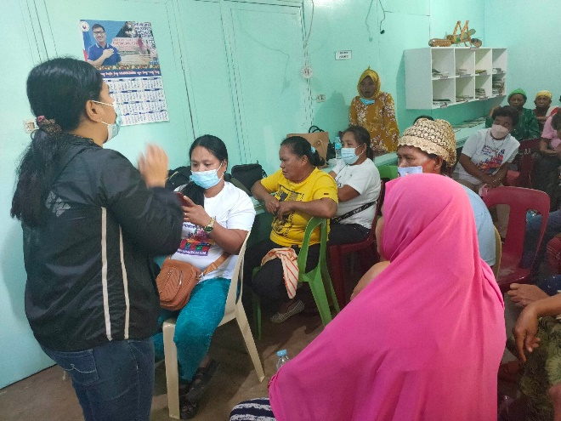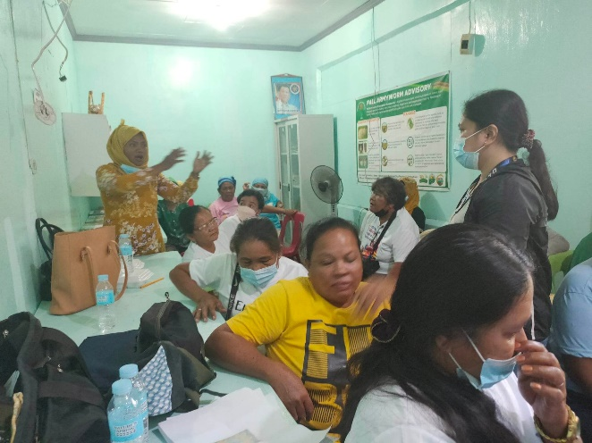
Figure 1. The participant is clarifying something from the project team during the inception meeting conducted at the FITS Center of the Office of the Municipal Agriculturists, Pikit, Cotabato.

After the inception meeting, the beneficiaries were given a time to loosen and know each other more. It was evident that they knew each other very well. Afterwards, they were organized through election of officers. Simple house rules were proposed and agreed during the meeting. Cellphone numbers were gathered to facilitate easy communication and coordination among them in preparation for the conduct of the training.
Conduct of TNA on fish processing food safety and fish smoking. A 3-page survey questionnaire on fish processing food safety and fish smoking was conducted through survey questionnaire in Filipino and was further explained to them in Maguindanaon through the help of Development Management (DM) Interns (Fig. 2).

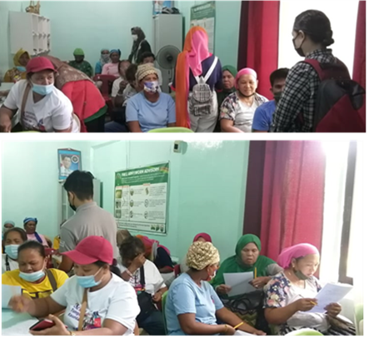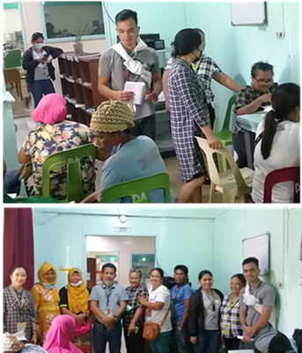
Figure 2. The beneficiaries answering the survey questionnaires while the members of the Project Team are assisting them.

Validation of the results of the TNA. After the data were gathered and analyzed, the results were validated to them. Further questions were asked to clarify some items, made some adjustments, and justifications, then tasking was done about the training (Fig. 3). A training design was made with the following objectives: 1) to increase the capacity of fish processor-beneficiaries on fish processing food safety; 2) to increase awareness on the techniques of fish smoking using different wood chips; and to conduct technology demonstration on fish smoking techniques using different wood chips as combusting materials.
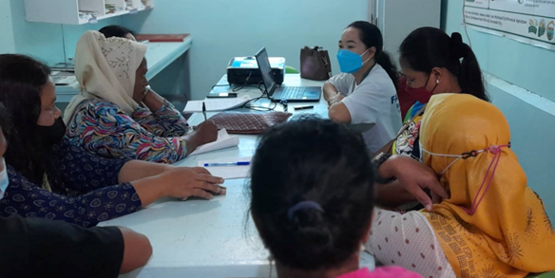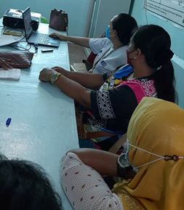
Figure 3. The Component leader, Dr. Mary Joy S. Canolas, together with the beneficiaries during the validation of TNA result at the FITS Center, OMAg, Pikit, Cotabato.

Profiling of beneficiaries. Some personal information like name, age, address, etc. and a photograph were taken from the beneficiaries and recorded for future reference. Below are some of the Profiles compiled (Fig. 4).

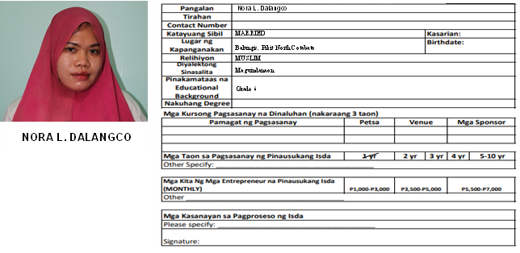
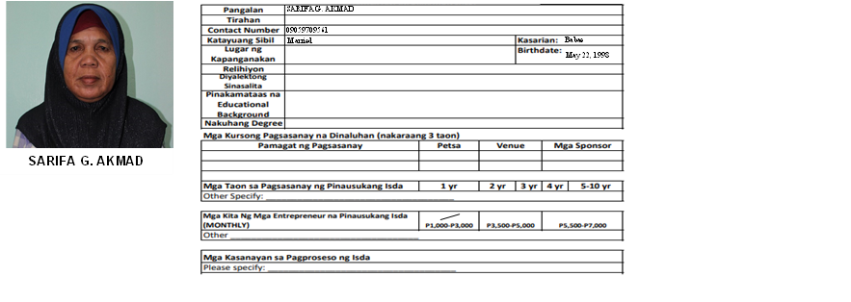
Figure 4. Profile pictures and some details of the Component 6 beneficiaries in Pikit, Cotabato.

Implementation (Community Development)
Technical training on fish processing food safety and techniques of fish smoking using different wood chips. A one-day training was conducted at the FITS Center of the Municipal Agriculturist Office of Pikit, Cotabato. It was attended by 15 beneficiaries. Some were not able to attend because they went to the distribution activities done by some politicians. The Resource Persons were Ms. Pia Amabelle M. Flores, Faculty of the Department of Fisheries, and Prof. Vic Laurence P. Oliva, Faculty of the Department of Animal Science, College of Agriculture, USM, Kabacan, Cotabato. Ms. Pia Amabelle M. Flores used lecture-discussion method (Fig. 5), while Prof. Vic Laurence P. Oliva, used lecture and demonstration method. He brought with him examples of wood chips like apple, citrus, mango, guava, and oak used for smoking meat and fish. He also brought some equipment like cold smoke generator smoker coil type and tube type. He demonstrated how smoke can be continuously generated using smoker tube type (Fig. 6).

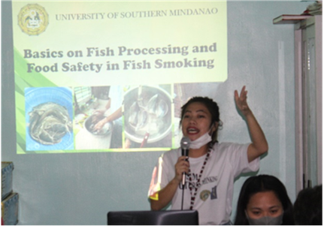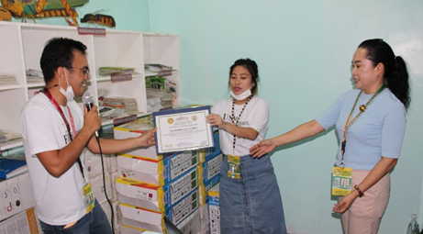
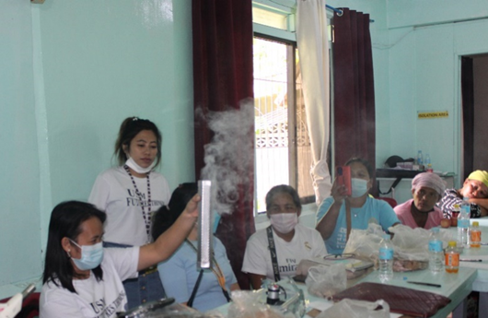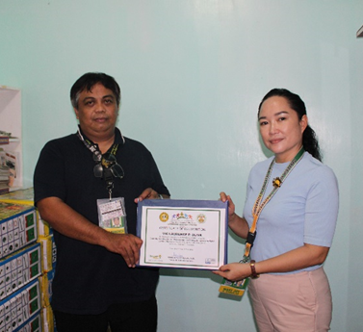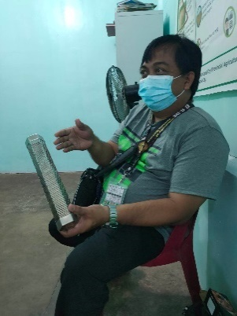
Figure 5. Ms. Pia Amabelle M. Flores (above) is delivering her lecture on the basics on fish processing and food safety in fish smoking. Prof. Vic Laurence P. Oliva (below) showing the tube type smoke generator.

Pre-test and post-test were administered before and after the training. The resource speakers were evaluated as well as well as the overall training activity.
Another activity on that day was the sensory evaluation of smoked catfish developed by Component 2 of this Project. The beneficiaries served as panel of evaluators. They were given samples of smoked catfish and scoresheets; they were given instructions on how to rate the products (Fig. 6).

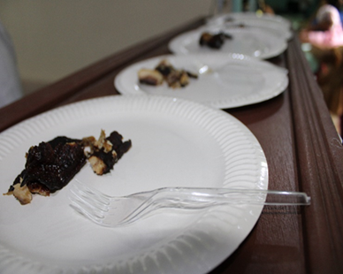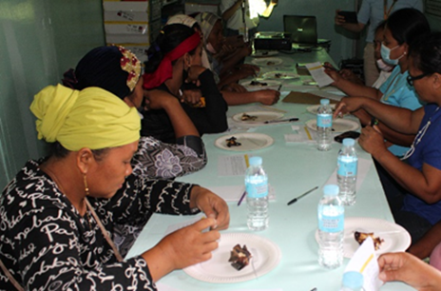
Figure 6. The beneficiaries rating the smoked catfish at the FITS Center, OMAg, Pikit. Cot.

Technology demonstration on cold smoking of mudfish using apple and guava wood chips. The techno-demo activity was designed that hot and cold smoking techniques will be done side by side. Since the beneficiaries were already practicing hot smoking, this technique was assigned to them using their usual combusting materials – coconut husks and corn cobs. Cold smoking was demonstrated by Prof. Vic Laurence P. Oliva using citrus and guava wood chips.
The techno-demo was done in one of the cottages of the Municipal Plaza of Pikit, Cotabato. Twenty heads of mudfish from Ligawasan marsh were purchased and divided into two. Ten pieces were used for hot smoking using coconut husks and corn cobs, while 10 heads were used for cold smoking using citrus and guava wood chips.
In hot smoking, the mudfish were gutted and cleaned properly but the scales were not removed, slits were made on both sides for easy skewering on a bamboo stick. The skewered mudfish were placed in a griller with covered sides around 10 inches (for corn cobs. The covered sides served as barrier for the wind so that the smoke will go up. A continuous extinction of flame was done by directly sprinkling a small amount of water. For the coconut husks, they used a common griller (Fig. 7).

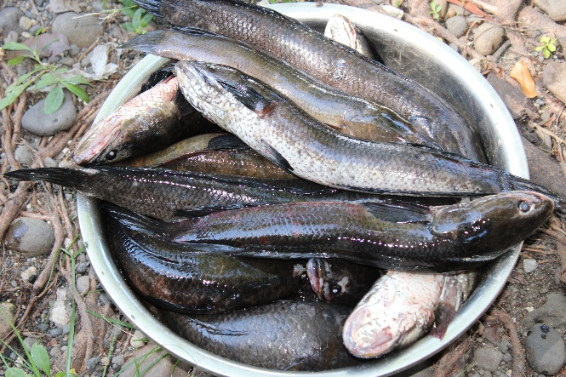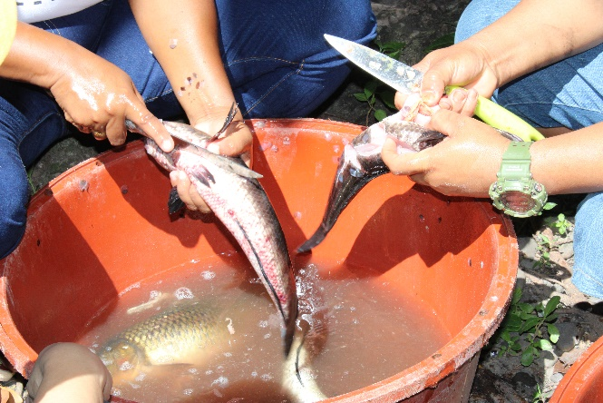
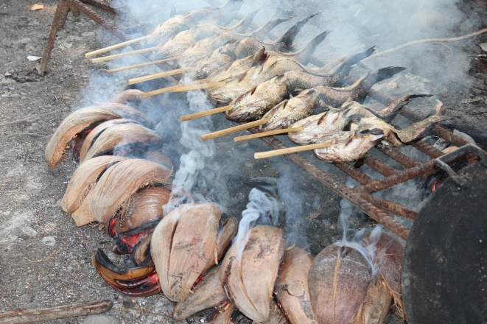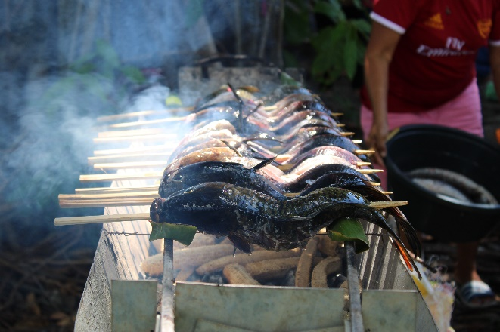
Figure 7. Hot smoking of mudfish using coconut husks and corn cobs in Pikit, Cotabato.

In cold smoking, the mudfish were gutted, cleaned properly, and with the scales removed. They were soaked in brine solution and patted dry using a paper towel. The mudfish were placed in the smoke house for about an hour (Fig. 8).
After smoking, the smoked mudfish were cooked by frying (“pinirito”) and stewing “ginataan”.

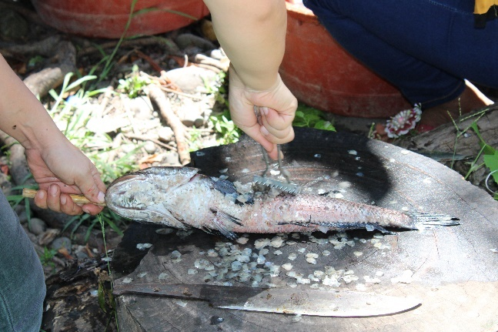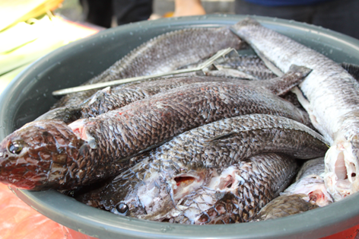
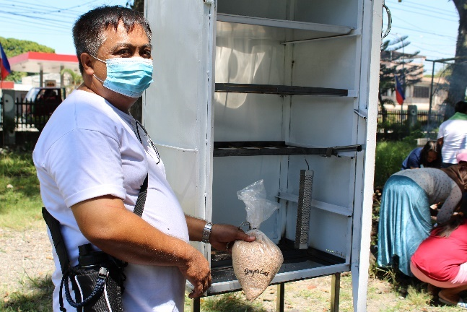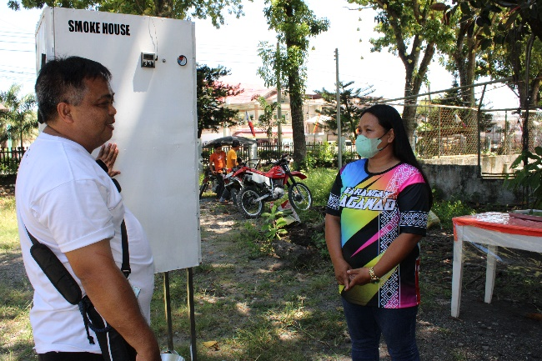
Figure 8. Prof. Vic Laurence P. Oliva preparing the smoke house for cold smoking using guava wood chips.

Participatory sensory evaluation of “pinirito” and “ginataang” smoked mudfish. The “pinirito” and “ginataang” smoked mudfish were evaluated by both the beneficiaries and facilitators (Fig. 9). They were given a scoresheet in Filipino and showed them the proper way of rating the food preparations. A four-point rating scale were used on the following parameters:
1. Hitsura (appearance)
2. Amoy (odor, aroma)
3. Pagkabuo ng isda (firmness) in “Ginataan”
4. Pagkatuyo ng isda (dryness) in “Prito”
5. Lasang pina usokan (smoky flavor)
6. Lasa (flavor)
7. Pagtanggap sa produkto (acceptability of the product)
8. Kung may magbebenta ba nito sa palengke ano ang bibilhin mo? (willingness to buy)
After the data were gathered, it was analyzed using Kruskal-Wallis non-parametric Analysis of Variance.
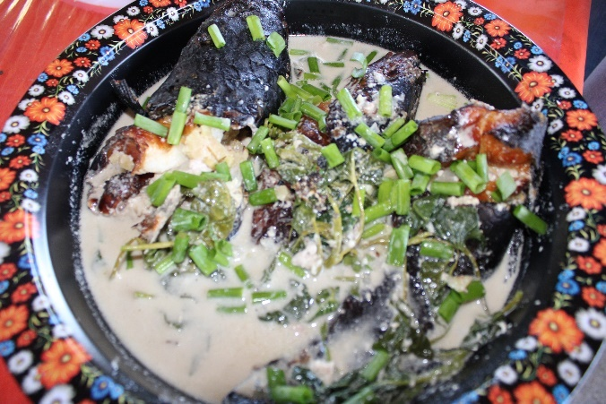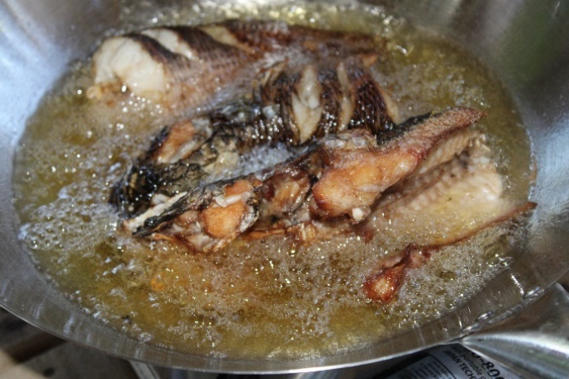
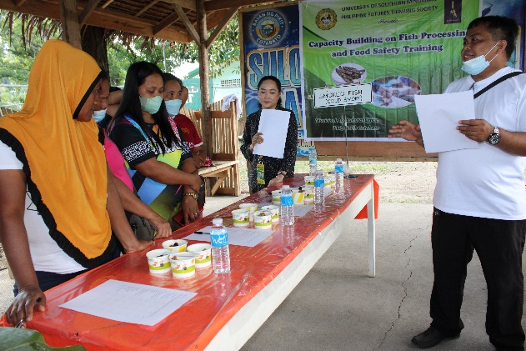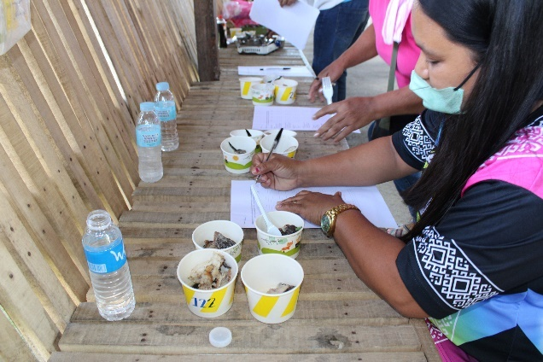
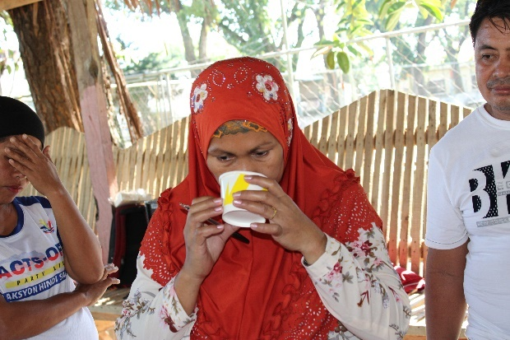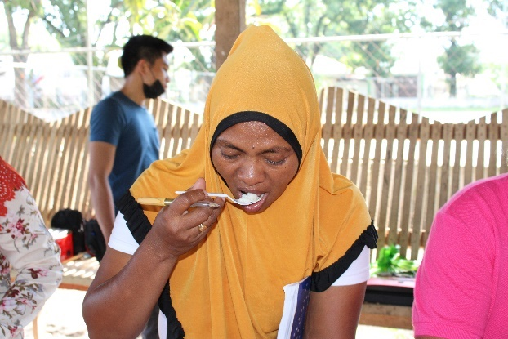
Figure 9. The beneficiaries were sensory evaluation of hot and cold smoked mudfish using different combusting materials.

IEC print materials development. Two IEC print materials were developed for this project titled “Mga Batayan sa Fish Smoking at Kaligtasan ng Pagkain” with Ms. Pia Amabelle M. Flores as the author/expert and “Paggamit ng iba’t ibang Wood Chips na Pampausok at Pampalasa ng Isda” with Prof. Vic Laurence P. Oliva as the author/expert. The IEC print materials were developed with close supervisions of the experts and the IEC In-charge of the Extension Services Office (ESO) of USM. Validation of the contents with the beneficiaries was done during the course of the project implementation, and the final copies were distributed during the Closing Program.

Post-implementation (Community Management)
The Closing Program served as the culminating event for the project. A short program was done. The beneficiaries were given a chance to speak about their learning experience. The highlights were the distribution of Certificate of Completion and TeknoGiya leaflets (Fig. 10).
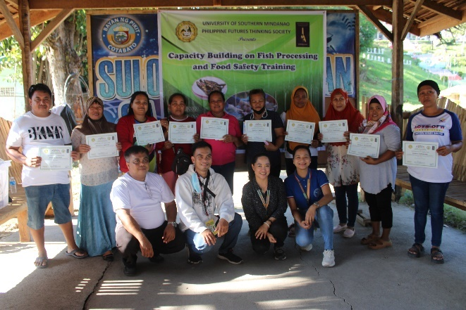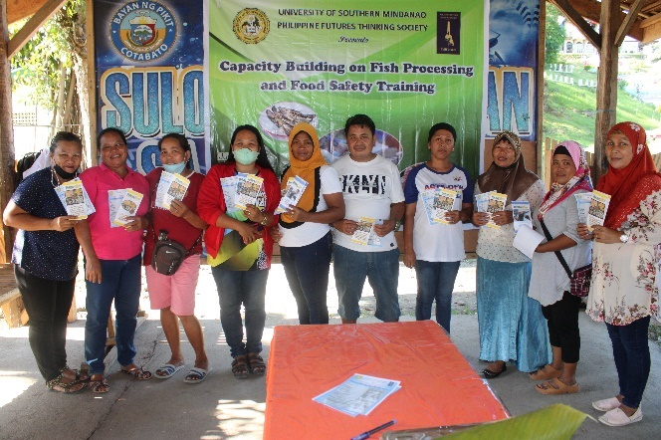
Figure 10. The beneficiaries holding their certificates of completion and TeknoGiya leaflets in Pikit, Cotabato.
- Accomplishments

Training Needs Assessment (TNA). Since the training to be done was pre-determined, the TNA was designed based on the basic procedure of fish processing and smoking. The result of the survey is presented in Table 1.
Most of the respondents rated themselves knowledgeable in the process of receiving, washing, evisceration and fish smoking while unknowledgeable in the process of brining, drying, and packaging. Although the TNA was written in Filipino, they still hardly understood the questions. So, it was translated to them one by one by the Development Management (DM) Interns who accompanied the group for their field exposures.
After the TNA was analyzed, it was validated with them. Further questions were asked to clarify some items. It was observed that not all of them were practicing fish smoking. Some of them were just curious about the activity and anticipating something, some had no experience but want to learn about fish smoking.
With the result, a Training Design was made to address their little/lack of knowledge in brining, drying, and packaging. Although they were knowledgeable in hot smoking, another technique, which was cold smoking was introduced using wood chips to give them options in using wood chips as alternative combusting materials in infusing smoky flavor to their products.

Table 1. Result of the Training Needs Assessment Conducted on Fish Processing Food Safety and Smoking. Pikit, Cotabato. 2022.
PROSESO | MGA KASAGUTAN (%) |  |  | REMARKS
PROSESO | OO | HINDI | HINDI ALAM | REMARKS
Preparasyon (preparation)
1. Meron na bang nakahandang asin at yelo bago dumating ang mga isda para maiwasan ang pagkabulok ng nito? | 68% | 32% | 0 | Ang mga isda ay bagong huli at mga buhay pa.
2. Ang mga isda ba ay nakaimbak sa isang refrigerator/timba na may yelo/o sa isang chiller bago iproseso para lutuin/smoking? | 50% | 50% | 0 | Ang mga buhay na isda ay naka imbak sa lagayan na mayroong tubig.
Pagtanggap (receiving)
1. Dinisenyo ba ang mga transport crates/kahon para sa madaling paglilinis nito? | 100% | 0 | 0 | Kadalasan nilalagay sa sako
2. Ang mga transport crates/kahon ba ay nililinis bago muling gamitin? | 95% | 0 | 5%
3. Ang asin at yelo ba ay nakaimbak sa kondisyon na pumipigil sa kontaminasyon nito? | 91% | 0 | 9%
Paghuhugas (washing)
1. Malinis ba ang tubig na ginagamit panghugas sa mga isda? | 95% | 5% | 0 | Hindi mainum pero malinis
2. Dalawang beses bang hinuhugasan ang mga isda? | 91% | 4.5% | 4.5% | Hanggang wala ng dugo ang tubig
Pagtatanggal ng laman-loob (evisceration)
1. Tinatanggal ba ang mga hasang, laman-loob at dugo ng isda? | 100% | 0 | 0
2. Ang isda ba ay hinuhugasan pagkatapos tanggalan ng laman-loob? | 95% | 0 | 5%
3. Ang mga isda ba ay hinuhugasan pagkatapos tanggalin ang kaliskis nito? | 95% | 0 | 5% | Hindi inaalisan ng kaliskis
Pagbababad ng isda sa tubig na may asin (brining)
1. Binababad ba ang malinis na isda sa brine solution upang maiwasan ang posibleng pagkasira? | 0 | 95% | 5% | Hindi ginagawa at hindi alam
Pagpapatuyo (drying)
1. Pinatuyo ba ang mga isda ng 2 hanggang 3 oras sa ilalim ng araw? | 0 | 86% | 14% | Hindi nagpapatuyo dahil kulang na sa oras
2. Kung hindi nagpapatuyo sa ilalim ng araw, gumamit ba ng paper towel o tissue upang masiguro na ang tubig ay natatanggal sa kalamnan ng mga isda? | 0 | 82% | 18% | Binababad sa malinis na tubig bago lutuin
Pagpapausok (smoking)
1. Gumagamit ba kayo ng drum smoker? | 64% | 27% | 9% | Ihawan ang gamit
2. Umaabot ba ng 2 oras hanggang 3 oras ang smoking hanggang maluto? | 72% | 18% | 9%
Pagbabalot (packaging)
1. Umaabot ba ng 2 linggo ang nakabalot na isda? | 9% | 72% | 18% | Isang araw lang ay masira na ang isda
2. Ang balot/packaging ba ng produkto ay nasisiguro ang proteksyon mula sa init, kahalumigmigan (moisture) at pagsingaw? | 27% | 64% | 9% | Dahon ng saging ang ginagamit na pambalot sa isda, kung minsan ay news paper
3. Ang packaging ba ay nakakatulong para ma imbak ang produkto? | 32% | 50% | 18%
4. Ang packaging ba ay dapat matibay upang hindi manganib ang mga produkto sa panahong ng paglilipat | 27% | 50% | 23%
5. Ang packaging ba ay dapat may katangian na lumilikha ng kumpiyansa sa isipan ng mga mamimili na ang produkto ay may kalidad? | 68% | 14% | 18%

Technical training on fish processing food safety and techniques of fish smoking using different wood chips. The Training was conducted days before election, thus the number of trainees dropped from 22 to 15.
Pre-test and post-test. A 10-item pre-test was administered before the training and the same questions were asked after the training was conducted. The result of the pre and post-tests is presented in Figure 11.
Figure shows the comparison between the pre and post-tests. Although most of their scores increased during post-test, there were three participants whose scores had decreased. It was because they were not assisted during the exam and the questions were too technical. There were two participants who did not answer because they forgot their eyeglasses.
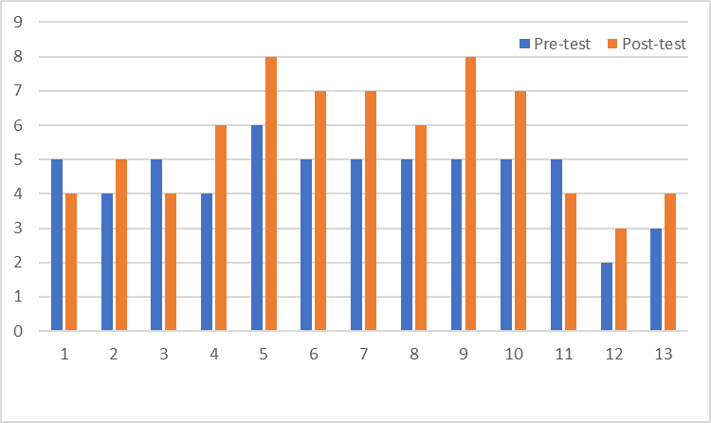
Training Participants
Number of Correct Answers
Figure 11. Result of the pre and post-tests on technical training on fish processing food safety and techniques of fish smoking using different wood chips.

Resource persons evaluation. After the lecture-discussion by Ms. Pia Amabelle M. Flores on Fish Processing Food Safety, and lecture-demonstration by Prof. Vic Laurence P. Oliva on Smoking Techniques using different Wood Chips, they were evaluated by the training participants. The result of the evaluation is shown in Table 2.
The evaluation parameters composed of 10 questions that focused on the ability of the resource person to deliver the topic. The rating scale was 5 (excellent), 4 (very satisfactory), 3 (satisfactory), 2 (fair), 1 (poor).
Both Ms. Pia Amabelle M. Flores and Prof. Vic Laurence P. Oliva got “excellent” in all the parameters.

Table 2. Result of Resource Persons Evaluation during the Training on Fish Processing Food Safety and Smoking Techniques using Different Wood Chips. Pikit, Cotabato. 2022
PARAMETERS | RESOURCE PERSONS
PARAMETERS | Ms. PAM Flores | Prof. VLP Oliva
1. Clarity of the topic objectives at the beginning | 5 | 4.87
2. Organization/ sequencing of the topics | 5 | 4.87
3. Clarity of topics/ ideas presented/ discussed | 5 | 4.87
4. Effectiveness of Methodologies used in teaching | 5 | 4.87
5. Quality and effectiveness of instructional aids/ materials used | 5 | 4.87
6. Ability to teach/ communicate ideas | 5 | 4.87
7. Ability to answer questions | 5 | 4.87
8. Ability to arouse/ sustain interest | 5 | 4.87
9. Ability to manage time | 5 | 4.87
10. How the topic was ended | 5 | 4.87

Overall Training/Activity Evaluation. The overall training evaluation was also conducted to determine the performance of the Training Management Team. The rating scale was 5 (excellent), 4 (very satisfactory), 3 (satisfactory), 2 (fair), 1 (poor). The result is presented in Table 3. The Training Management Team obtained a rating of “excellent” in all parameters.

Table 3. Result of the Overall Training/Activity Evaluation. Pikit, Cotabato. 2022.
PARAMETERS | RATING
1. Meeting my expectations | 5
2. Attainment of the objectives | 5
3. The course content/topics | 5
4. The activities included | 5
5. Methologies used | 5
6. Instructional materials/presentation aids | 5
7. Choice of Resource Persons | 5
8. Training Management Team and Secretariat | 5
9. Training facilitators and services | 5

Participatory sensory evaluation of “piniritong” smoked mudfish. The result of the participatory sensory evaluation of “piniritong” smoked mudfish is presented in Table 4.
A significant difference (P<0.05) was obtained by cold smoking with guava and citrus wood chips as combusting materials in “piniritong” smoked mudfish in terms of dryness and taste. Mudfish smoked using cold smoking were drier compared to hot smoking. This was due to the brining and drying process before smoking. While the taste could have been influenced by the guava and citrus smoky flavor.

Table 4. Mean rank of the sensory characteristics of “Piniritong” Smoked Mudfish. Pikit, Cotabato. 2022.
Method/Combusting Material | Hitsura ^{ns}  (appearance) | Amoy ^{ns}  (odor/  aroma) | Pagkatuyo *  (dryness) | Lasang usok ^{ns}  (smoke flavor) | Lasa*  (taste)
Hot smoking/Corn cobs | 35.3 | 28.6 | 23.0^{b} | 30.6 | 29.2^{b}
Hot smoking/Coconut husks | 32.3 | 35.0 | 27.7^{b} | 28.0 | 28.9^{b}
Cold smoking/Guava wood chips | 28.4 | 29.8 | 34.7ª | 37.4 | 29.2^{b}
Cold smoking/Citrus wood chips | 34.1 | 36.7 | 44.7ª | 32.5 | 42.8ª
ns = not significant
* = significant (P<0.05)
ab = mean rank with different superscripts differs significantly (P<0.05)

Table 5 presents the mean rank of the sensory characteristics of “ginataang” smoked mudfish. A significant difference (P<0.05) was observed in terms of firmness in favor of cold smoking with citrus wood chips as combusting material. The mudfish under cold smoking underwent brining and drying before smoking, thus even when cooked with liquid, they retained their firmness.
Table 5. Mean rank of the sensory characteristics of “Ginataang” Smoked Mudfish. Pikit, Cotabato. 2022.
Method/Combusting Material | Hitsura ^{ns}  (appearance) | Amoy ^{ns}  (odor/  aroma) | Pagkabuo * (firmness) | Lasang usok ^{ns}  (smoke flavor) | Lasa ^{ns}  (taste)
Hot smoking/Corn cobs | 37.1 | 35.0 | 28.43^{ab} | 30.2 | 32.6
Hot smoking/Coconut husks | 33.8 | 35.6 | 15.0^{b} | 26.1 | 28.2
Cold smoking/Guava wood chips | 30.3 | 29.8 | 33.6^{ab} | 33.7 | 34.4
Cold smoking/Citrus wood chips | 28.9 | 29.7 | 45.0ª | 31.2 | 34.8
ns = not significant
* = significant (P<0.05)
ab = mean rank with different superscripts differs significantly (P<0.05)

Table 6 presents the mean rank on acceptability of smoked mudfish cooked by frying and stewing. A significant difference (P<0.05) was observed in “Pinirito” where cold smoking with citrus wood chips was ranked first and significantly different to hot smoking whether with coconut husks or corn cobs as combusting materials. It implies that cold smoking using wood chips are acceptable to the fish processor-entrepreneurs of Pikit, Cotabato.
Table 6. Acceptability Smoked Mudfish. Pikit, Cotabato. 2022.
Method/Combusting Material | “Pinirito” * | Method/Combusting Material | “Ginataan” ^{ns}
Hot smoking/Corn cobs | 27.1^{b} | Hot smoking/Corn cob | 27.8
Hot smoking/Coconut husks | 28.5^{b} | Hot smoking/Coconut husk | 27.4
Cold smoking/Guava wood chips | 32.75^{ab} | Cold smoking/Guava wood chips | 33.1
Cold smoking/Citrus wood chips | 41.62ª | Cold smoking/Citrus wood chips | 33.6
ns = not significant
* = significant (P<0.05)
ab = mean rank with different superscripts differs significantly (P<0.05)

Table 7 presents the willingness to buy smoked mudfish if available in the market. Result shows that most of the respondents are willing to buy cold smoked mudfish with citrus as combusting material either in “pinirito” or “ginataan”. This implies that the introduction of alternative smoking technique which is cold smoking was successful and has an economic potential in the area.

Table 7. Willing to buy Smoked Mudfish. Pikit, Cotabato. 2022.
Method/Combusting Material | “Pinirito” | Method/Combusting Material | “Ginataan”
Hot smoking/Corn cobs | 25% | Hot smoking/Corn cob | 20%
Hot smoking/Coconut husks | 12.5% | Hot smoking/Coconut husk | 13%
Cold smoking/Guava wood chips | 6.25% | Cold smoking/Guava wood chips | 20%
Cold smoking/Citrus wood chips | 68.75 | Cold smoking/Citrus wood chips | 47%

Figure 12 presents the vacuum-packed raw smoked mudfish. It was just shown to them so that they can have an idea about the proper packaging if ever they have surplus.

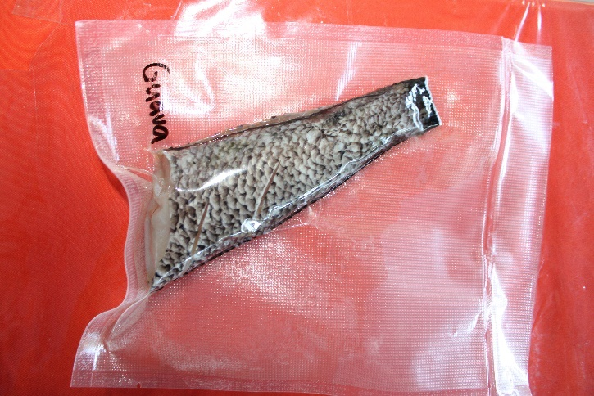
Figure 12. Vacuum packed raw cold smoked mudfish using guava chips as combusting material.

IEC print materials. Two IEC print materials were developed by the resource persons as shown below (Figure 13).
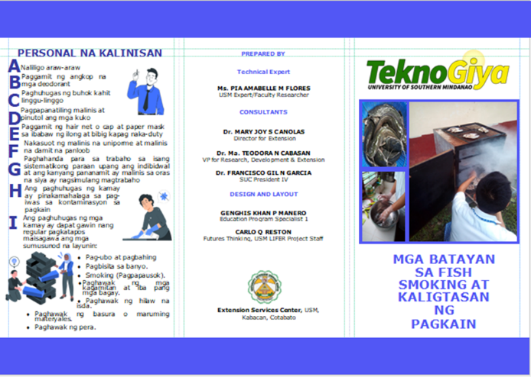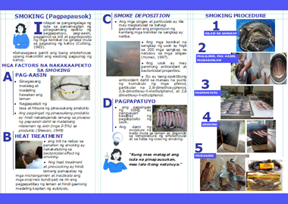

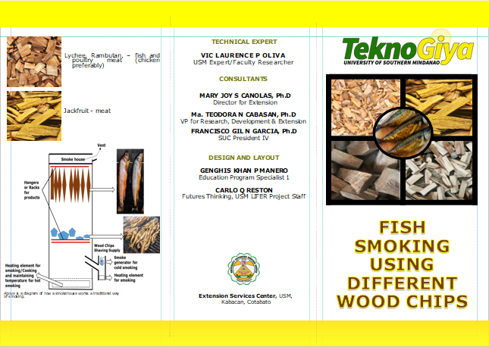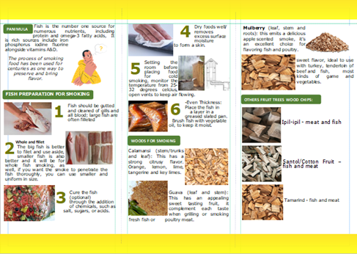
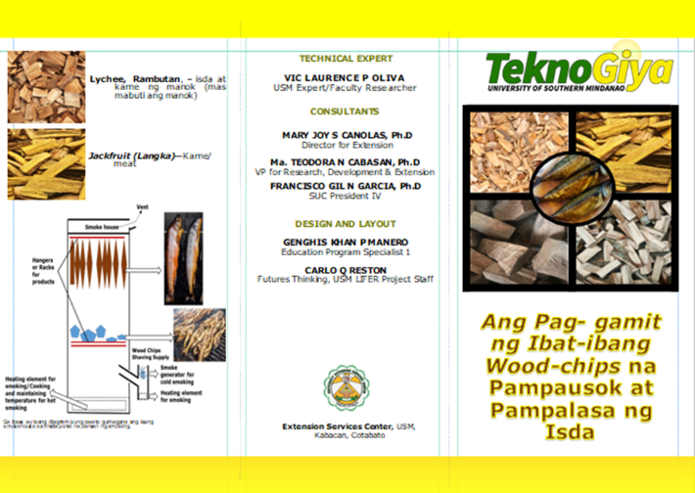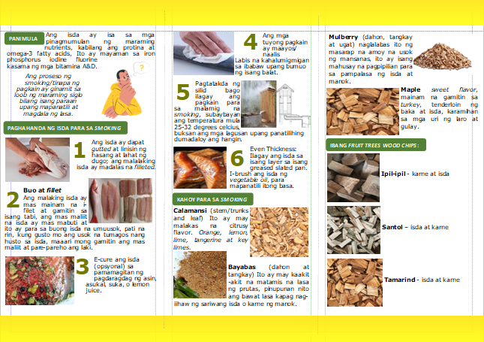
Figure 13. TeknoGiya leaflet developed titled “Mga batayan sa fish smoking at kaligtasan ng Pagkain”, “Fish smoking using different wood chips”, and “Ang Pag-gamit ng ibat-ibang wood chips na pampausok at pampalasa ng isda”.

- References (in APA format)

1. Hinks, J. (2018). The World Is Headed for a Food Security Crisis. Here's How We Can Avert It. Available online at Ithttps://time.com/5216532/global-food-security-richard-deverell/. Accessed Nov 27, 2022.

2.Verzosa, D.M. (2021). USM Embarks on Futures Thinking Program. Available online at https://www.usm.edu.ph/usm-embarks-on-futures-thinking-program/. Accessed Nov 27, 2022.

3. Key Biodiversity Areas Partnership (2022). Key Biodiversity Areas factsheet: Liguasan marsh. Available online at https://www.keybiodiversityareas.org/site/factsheet/9802. Accessed Nov 29, 2022.

4. Sarmiento, R. (2012). "Liguasan Marsh eyed as freshwater fish biodiversity center in Mindanao". BusinessWorld. Accessed Nov 27, 2022.

5. Project brief (2004). Proposed Ligawasan Marsh Protected Area. Available online at https://faspselib.denr.gov.ph/sites/default/files//Publication%20Files/Volume%20III%20-%20Project%20Brief.pdf. Accessed Nov 29, 2022.

- Problems Met and Recommended Action

1. The training was done during peak of election campaign (May 2022), that made the number of beneficiaries plummeted.

2. Very short period for social preparation that no partnership/collaboration was forged.

- Budget Utilization

Component | Allocation | Utilized | % Utilized
Communication | 4,000.00 | 4,000.00 | 100%
Representation | 20,000.00 | 20,000.00 | 100%
Research Staff | 27,000.00 | 27,000.00 | 100%
Training Expenses | 27,000.00 | 27,000.00 | 100%
Miscellaneous | 6,000.00 | 6,000.00 | 100%
Total | 84,000.00 | 84,000.00 | 100%

- Attachments:

N/A

