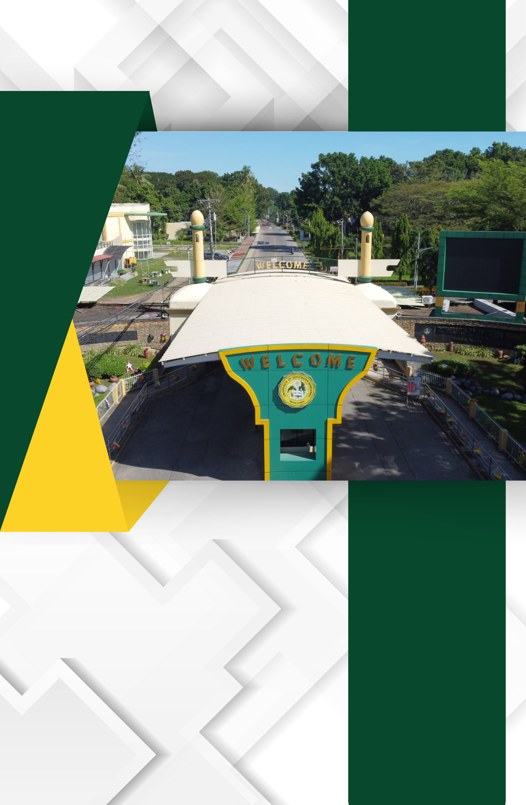

H.2. Inventory of Equipment, Furniture and Amenities at the Student Center

