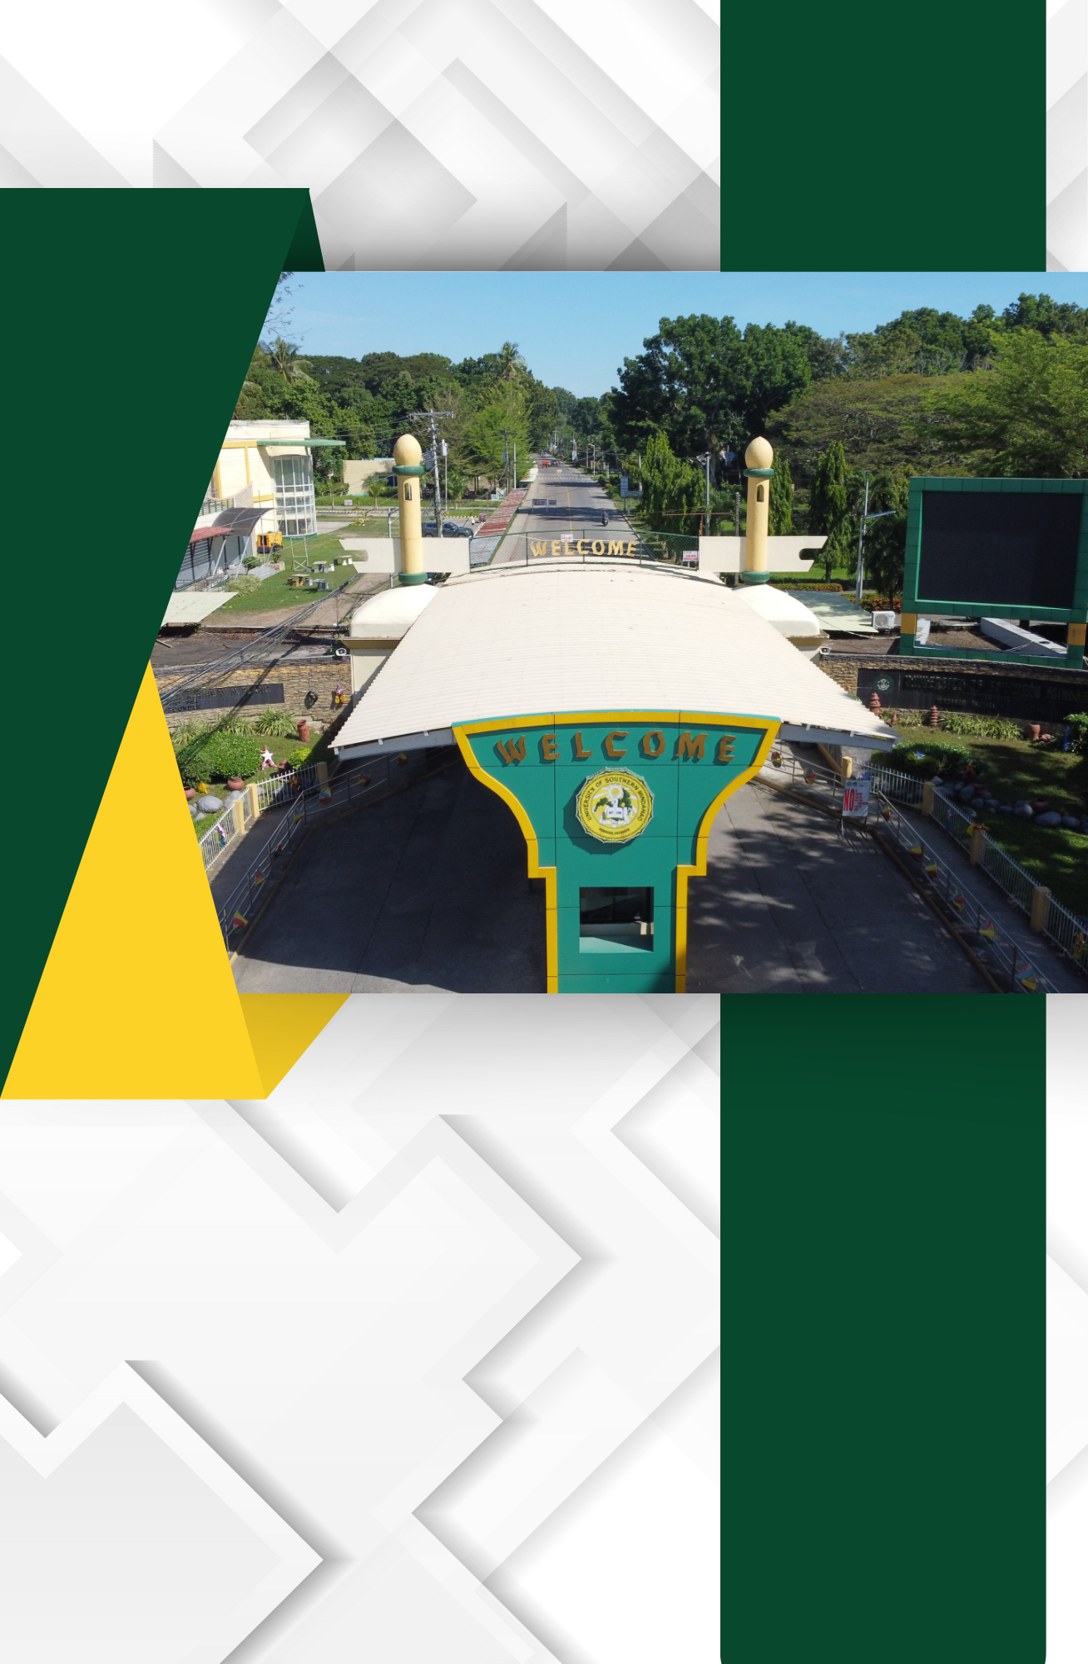

E.5. File Copies of Approved Requests for the Use of the Function Rooms

File Copies of Approved Requests for the Use of the Function Rooms

