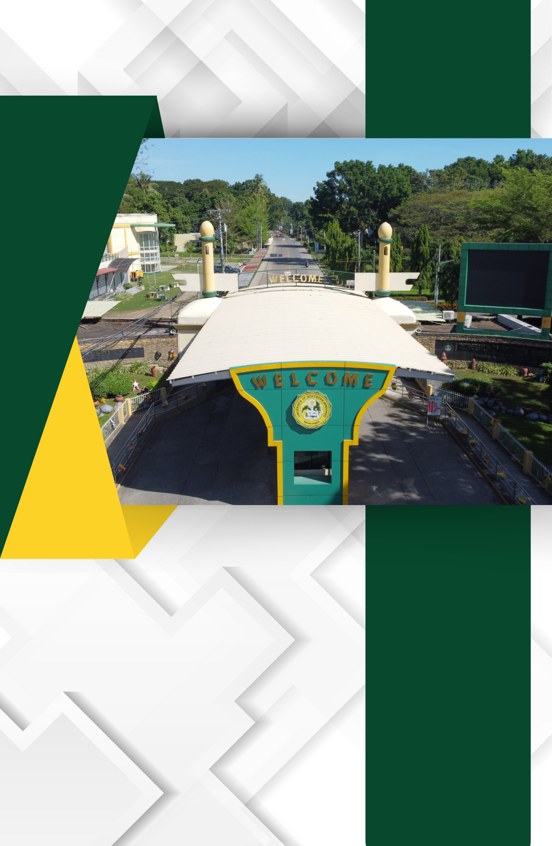

E.4. List and Description of Function Rooms (administrative office, faculty room, faculty lounge, music room, conference hall, multimedia room, etc.

List and Description of Function Rooms with Photos

