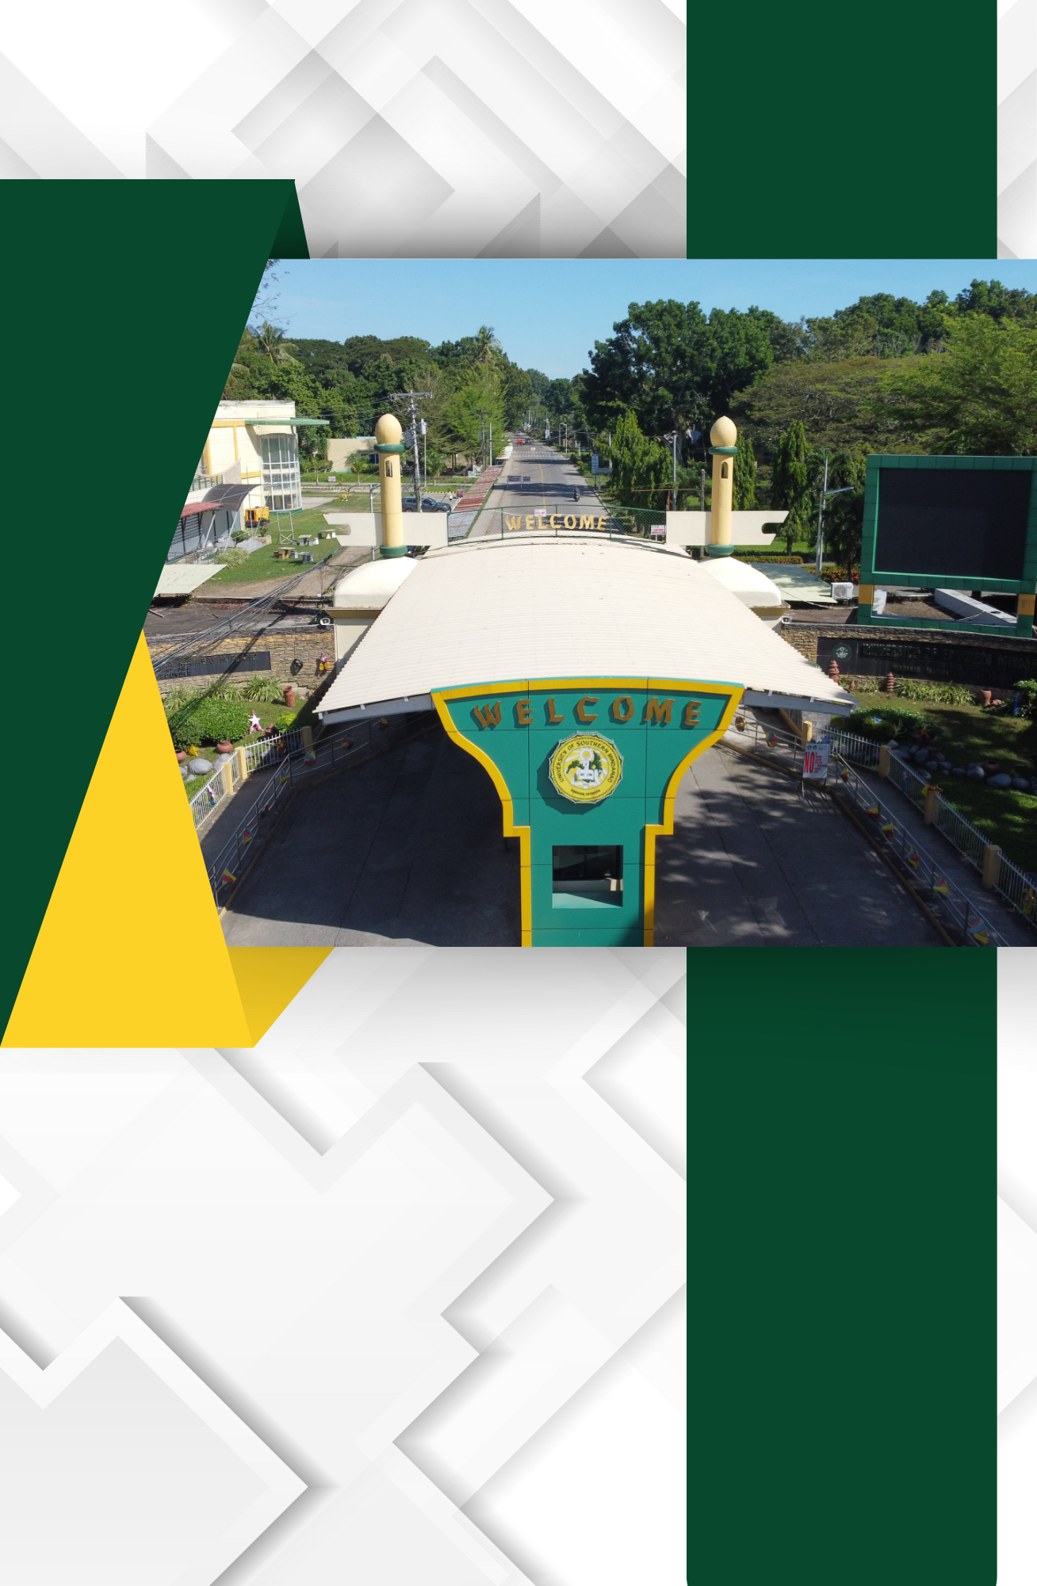

E.2. Inventory of Equipment, Amenities and Supplies in Function Rooms and Offices

Inventory of Equipment, Amenities and Supplies in Function Rooms and Offices

