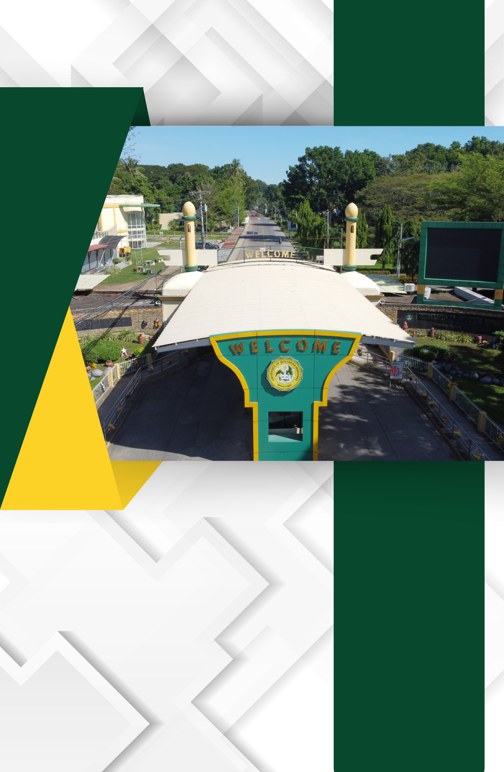

D.2. Sample of Photographs of Material Resources Inside the Classroom

Material Resources Inside the Classroom

