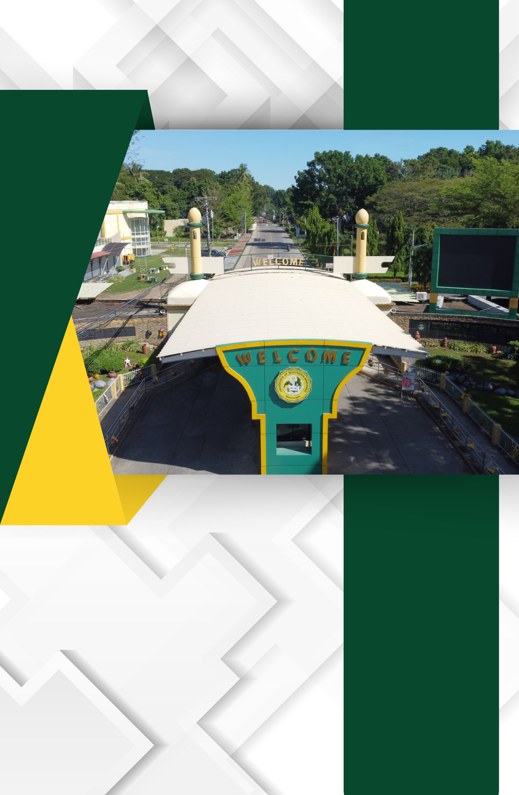

D.1. Number of Classrooms Utilized by the Program under Survey

Table of the Number of Classrooms Utilized with Photos

