

C.2. Evidence that Electrical Lines are Safely Installed and Periodically Checked

Circuit Breakers and Electrical Lines

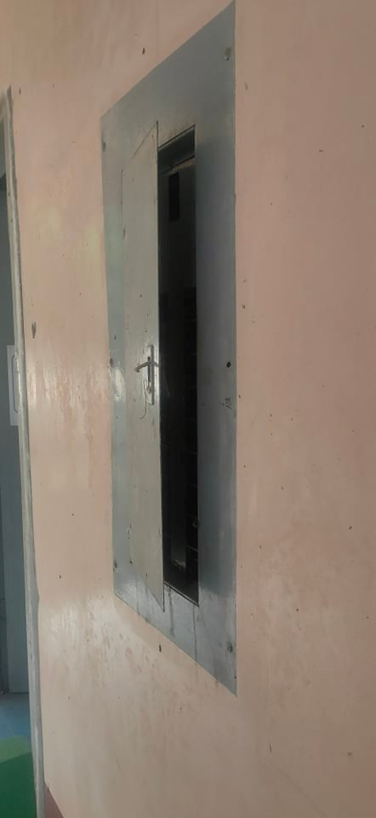
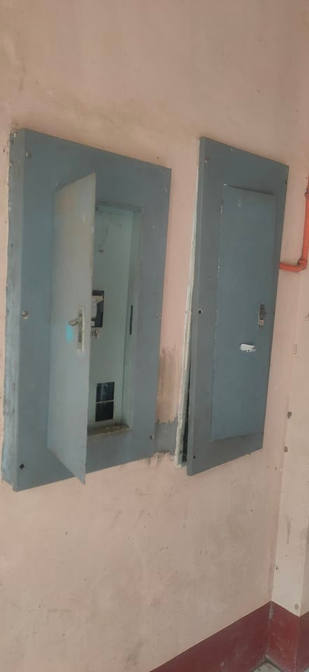

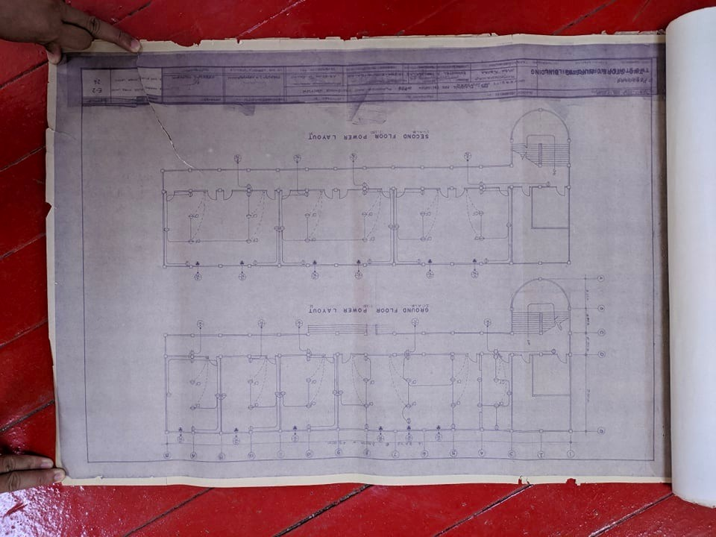
Building Power and Lighting Layout
Evidence that Electrical Lines are Periodically Checked

