

B.2.4. cleanliness and orderliness in the campus;

The university emphasizes campus cleanliness and orderliness as a core component of its waste management and sustainability initiatives.
Routine cleaning schedules, in collaboration with the campus janitorial team, ensure that common areas, walkways, and facilities remain litter-free and orderly.
Dedicated waste disposal areas and visible reminders encourage the campus community to take responsibility for maintaining a clean and organized environment, supporting the university’s commitment to health, safety, and aesthetics.
Machine and Campus Ground Maintenance

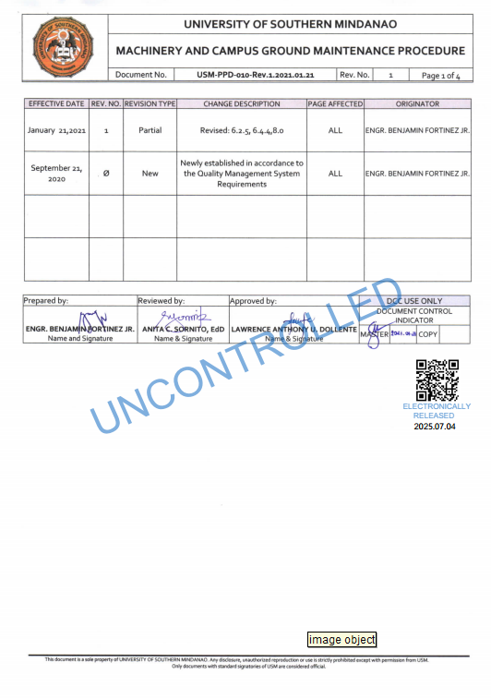

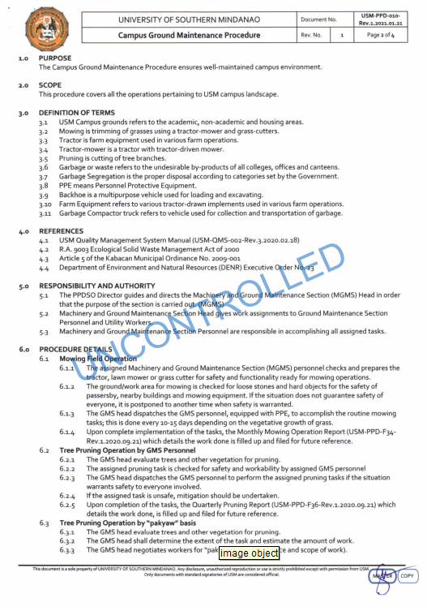

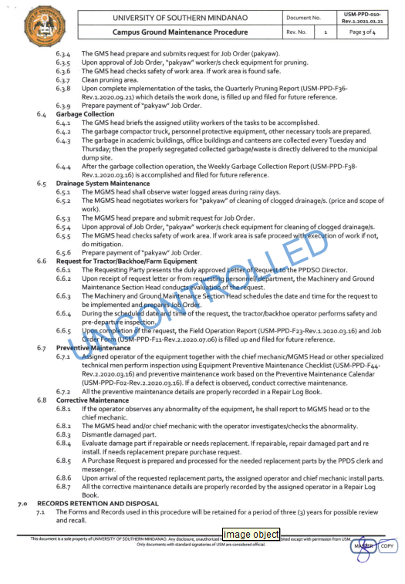

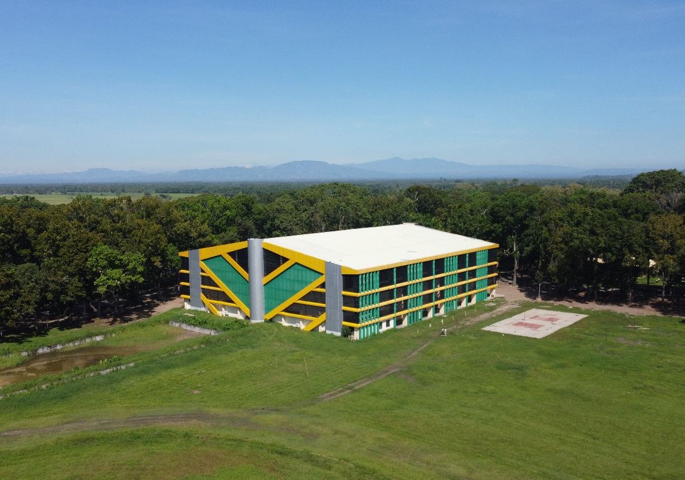

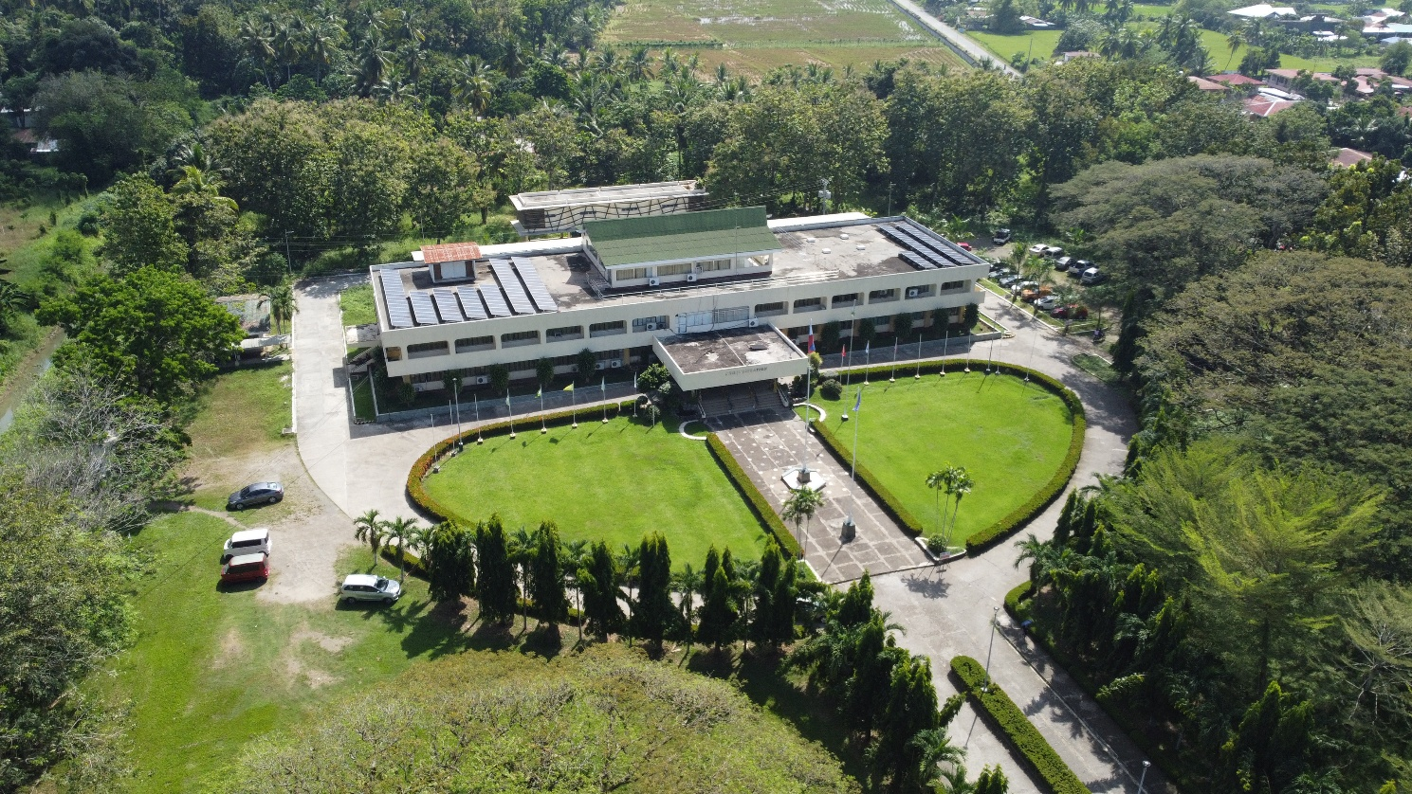

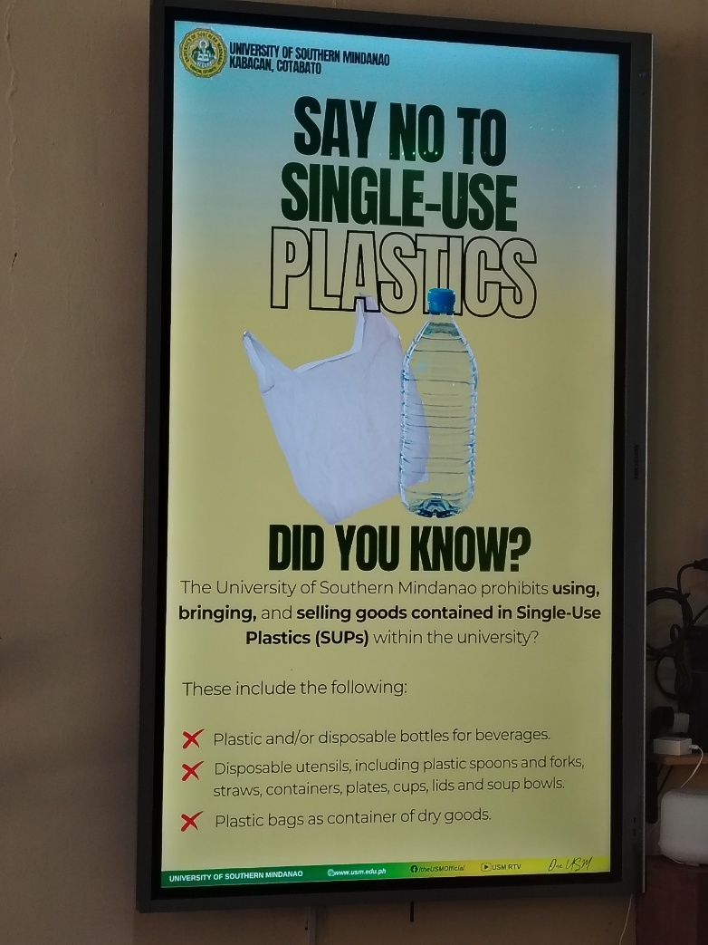
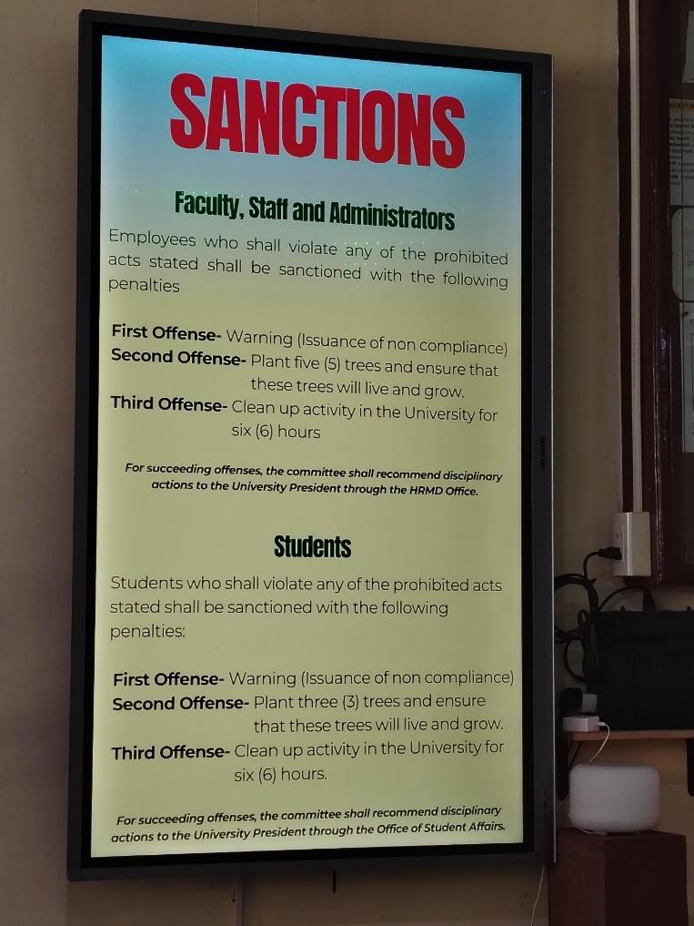
No SUPs Policy

