

B.2.2. waste management;
The University of Southern Mindanao (USM) Waste Management Program, launched campus-wide in June 2011, aims to promote environmental responsibility and sustainable waste practices across the university. The program builds upon the school’s longstanding commitment to effective solid waste management, which began even before the enactment of the Philippine Ecological Solid Waste Management Act of 2000 (R.A. 9003). The program includes comprehensive strategies for waste reduction, segregation, and recycling to create a greener campus environment.

Key Components of the USM Waste Management Program
- Waste Segregation at the Source
- All departments and colleges within the university are designated as "point sources" of waste and are required to implement strict waste segregation protocols.
- Colleges must separate waste into designated categories—such as recyclables, biodegradable waste, and residual waste—before storage.
- Properly segregated waste is temporarily stored at each college’s Materials Recovery Facility (MRF). The MRF serves as a local collection point, allowing for organized and efficient waste management.
- Collection and Transport Protocol
- The USM drum truck is responsible for collecting waste from each college's MRF. However, the university strictly enforces a no collection policy for non-segregated waste. Only properly sorted waste is collected to ensure compliance with the university’s waste management standards and to promote accountability among departments.
- The collected waste is then processed according to its type, with recyclables directed to appropriate facilities and residual waste minimized to reduce landfill contributions.
- No Single-Use Plastics Policy
- In alignment with the university’s environmental objectives, single-use plastics are strictly prohibited on campus. This includes items such as plastic bags, straws, disposable cutlery, plastic bottles, and other non-reusable plastic products.
- The policy encourages students, faculty, staff, and visitors to bring reusable containers, bottles, and bags, and to support the use of biodegradable or recyclable alternatives wherever possible.
- Vendors and campus facilities are required to comply with this policy by offering sustainable alternatives, helping to significantly reduce plastic waste within the university.

- Educational Initiatives and Awareness Programs
- To ensure consistent adherence to the waste management protocols, the university conducts regular educational campaigns, seminars, and workshops on the importance of sustainable practices and the impact of waste on the environment.
- Posters, signage, and waste segregation guides are displayed around the campus to remind students and staff of proper waste disposal practices and to raise awareness about the dangers of single-use plastics.
- Monitoring and Compliance
- The university’s Waste Management Office regularly monitors compliance with the waste management policies, including the segregation and single-use plastic prohibition.
- Non-compliance by any college or department may result in penalties or the suspension of waste collection services until proper segregation practices are resumed.

Waste Management Manual

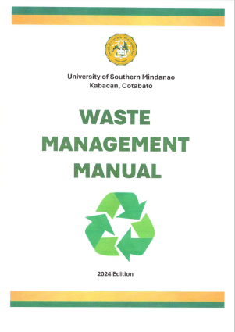

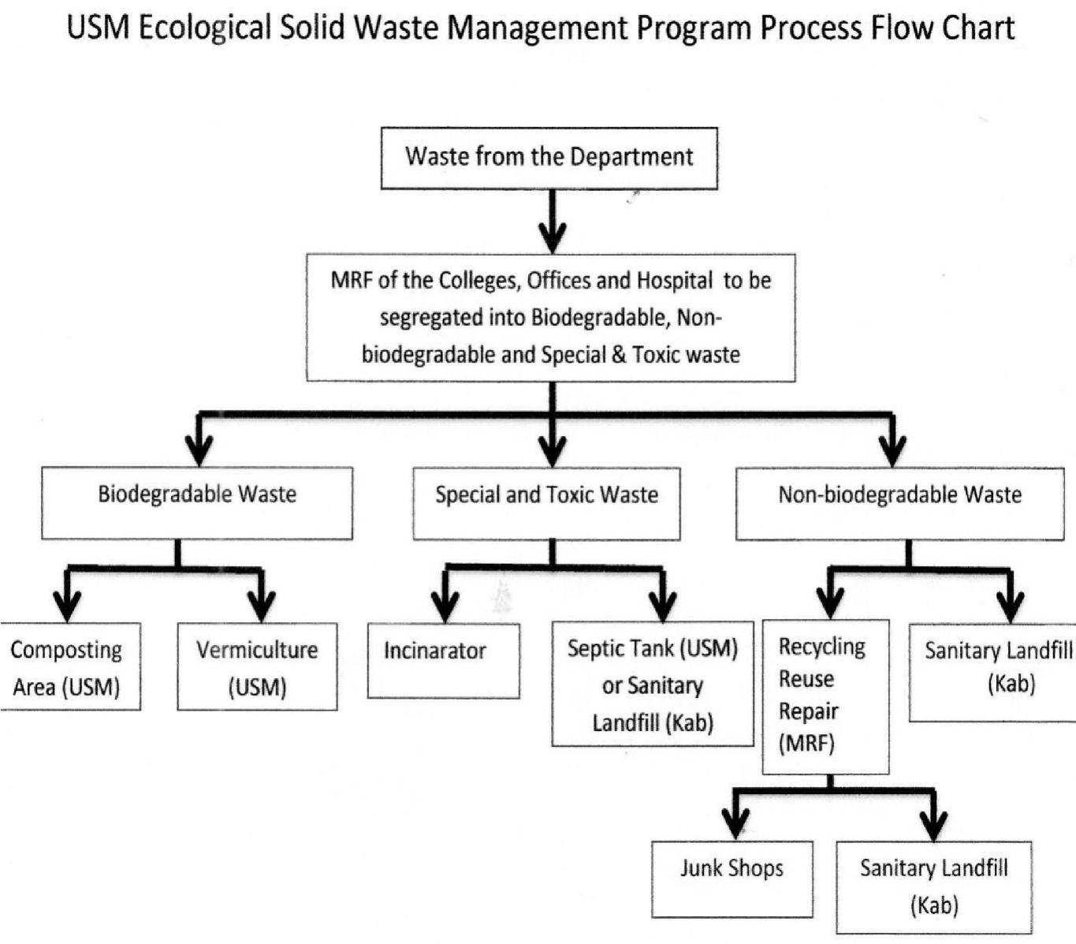

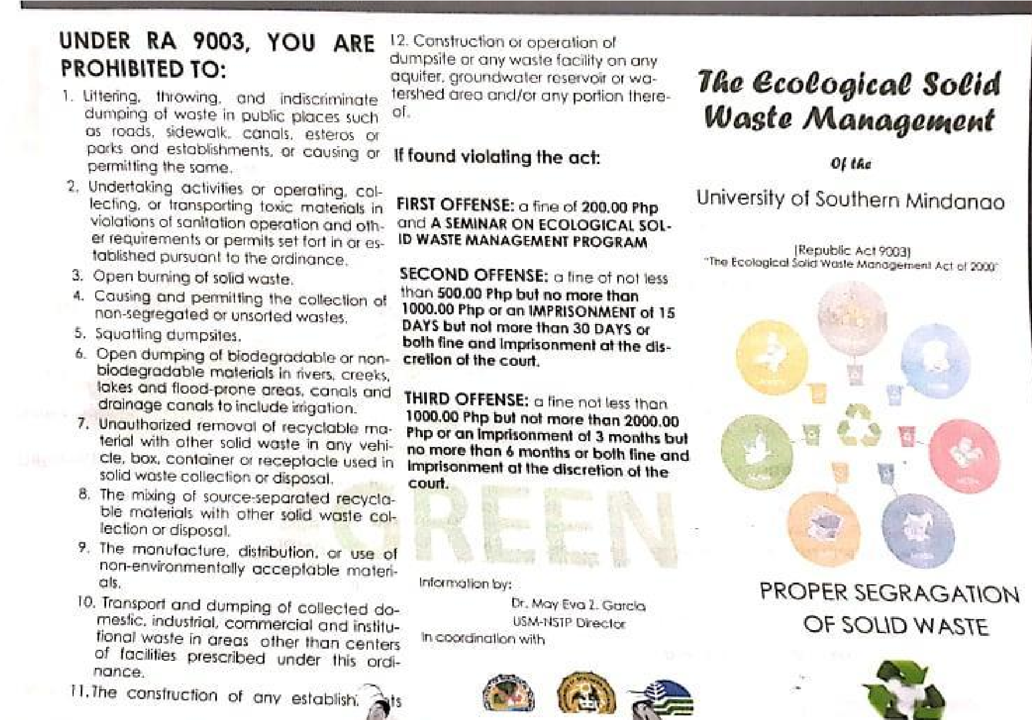
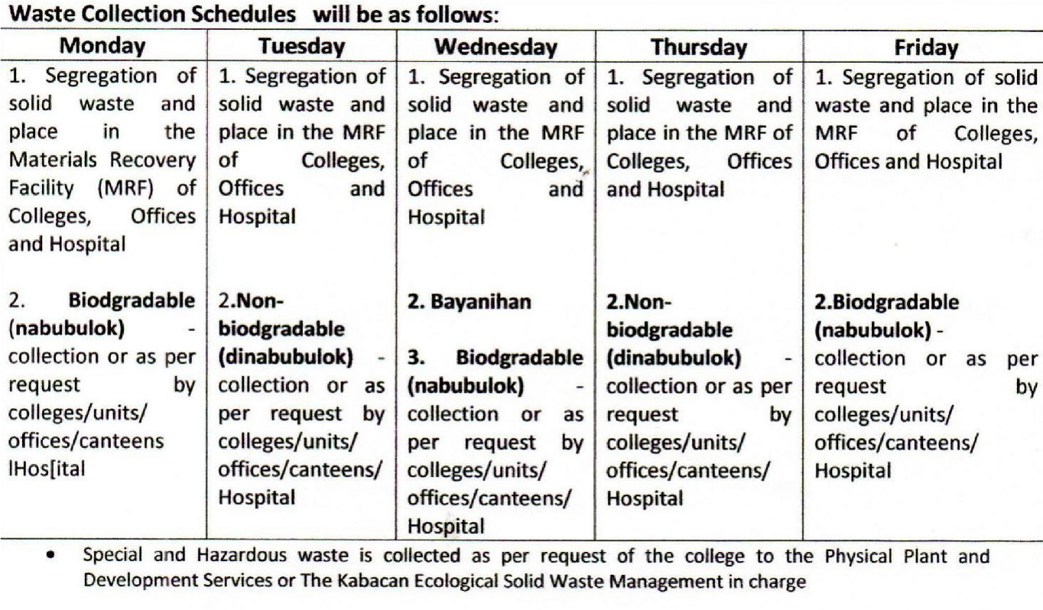

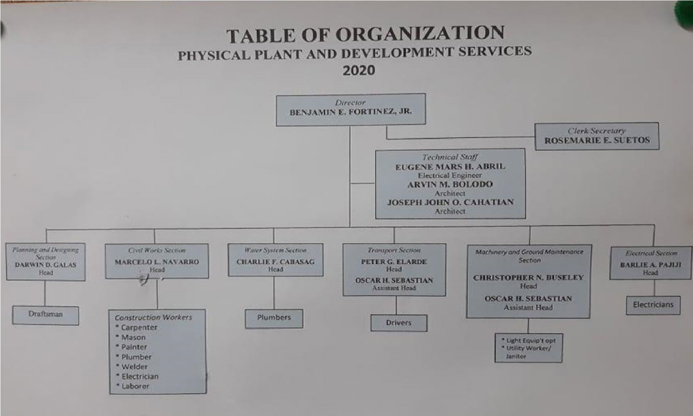
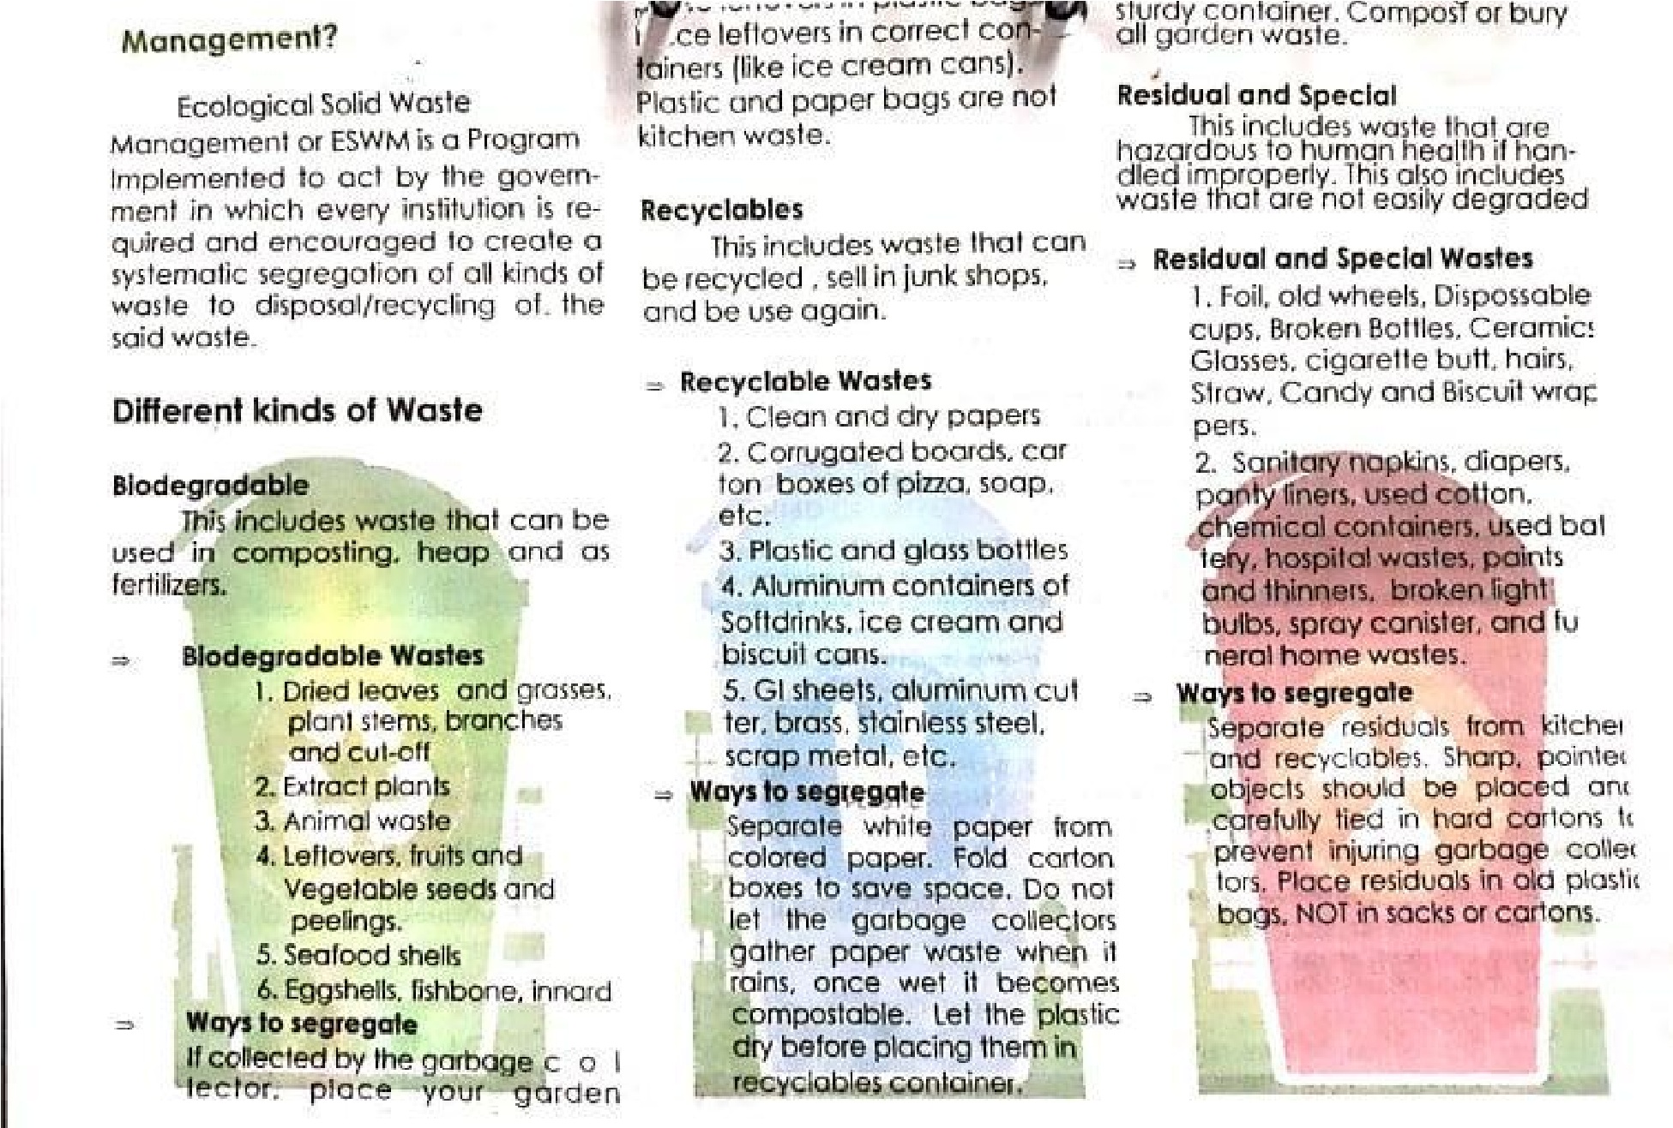
University Garbage Truck
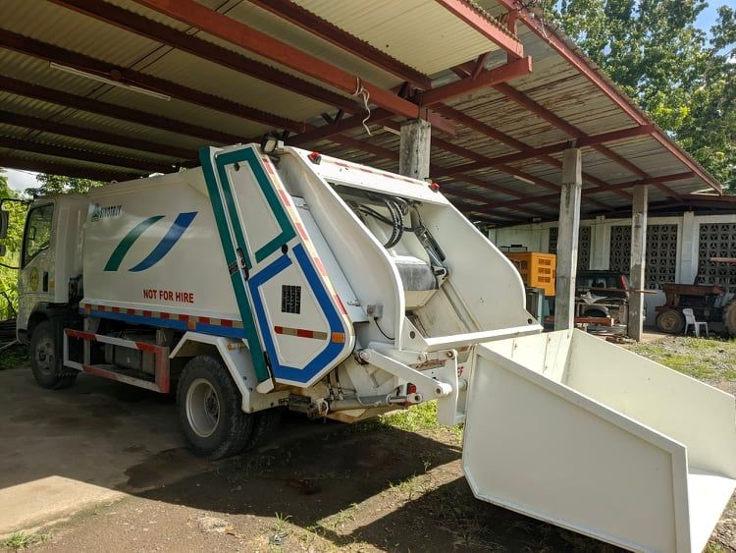
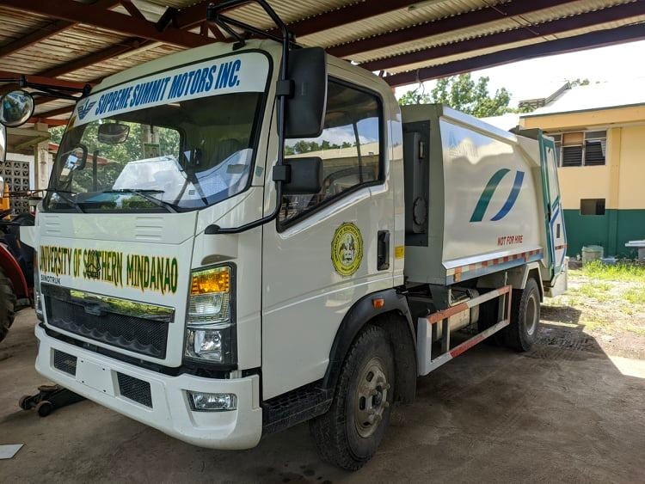
No Single-Use Plastics Policy in the University

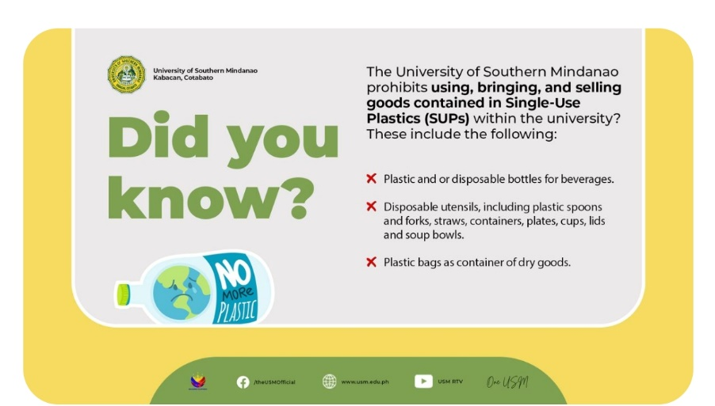
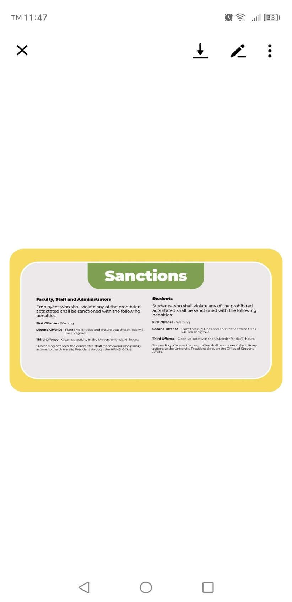

Waste Segregation Bins of the College

